Short Description

Leucospermum

Cultivar name: ……………………………………………….

Characteristics | States of expression
Plant
Plant: growth habit | erect  spreading  prostrate
Plant: lignotuber | absent  present
Leaf
Leaf: length | cm
Leaf: width | cm
Leaf: average number of teeth (mature leaf tips)
Leaf: colour (if a combination of colours occur, please combine the colours accordingly) | grey  yellow  green  dark green  other (specify)
Flower (observations to be done on freshly fully opened flower heads)
Flowering season (months)
Indicate hemisphere
Flowering season (months)  Indicate hemisphere | Southern Hemisphere  Northern Hemisphere
Flowering branch: clustering of fully developed flower heads (“conflorescence” habit) | always absent  sometimes present  always present
Flower head: length | cm
Flower head: diameter | cm
Flower head: predominant colour
Flower head: predominant colour | RHS:
Floret: colour of rolled up perianth segment (“ribbons”)
Floret: colour of rolled up perianth segment (“ribbons”) | RHS:
Floret: predominant colour of style
Floret: predominant colour of style | RHS:

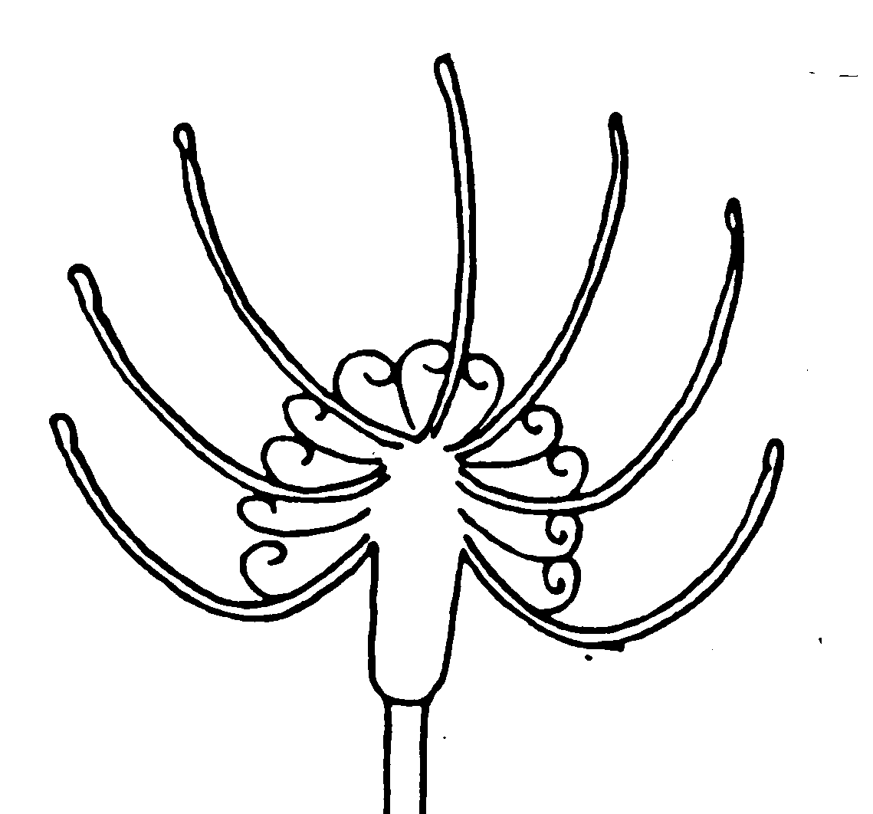
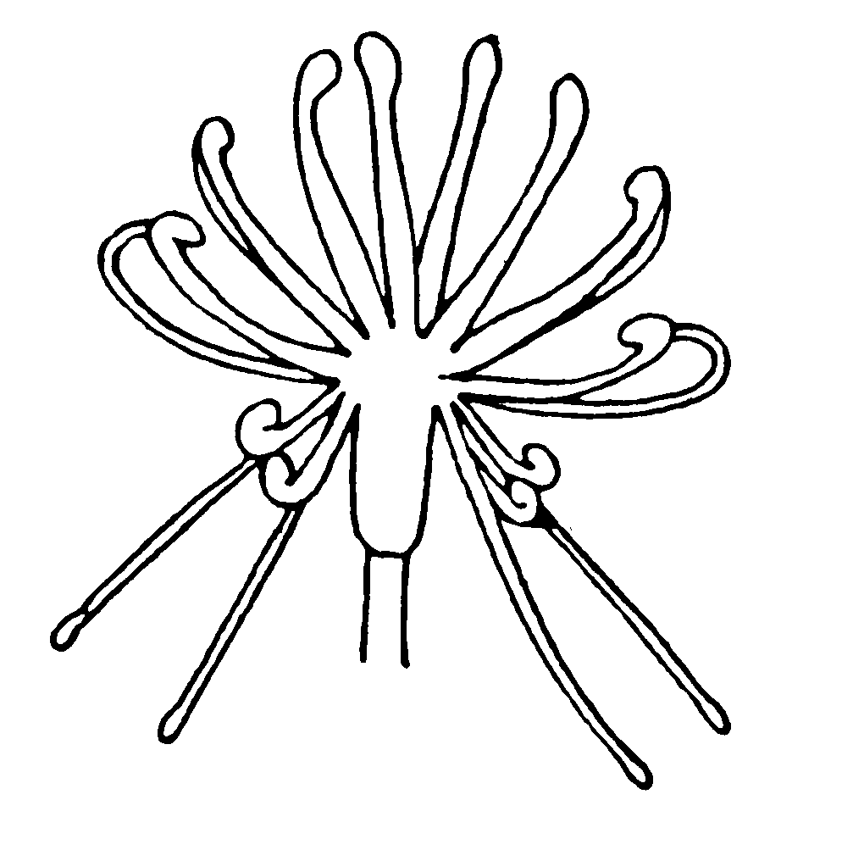
Flower head: length and width
l
l
l
w
w
w
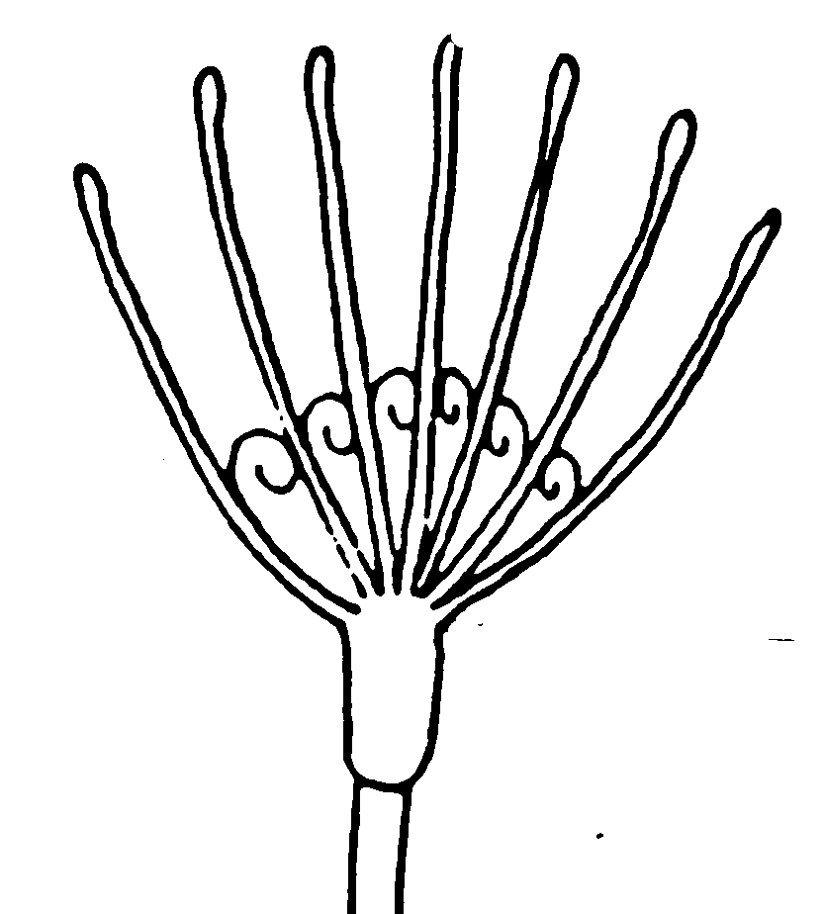
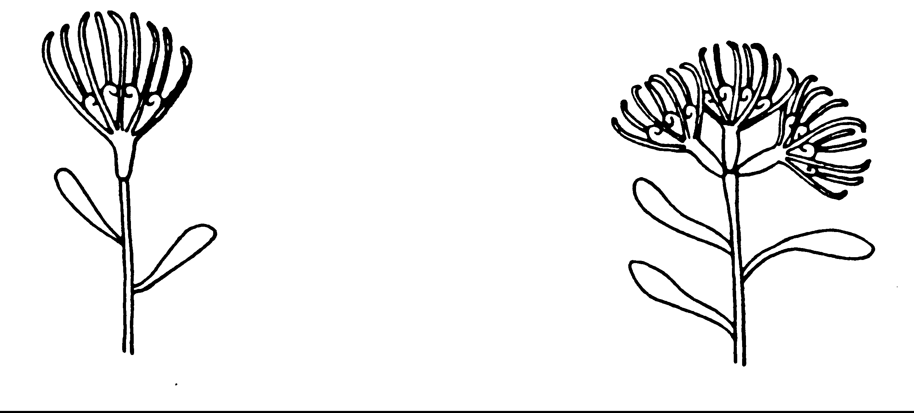Flower head: clustering
absent present

