IPCR Short Description:

Leucadendron

Cultivar name: ……………………………………………….

Characteristics | States of expression
Plant
Plant: sex | male  female
Plant: growth habit | erect  spreading  prostrate
Plant: lignotuber | absent  present
Foliage leaf
Leaf: length | cm
Leaf: width | cm
Leaf: predominant colour (if a combination of colours occur, please combine the colours accordingly) | grey  yellow  green  dark green  red  purplish  other (specify)
True flowering
Flowering season (months)
Indicate hemisphere
Flowering season (months)  Indicate hemisphere | Southern Hemisphere
Flowering season (months)  Indicate hemisphere | Northern Hemisphere
Flower head: fragrance | absent  present
Outer involucral leaf: length  (outer involucral leaves are the leaves surrounding the inner involucral leaves and are implanted on the apical 5-10 mm of the flowering branch) | cm
Outer involucral leaf: width | cm
Outer involucral leaf: predominant colour
Outer involucral leaf: predominant colour | RHS:
Inner involucral leaf: length  (inner involucral leaves are the leaves closest to the cone at their base) | cm
Inner involucral leaf: width | cm
Inner involucral leaf: predominant colour
Inner involucral leaf: predominant colour | RHS:
Inner involucral leaf: shape of apex | long acute  acute  obtuse  rounded  truncate
Cone (inflorescence): degree of concealment by involucral leaves | fully exposed  somewhat concealed  fully concealed
Cone: length | cm
Cone: diameter | cm

Leucadendron (cont.)

Cultivar name: ……………………………………………….

Female cone: colour (when styles are visible)
Female cone: colour (when styles are visible) | RHS:
Male cone: colour (before shedding of pollen)
Male cone: colour (before shedding of pollen) | RHS:
Colour changes out of flowering season (e.g. ‘Safari Sunset’)
Foliage leaf: colour change out of flowering season | absent  present
Foliage leaf: colour change out of flowering season | colour:
Foliage leaf: season of colour change | spring  summer  autumn  winter
Outer involucral leaf: colour change out of flowering season | absent  present
Outer involucral leaf: colour change out of flowering season | colour:
Outer involucral leaf: season of colour change | spring  summer  autumn  winter
Inner involucral leaf: colour change out of flowering season | absent  present
Inner involucral leaf: colour change out of flowering season | colour:
Inner involucral leaf: season of colour change | spring  summer  autumn  winter

flower head
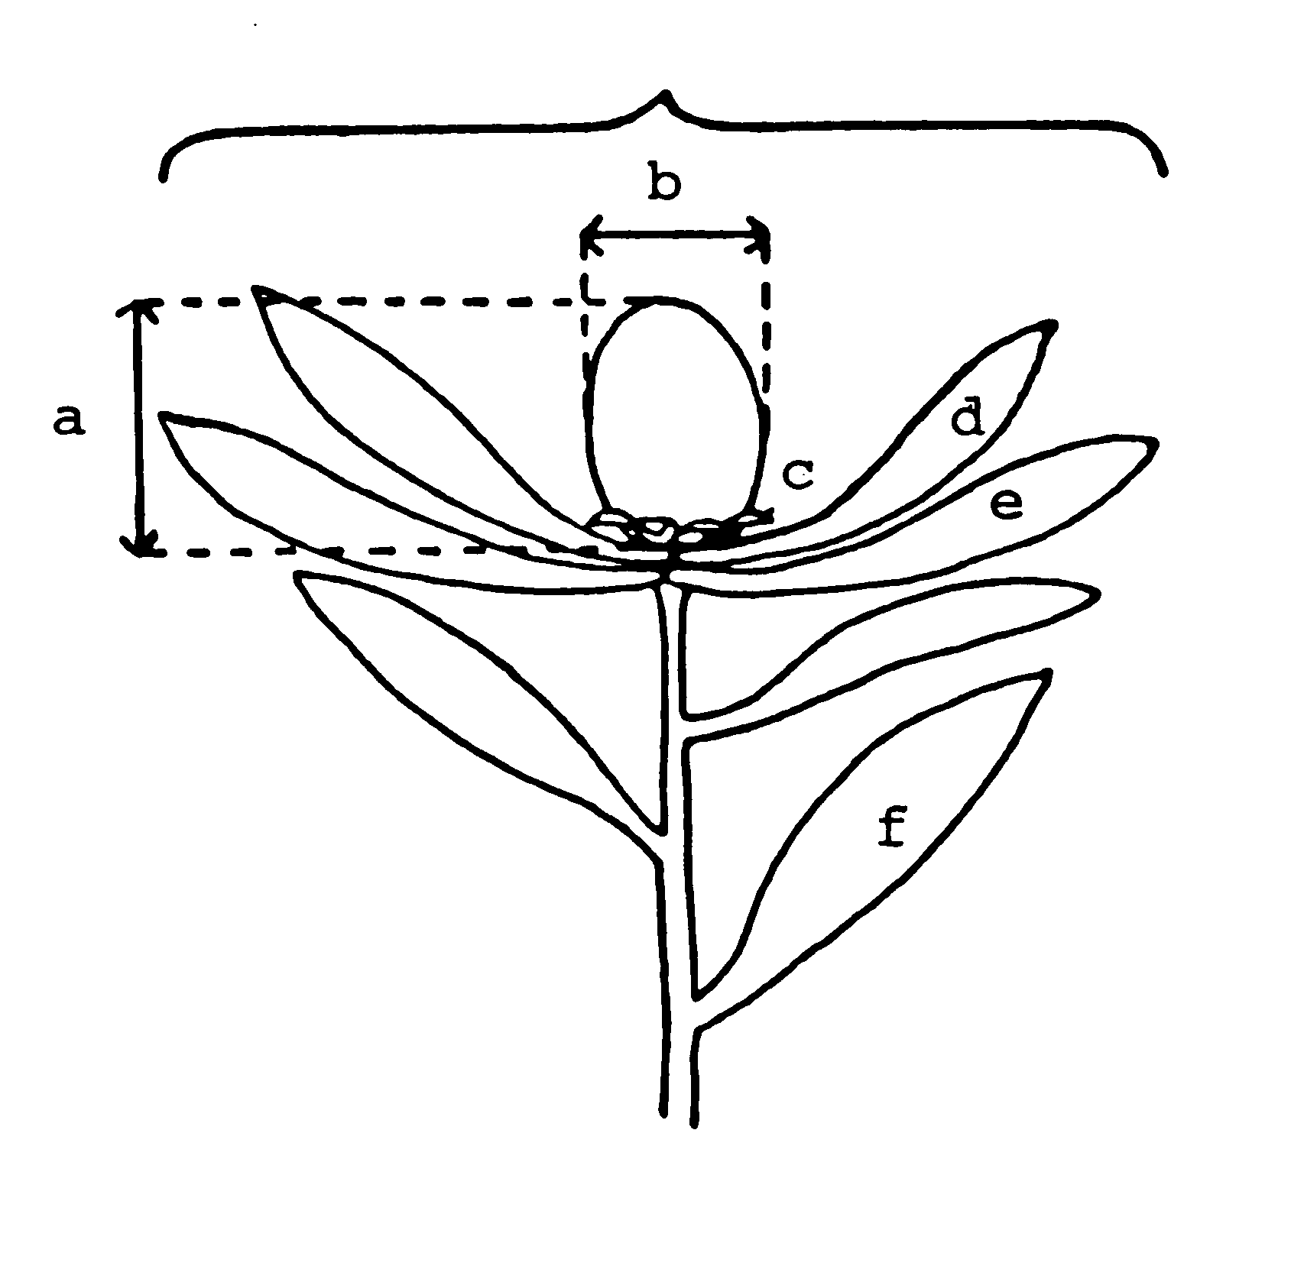

a length of cone
b diameter of cone
c basal bract
d inner involucral leaf
e outer involucral leaf
f foliage leaf

