Short Description

Protea

Cultivar name: ……………………………………………….

Characteristics | States of expression
Plant
Plant: growth habit | erect  spreading  prostrate
Plant: lignotuber | absent  present
Leaf
Leaf: length | cm
Leaf: width | cm
Leaf: position of broadest part | below middle  in the middle  above the middle  along most of the length
Leaf: colour (if a combination of colours occur, please combine the colours accordingly) | grey  yellow  green  dark green  other (specify)
Leaf: petiole | absent  present
Petiole: length | cm
Flower (observations to be done on freshly fully opened flower heads)
Flowering season (months)
Indicate hemisphere
Flowering season (months)  Indicate hemisphere | Southern Hemisphere  Northern Hemisphere
Flower head: length | cm
Flower head: diameter | cm
Flower head: shape of involucre | cylindrical  semi-globose  obovate  obconical  saucer-shaped
Flower head: predominant colour
Flower head: predominant colour | RHS:
Inner involucral bract: fringe on margin | absent  present
Inner involucral bract: apical tuft | absent  present
Inner involucral bract: colour of apical tuft
Floret mass: shape of apex | flattened  rounded  pointed  elongated point in middle
Floret mass: colour

Protea flower head:

a
b
a
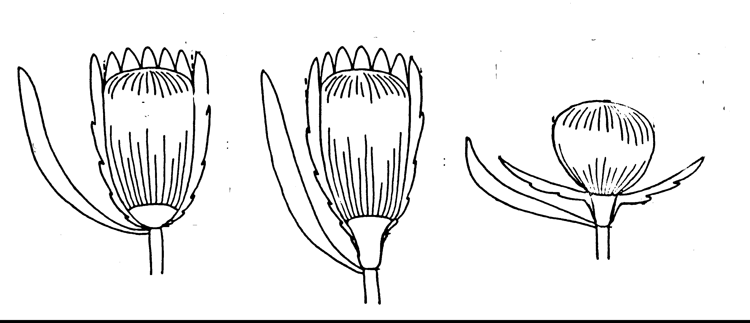

involucre
floret mass
c
c
c
foliage leaf

b

a diameter of floret mass
b diameter of flower head
c length of flower head

