Short Description

Serruria

Cultivar name: ………………………………………………

Characteristics | States of expression
Plant
Plant: growth habit | upright  semi-upright  spreading  semi-prostrate  prostrate
Plant: lignotuber | absent  present
Leaf
Leaf: length | cm
Leaf: colour (if a combination of colours occurs, please combine the colours accordingly) | grey  yellow  green  dark green  other (specify)
Flower (observations to be done on freshly fully opened flower heads)
Flowering season (months)
Indicate hemisphere
Flowering season (months)  Indicate hemisphere | Southern Hemisphere  Northern Hemisphere
Flowering branch: number of flower heads (if branched, with multiple heads)
Flower head: diameter | cm
Flower head: well developed involucral bracts | absent  present
Involucral bracts: length | cm
Involucral bracts: width | cm
Involucral bracts: colour
Involucral bracts: colour | RHS:
Floret mass: diameter | cm
Floret mass: colour of upper part | greyish  whitish  pinkish  reddish
a
b
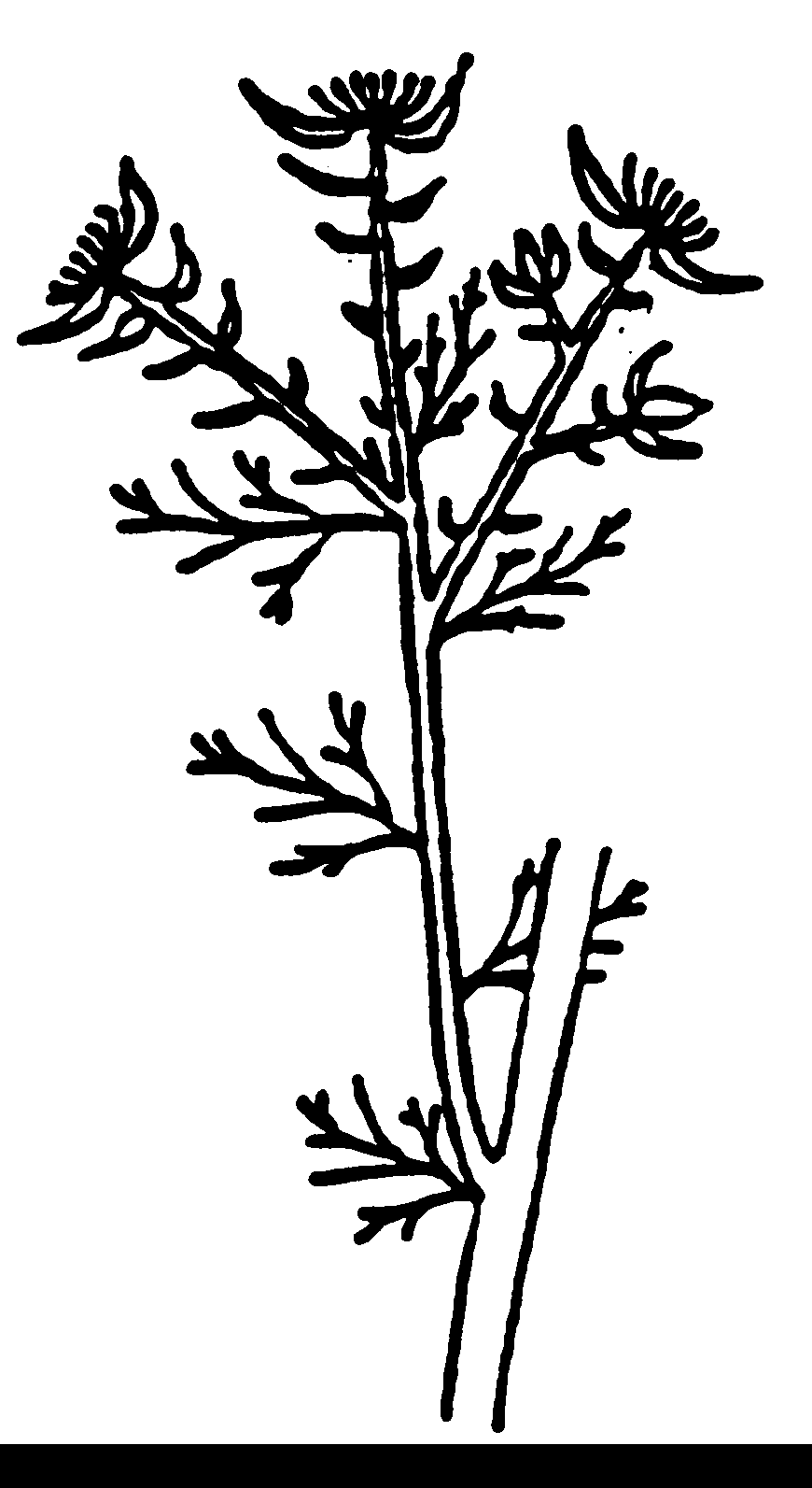
c
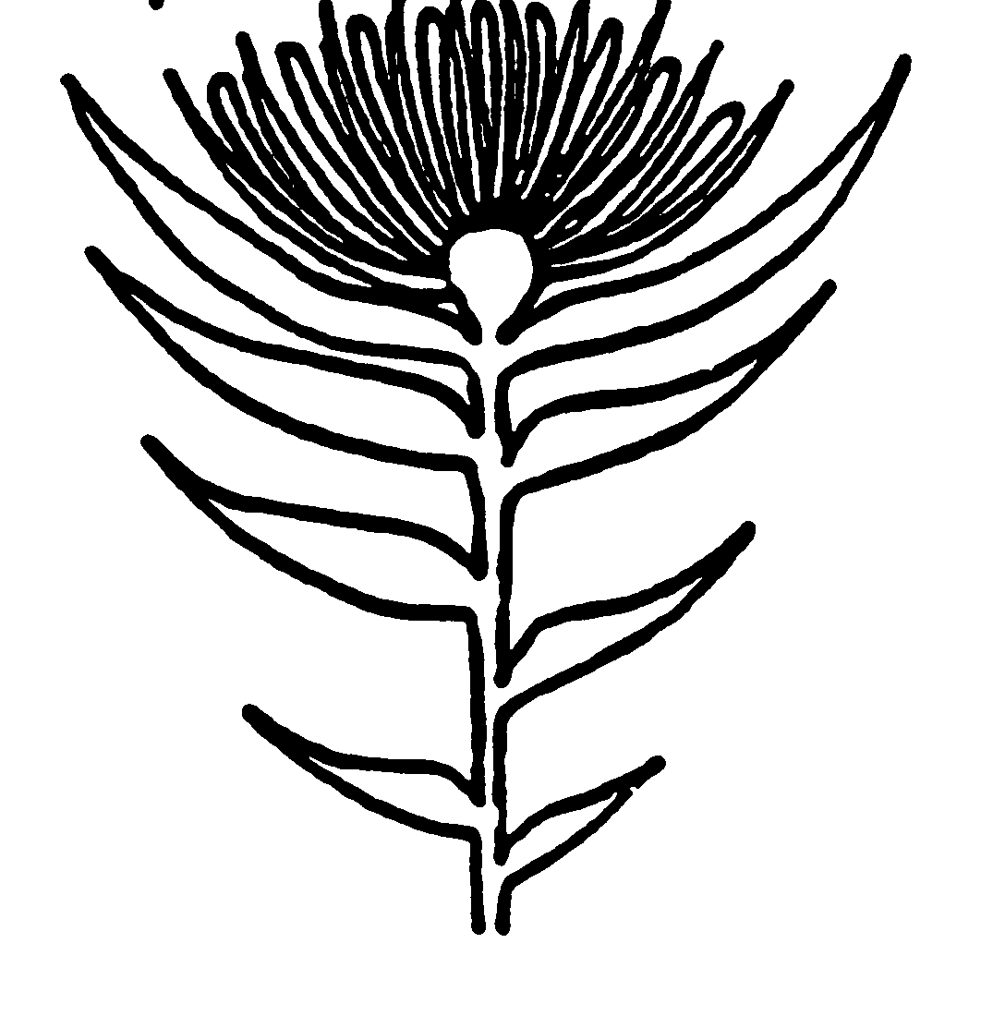
a diameter of flower head
Branched flowering branch
b diameter of floret mass
c well developed involucral bract (e.g. Blushing Bride)

