**SAMIC Contacts:**

**EXECUTIVE DIRECTOR**

[[](http://samic.co.za/rudi-van-der-westhuizen/)](http://samic.co.za/rudi-van-der-westhuizen/)

Rudi van der Westhuizen

Po Box 36802

Menlo Park

0102

Tel: 012 361 4545

Fax: 012 361 9837

Cell: 082 900 3005

Email: [rudivdw@samic.co.za](mailto:rudivdw@samic.co.za)

**PERSONAL ASSISTANT TO THE EXECUTIVE DIRECTOR**

[[](http://samic.co.za/img_0008/)<img src="http://samic.co.za/wp- vw, 233px" />](http://samic.co.za/img_0008/)

Orpa Thirion

Po Box 36802

Menlo Park

0102

Tel: 012 361 4545

Fax: 012 361 9837

Email: [rudivdw@samic.co.za](mailto:rudivdw@samic.co.za)

**DEPUTY TECHNICAL MANAGER/DEPUTY DIRECTOR**

[[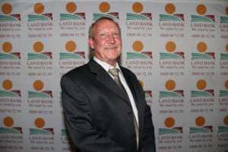](http://samic.co.za/hennie-gerber/)<img src="http://samic.co.za/wp-content/uploads/2019/09/Hennie-Gerber-300x200.jpg" width="300" height="200" alt=""](http://samic.co.za/hennie-gerber/) Hennie Gerber

Cell: 082 901 6385  
Fax: 011 696 1525  
E-mail: [hennie@samic.co.za](mailto:hennie@samic.co.za)

**REGIONAL MANAGER**

[[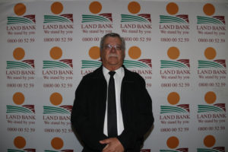](http://samic.co.za/dirk-zandberg-snr/)< con](http://samic.co.za/dirk-zandberg-snr/)

Dirk Zandberg

Cell: 082 900 3026

Fax: 086 680 7109  
E-mail: [dirkz@samic.co.za](mailto:dirkz@samic.co.za)

**QC / TECHNICAL MANAGER**

[[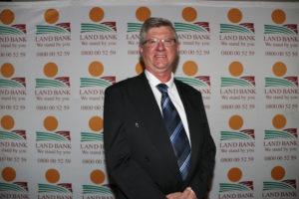](http://samic.co.za/neels-nell/)<img src="http://samic.co.za/wp-content/uploads/2019/09/Neels-Nell-300x200.jpg" width="300" height="](http://samic.co.za/neels-nell/)

Neels Nell

Po Box 36802

Menlo Park

0102

Tel: 012 361 4545

Fax: 012 361 9837

Cell: 082 900 3022

Email: neelsn@samic.co.za

**CLASSIQUIP DEBIT /CREDIT CONTROLLER**

[[](http://samic.co.za/wp-content/uploads/2016/03/Patti-Kistan-e1479470596844.jpg)](http://samic.co.za/wp-content/uploads/2016/03/Patti-Kistan-e1479470596844.jpg)

Patti Kistan

Po Box 36802

Menlo Park

0102

Tel: 012 361 4545

Fax: 012 361 9837

Email: [pattik@samic.co.za](mailto:pattik@samic.co.za)

Sole trader of classifying roller mark equipment sold to abattoirs classifying in South Africa.

**NATIONAL MANAGER TRANSFORMATION**

[[](http://samic.co.za/chris-ngeleza/)](#<img src="http://samic.co.za/wp-content/uploads/2019/09/Chris-Ngeleza-300x200.jpg" width="300" height="200" alt=")

Chris Ngeleza

Cell: 082 941 0688  
Fax: 086 643 1354  
E-mail: [chrisn@samic.co.za](mailto:chrisn@samic.co.za)

**NATIONAL MANAGER HIDES AND SKINS AUDIT COORDINATOR & MOHAIR**

[[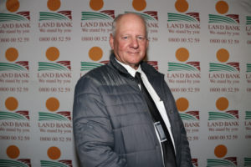](http://samic.co.za/steve-van-schoor/)<](http://samic.co.za/steve-van-schoor/)

Steve van Schoor

Cell: 082 900 3037  
Fax: 086 557 0746  
E-mail: [steve@samic.co.za](mailto:steve@samic.co.za)