

Abstracts: Submitted abstracts should not exceed 250 words. On the abstract please indicate if oral or poster is preferred. See example of abstract. Arial font size 11 and single line spacing. Abstracts will be published in the conference proceedings as received. Abstracts will only be published if authors register by 10 June 2016. Please send your abstracts in Word-format to the conference Secretariat at sasev@sasev.org

Kind regards,
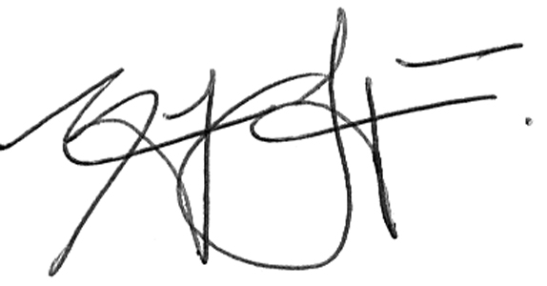
Chairperson: Conference Committee
-------------------------------------------------------------------------------------------------------------------------

EXAMPLE of Abstract

How has legislation changed over the last 40 years with regards to label requirements, preservatives and compulsory analyses

W. Jonker¹
¹Department of Agriculture, Forestry and Fisheries, Plant Quarantine Stations, Private Bag X5015, Stellenbosch, 7600, South Africa
Email: WendyJ@daff.gov.za

Legislation plays an important role in wine trade. It is crucial that South African legislation remains relevant and is frequently aligned with international requirements. Harmonization of labelling regulations, additives and analytical requirements with international norms and standards lay the foundation to ensure that the South African wine industry remains competitive and that government are able to provide the necessary assurances required by the consumer. The legislative environment for liquor products has changed tremendously over the last 40 years since the repeal of the Wine, Other Fermented Beverages and Spirits Act, 1957 and the Wine and Spirit Control Act, 1970. These acts became outdated over time and surplus control of wine was abolished by the Minister of Agriculture. The Liquor Products Act, Act 60 of 1989 replaced these acts and aimed to provide a legislative framework that is less rigid, quicker to amend and enable the South African wine industry to be competitive in an ever changing environment.

Oral presentation

