 |  |  | Application date:
 |  |  | (not to be filled in by the applicant)
TECHNICAL QUESTIONNAIRE
to be completed in connection with an application for plant breeders’ rights

1. Subject of the Technical Questionnaire
1.1 Botanical name | Triticum aestivum
1.2 Common Name | Wheat
2. Applicant
Name
Address
Telephone No.
Fax No.
E-mail address
Breeder (if different from applicant)
3. Proposed denomination and breeder’s reference
Proposed denomination
(if available)

Breeder’s reference
4. Information on the breeding scheme and propagation of the variety

4.1 Origin of variety

(i) imported from: ………………………………………. [ ]
OR
bred in South Africa [ ]

- Mutation- indicate parent varieties…………………………………… …
a) accidental [ ]
b) induced [ ]

iii) Inbreeding [ ]

v) Synthesis

vi) Discovered in nature or elsewhere ( indicate where and when )
…………………………………………………………………………….
…………………………………………………………………………….

vi) Other ( specify )
…………………………………………………………………………….
…………………………………………………………………………….

  - Method of propagating the variety
i) Crossing
a) single cross hybrid [ ]
b) three-way cross hybrid [ ]
c) double cross hybrid [ ]

ii) Open – pollinated [ ]

  - Other information

- Has this variety been sold or marketed in South Africa previously?

Yes [ ] No [ ]

If yes, indicate where and when…………………………………………………
……………………………………………………………………….

Characteristics of the variety to be indicated (the number in brackets refers to the corresponding characteristic in Test Guidelines; please mark the note which best corresponds

 | Characteristics | Example Varieties or Illustration | Note
5.1 | Seasonal type:
(33) | Winter |  | [ ]
 | Alternative |  | [ ]
 | Spring |  | [ ]
5.2 | Time of ear emergence: ( 1st spikelet visible on 50% of ears , quote mean
 | number of days after planting of variety as well as of 2 well-known
 | comparable S.A. varieties)
(5) | i) Candidate variety | ..……………………. | Days
 | ii) Comparable varieties | ..……………………. | Days
 |  | ..……………………. | Days
5.3 | Plant: length ( stem + ear + awns ), quote length of candidate variety as
 | well as 2 well-known comparable S.A. varieties.
 | i) Candidate variety | ..……………………. | cm.
 | ii) Comparable varieties | ..……………………. | cm.
 |  | ..……………………. | cm.
5.4 | Straw: pith in cross section ( halfway between base of ear and node below )
 | thin pith | 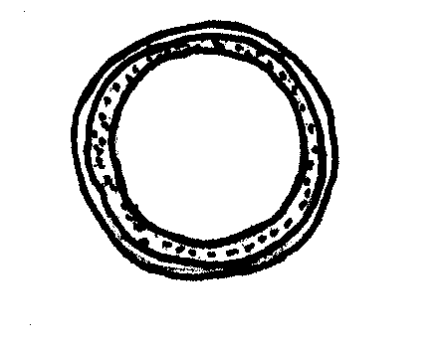 | 3[ ]
 | medium pith | 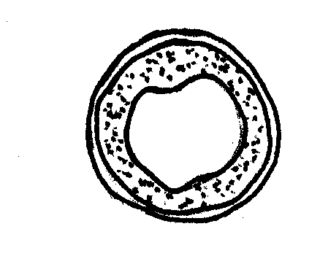 | 5[ ]
 | thick pith | 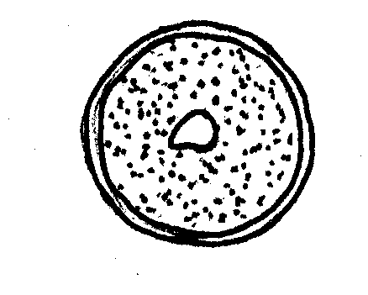 | 7[ ]
5.5 | Ear: colour ( at maturity )
 | White |  | 1[ ]
 | Coloured |  | 2[ ]
5.6 | Ear: shape
 | Tapering | 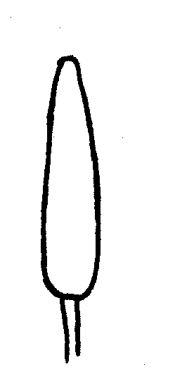 | 1[ ]
 | Parallel | 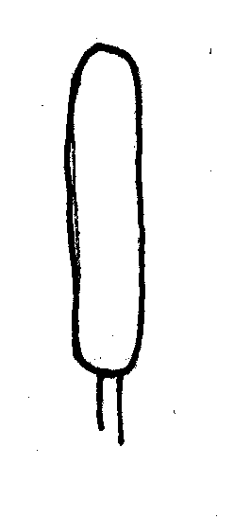 | 2[ ]
 | Fusiform | 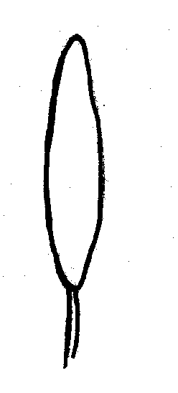 | 3[ ]
 | Clavate | 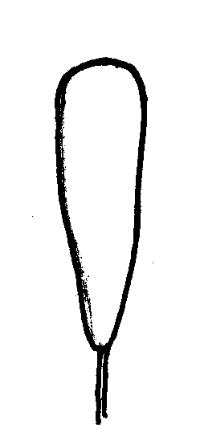 | 4[ ]
5.8 | Awns or scurs: presence
 | Both present | 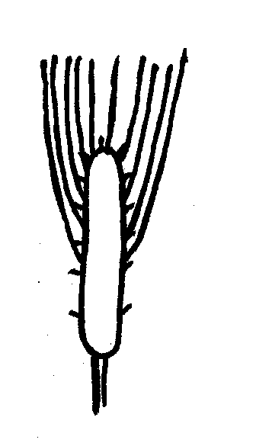 | 1[ ]
 | Scurs present | 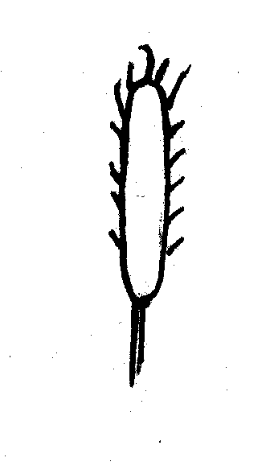 | 2[ ]
 | Awns present | 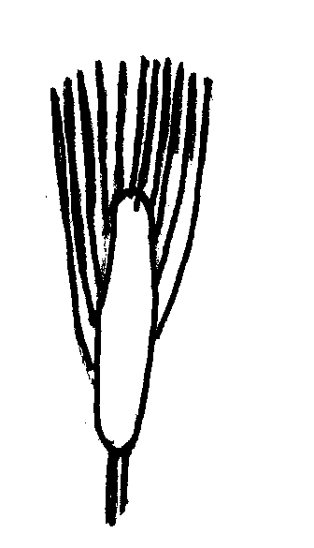 | 3[ ]
5.9 | Grain: shape
 | Rounded | 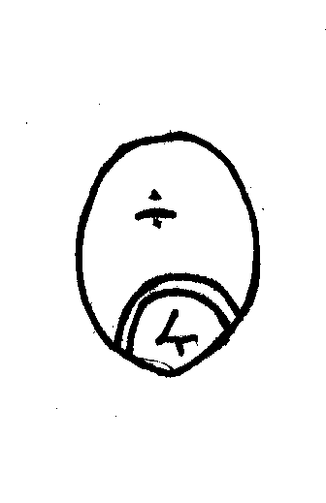 | 1[ ]
 | Ovoid | 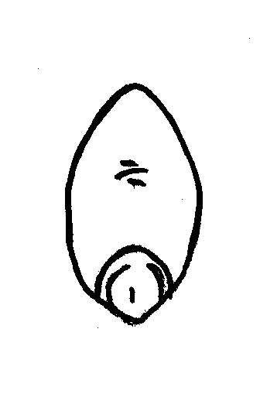 | 2[ ]
 | Elongated | 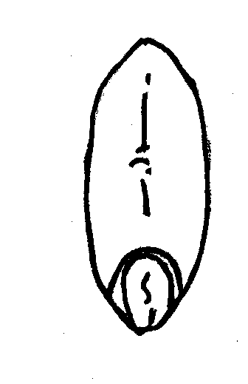 | 3[ ]
5.10 | Grain: colour
 | White |  | 1[ ]
 | Red |  | 2[ ]

6. Similar varieties and differences from these varieties (varieties known in South Africa)
Denomination(s) of variety(ies) similar to your candidate variety | Characteristic(s) in which your candidate variety differs from the similar variety(ies) | Describe the expression of the characteristic(s) for the similar variety(ies) | Describe the expression of the characteristic(s) for your candidate variety
Example | Flag leaf: glaucosity of sheath | absent | medium
Comments:

#7. Additional information which may help in the examination of the variety

7.1 In addition to the information provided in sections 5 and 6, are there any additional characteristics which may help to distinguish the variety?

Yes [ ] No [ ]

(If yes, please provide details)

7.2 Are there any special conditions for growing the variety or conducting the examination?

Yes [ ] No [ ]

(If yes, please provide details)

7.3 Other information

    - Main use

- Seed [ ]
- Bread [ ]

7.3.2 Cultivation type

- Irrigation [ ]
- dryland [ ]

8. Authorization for release

(a) Does the variety require prior authorization for release under legislation concerning the protection of the environment, human and animal health?

Yes [ ] No [ ]

(b) Has such authorization been obtained?

Yes [ ] No [ ]

If the answer to (b) is yes, please attach a copy of the authorization.

9. Information on plant material to be examined or submitted for examination.

9.1 The expression of a characteristic or several characteristics of a variety may be affected by factors, such as pests and disease, chemical treatment (e.g. growth retardants or pesticides), effects of tissue culture, different rootstocks, scions taken from different growth phases of a tree, etc.

9.2 The plant material should not have undergone any treatment which would affect the expression of the characteristics of the variety, unless the competent authorities allow or request such treatment. If the plant material has undergone such treatment, full details of the treatment must be given. In this respect, please indicate below, to the best of your knowledge, if the plant material to be examined has been subjected to:

(a) Microorganisms (e.g. virus, bacteria, phytoplasma) Yes [ ] No [ ]

(b) Chemical treatment (e.g. growth retardant, pesticide) Yes [ ] No [ ]

(c) Tissue culture Yes [ ] No [ ]

(d) Other factors Yes [ ] No [ ]

Please provide details of where you have indicated “yes”.

……………………………………………………………

10. I hereby declare that, to the best of my knowledge, the information provided in this form is correct:

Applicant’s name

Signature Date

# Authorities may allow certain of this information to be provided in a confidential section of the Technical Questionnaire.

