TECHNICAL QUESTIONNAIRE |  |  | Reference Number:
 |  |  | Application date:
 |  |  | (not to be filled in by the applicant)
TECHNICAL QUESTIONNAIRE
to be completed in connection with an application for plant breeders’ rights

1. Subject of the Technical Questionnaire
1.1 Botanical name | Prunus domestica L.
1.2 Common Name | EUROPEAN PLUM (fruit varieties only)
2. Applicant
Name
Address
Telephone No.
Fax No.
E-mail address
Breeder (if different from applicant)
3. Proposed denomination and breeder’s reference
Proposed denomination
(if available)

Breeder’s reference
4. Information on the breeding scheme and propagation of the variety

4.1 Origin of variety

(a) imported from: ………………………………………. [ ]
OR
(b) bred in South Africa [ ]

4.2 Breeding scheme (optional)

4.3 Method of propagating the variety (optional)

4.4 Other information

(a) Has this variety been sold or marketed in South Africa previously?

Yes [ ] No [ ]

If yes, indicate where and when

………………………………………………………………….

5. Characteristics of the variety to be indicated (the number in brackets refers to the corresponding characteristic in Test Guidelines; please mark the note which best corresponds).

 | Characteristics |  |  | Example Varieties |  | Note
5.1  (43) | Fruit: size  very small  small  medium  large  very large |  |  |  |  | 1[ ]  3[ ]  5[ ]  7[ ]  9[ ]
5.2  (44) | Fruit: shape in lateral view  elliptic 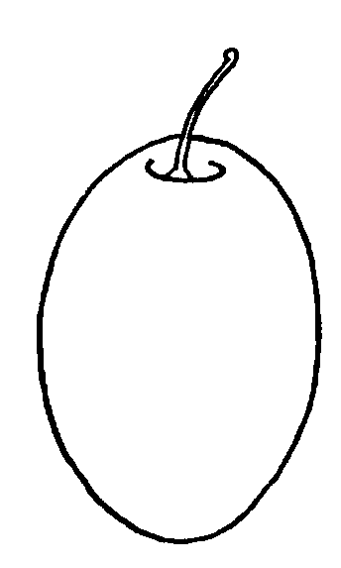  circular 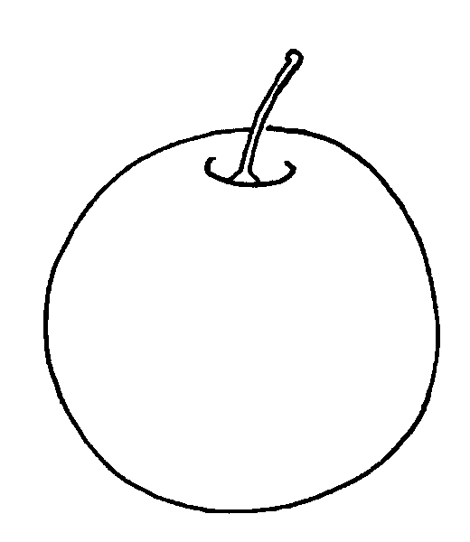  ovate 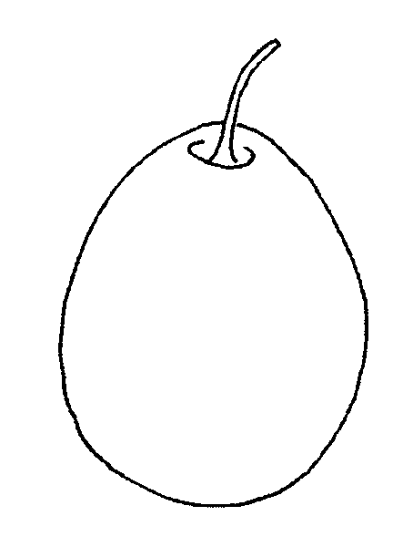  obovate 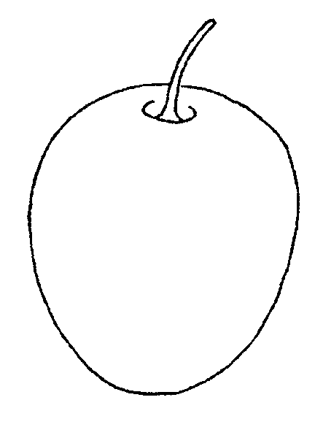  transverse elliptic 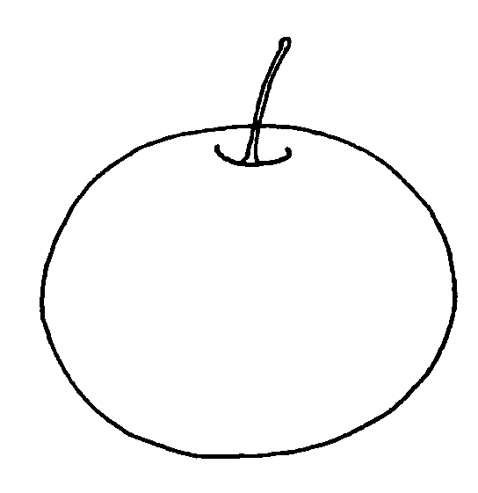 |  |  |  |  | 1[ ]  2[ ]  3[ ]  4[ ]  5[ ]
5.3  (50) | Fruit: ground color of skin (after removing bloom)  whitish  green  yellowish  yellow  orange yellow  red  light violet  dark violet  violet blue  dark blue |  |  |  |  | 1[ ]  2[ ]  3[ ]  4[ ]  5[ ]  6[ ]  7[ ]  8[ ]  9[ ]  10[ ]
5.4  (51) | Fruit: color of flesh  whitish  green  yellowish green  yellow  orange  red |  |  |  |  | 1[ ]  2[ ]  3[ ]  4[ ]  5[ ]  6[ ]
5.5  (54) | Fruit: degree of adherence of stone to flesh  non-adherent  semi-adherent  adherent |  |  |  |  | 1[ ]  2[ ]  3[ ]
5.6  (62) | Time of beginning of flowering  very early  early  medium  late  very late |  |  |  |  | 1[ ]  3[ ]  5[ ]  7[ ]  9[ ]
5.7  (63) | Time of maturity for consumption  very early  early  medium  late  very late |  |  |  |  | 1[ ]  3[ ]  5[ ]  7[ ]  9[ ]
6. Similar varieties and differences from these varieties

Please use the following table and box for comments to provide information on how your candidate variety differs from the variety (or varieties) which, to the best of your knowledge, is (or are) most similar. This information may help the examination authority to conduct its examination of distinctness in a more efficient way.

Denomination(s) of variety(ies) similar to your candidate variety |  | Characteristic(s) in which your candidate variety differs from the similar variety(ies) | Describe the expression of the characteristic(s) for the similar variety(ies) |  | Describe the expression of the characteristic(s) for your candidate variety
Comments:

7. Additional information which may help in the examination of the variety

7.1 In addition to the information provided in sections 5 and 6, are there any additional characteristics which may help to distinguish the variety?

Yes [ ] No [ ]

(If yes, please provide details)

7.2 Are there any special conditions for growing the variety or conducting the examination?

Yes [ ] No [ ]

(If yes, please provide details)

7.3 Other information

A representative color photograph of the variety should accompany the Technical Questionnaire.

8. Authorization for release

(a) Does the variety require prior authorization for release under legislation concerning the protection of the environment, human and animal health?

Yes [ ] No [ ]

(b) Has such authorization been obtained?

Yes [ ] No [ ]

If the answer to (b) is yes, please attach a copy of the authorization.

9. Information on plant material to be examined or submitted for examination.

9.1 The expression of a characteristic or several characteristics of a variety may be affected by factors, such as pests and disease, chemical treatment (e.g. growth retardants or pesticides), effects of tissue culture, different rootstocks, scions taken from different growth phases of a tree, etc.

9.2 The plant material should not have undergone any treatment which would affect the expression of the characteristics of the variety, unless the competent authorities allow or request such treatment. If the plant material has undergone such treatment, full details of the treatment must be given. In this respect, please indicate below, to the best of your knowledge, if the plant material to be examined has been subjected to:

(a) Microorganisms (e.g. virus, bacteria, phytoplasma) Yes [ ] No [ ]

(b) Chemical treatment (e.g. growth retardant, pesticide) Yes [ ] No [ ]

(c) Tissue culture Yes [ ] No [ ]

(d) Other factors Yes [ ] No [ ]

Please provide details of where you have indicated “yes”.

……………………………………………………………

  - Has the plant material to be examined been tested for the presence of virus or other pathogens?

Yes [ ]
(please provide details of tests results)

No [ ]

10. I hereby declare that, to the best of my knowledge, the information provided in this form is correct:

Applicant’s name

Signature Date

