|  |  |
| --- | --- |
|  | **CROP ESTIMATES COMMITTEE** |

**DATE**: 27 August 2008

**TIME**: 10:00

**VENUE**: Board Room, 7th Floor, Sefala Building, 503 Belvedere Street, Arcadia, Pretoria.

**AGENDA**

**FINAL PRODUCTION ESTIMATE OF SUMMER CROPS (2007/08) AND REVISED AREA ESTIMATE AND FIRST PRODUCTION FORECAST OF WINTER CROPS (2008)**

1. OPENING AND WELCOME

2. ATTENDANCE

3. PERSONALIA

4. FINALISATION OF AGENDA

5. APPROVAL OF PREVIOUS MINUTES

5.1 Meeting held on 24 July 2008

6. MATTERS ARISING

6.1

6.2

7. ADDITIONAL ITEMS

7.1 Objective yield determination: 2008/09 production season WH Kilian

7.2

8. WEATHER CONDITIONS: INFORMATION SESSION

1. INPUTS FROM OTHER DATA SUPPLIERS

9.1 National Crop Statistics Consortium

10. WINTER CROPS (2008 SEASON)

10.1 Revised area estimate and first production forecast

11. SUMMER CROPS (2007/08 Season)

11.1 Final production estimate

12. NEXT MEETING – 23 September 2008

-------------000-------------

**MINUTES OF THE CROP ESTIMATES COMMITTEE MEETING HELD ON 24 July 2008 AT 10:00, BOARD ROOM, 7TH FLOOR, SEFALA BUILDING, ARCADIA, PRETORIA.**

**1.** **OPENING AND WELCOME**

The Chairperson, Mr R.D. Dredge, welcomed the attendees.

**2. ATTENDANCE**

**PRESENT:**

Mr R. Dredge Chief Director, Economic and Statistical Services, DoA

Mr B. Netshifhefhe Agricultural Statistics, DoA

MrsR. Beukes Agricultural Statistics, DoA

Ms M. Scheepers Agricultural Statistics, DoA

Ms O. Mathole Agricultural Statistics, DoA

Mrs W. Durand ARC-Grain Crops Institute

Mr T. Newby ARC-Institute for Soil, Climate and Water

Mr J. Malherbe ARC-Institute for Soil, Climate and Water (partial attendance)

Mr W. Kilian ARC-Small Grains Institute

Mrs L. Mellet NAMC

Mr H. Cerfonteyn PDA-Western Cape

Mr A. Fourie PDA-Free State

Dr T.T. Silwana PDA-Eastern Cape

Mr G. Müller PDA-KwaZulu-Natal

Mr J. Slabbert PDA-Limpopo

Mrs Z. Rakuambo PDA-Gauteng

Mrs E. Victor PDA-North West

**ABSENT WITH APOLOGY:**

Ms E. Matsei Director, Agricultural Statistics, DoA

Ms A. Swanepoel PDA-Northern Cape

Mr M.L. Scheltens PDA-Mpumalanga

1. **PERSONALIA**

The following members were congratulated on their birthdays during July:

Ellen Matsei, Rona Beukes, Lizette Mellet, Annette Swanepoel, Jaco Slabbert and Fanie Ferreira.

**4. APPROVAL OF PREVIOUS MINUTES**

The minutes of the meeting held on 26 June 2008, were accepted without any amendments.

**5. MATTERS ARISING**

5.1 Eastern Cape: PICES results reviewed

Ms Scheepers reported that the matter has not been resolved yet. It was suggested that the item be removed from the agenda until further notice.

**6. ADDITIONAL ITEMS**

6.1 Letter from Grain Silo Industry (GSI)

Mrs Beukes reported that a letter was received from GSI on the 17th June 2008 where they indicated that their Directors decided that the CEC has to collect the monthly estimates themselves as from July 2008. The letter from GSI is attached as Annexure A. During the collection of the information, some problems were experienced that need to be addressed in the coming months.

6.2 Correspondence from Maize Forum

Mrs Beukes reported that in attempt to arrange another meeting date between the CEC and the Maize Trust, the Maize Forum Steering Committee indicated that the issue would rather be taken up directly with the DG of the DoA.

**7. WEATHER CONDITIONS: INFORMATION SESSION**

Mr J. Malherbe of the ARC: ISCW presented an overview of the weather conditions.

**Total rainfall for July 2008 compared to the long term mean:**

|  |
| --- |
| Considering the rainfall map for the period 1 to 20 July 2008, the rainfall pattern was such that most of the interior areas received between 0 to 25% of their average rainfall for July, while most of the winter rainfall areas received above-normal (100 to 200% of the average) rainfall. Exceptions are isolated areas of the North West and Limpopo Provinces. The western parts of the Western Cape were characterised by flood occurrences during July, especially the Swartland areas, but with reference to the Rûens areas - limited rainfall was received. |

**Expected total rainfall forecast for the period August to October 2008:**

According to the Seasonal Consensus Probabilistic Forecast of expected rainfall, it was reported that the country is in a more neutral phase and although temperatures are rising, it won’t reach the El Niño threshold. It was reported that an incidence of a wetter winter season and an early start to the summer rainfall season could occur over the country.

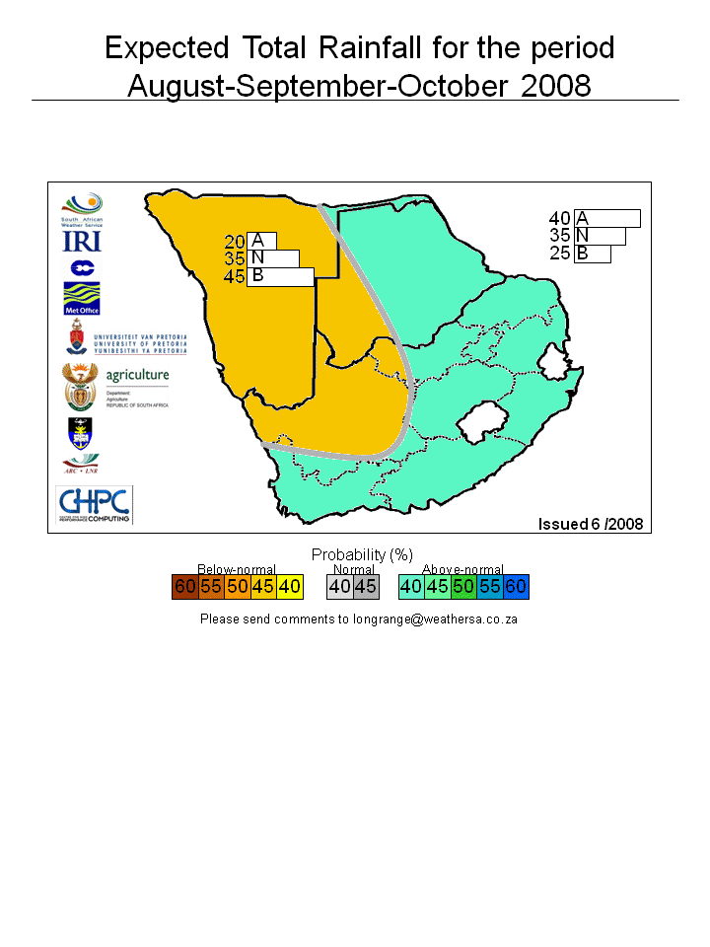

**8. INPUTS FROM OTHER DATA SUPPLIERS**

Inputs regarding projected crop sizes and yield potential were received from the PDAs, ARC:GCI, SACOTA and DPO.

**9. WINTER CROPS (2008 PRODUCTION SEASON)**

9.1 Preliminary area estimate

|  |  |  |  |  |
| --- | --- | --- | --- | --- |
| CROP | **AREA PLANTED**  **2008**  **HA** **A** | AREA PLANTED  2007  HA B | FINAL CROP  2007  TONS C | CHANGE  2008 vs 2007 % A/B |
| **Commercial:** | | | | |
| Wheat | **752 500** | 632 000 | 1 905 000 | +19,07 |
| Malting barley | **70 000** | 73 360 | 222 500 | -4,58 |
| Canola | **35 000** | 33 200 | 38 150 | +5,42 |
| TOTAL | **857 500** | 738 560 | 2 165 650 | +16,10 |

9.2 Discussion

|  |  |
| --- | --- |
| WHEAT: | The preliminary area estimate for wheat is 752  500 ha, which is 19,1% more than the 632  000 ha planted for the previous season. An estimated 350  000 ha or 47% are in the Western Cape, 290  000 ha or 39% in the Free State and 46  000 ha or 6% in the Northern Cape. |
| OTHER CROPS: | The preliminary area estimate for malting barley is 70  000 ha, which is 4,6% less than the 73  360 ha of last season. The area planted to canola is 35  000 ha, or 5,4% more than the 33 200 ha planted for the previous season. |

**10. SUMMER CROPS (2007/08 PRODUCTION SEASON)**

10.1 Sixth production forecast

|  |  |  |  |  |  |  |
| --- | --- | --- | --- | --- | --- | --- |
| Crop | **Area Planted**  **2007/08**  **Ha** | **6th Forecast**  **2007/08**  **Tons** | 5th Forecast  2007/08  Tons | Area Planted  2006/07  Ha | Final Crop  2006/07  Tons | Change  2007/08 vs 2006/07  % |
|  | **(A)** | **(B)** | (C) | (D) | (E) | (B) ÷ (C) |
| **Commercial:** | | | | | | |
| White Maize | **1  737  000** | **6 861 400** | 6 861 400 | 1 624 800 | 4 315 000 | +2,60 |
| Yellow Maize | **1  062  000** | **4 736 200** | 4 736 200 | 927 000 | 2 810 000 | +3,59 |
| Total maize | **2  799  000** | **11 597 600** | 11 597 600 | 2 551 800 | 7 125 000 | +3,00 |
| Sunflower seed | **564  300** | **885 560** | 872 060 | 316 350 | 300 000 | +6,60 |
| Soya-beans | **174  400** | **322 995** | 328 195 | 183 000 | 205 000 | +5,71 |
| Groundnuts | **54  200** | **85 360** | 85 360 | 40 770 | 58 000 | +3,86 |
| Sorghum | **89  800** | **269 425** | 272 475 | 69 000 | 176 000 | +5,65 |
| Dry beans | **43  800** | **58 975** | 58 975 | 50 725 | 39 545 | - |
| TOTAL | **3 725 500** | **13 219 915** | 13 214 665 | 3 211 645 | 7 903 545 | +3,34 |

10.2 Discussion

|  |  |
| --- | --- |
| COMMERCIAL MAIZE: | The size of the expected commercial maize crop remained unchanged at 11,598 mill. tons. The area planted also remained unchanged at 2,799 mill ha with an expected yield of 4,14 t/ha.  The area for white maize is 1,737 mill. ha, and for yellow maize it is 1,062 mill. ha. The ratio of white to yellow maize plantings is 62:38 as against the previous seasons’ 64:36.  The production forecast of white maize is 6,861 mill. tons with an expected yield of 3,95 t/ha. In the case of yellow maize the production forecast is 4,736 mill. tons with a yield of 4,46 t/ha. |
| SUNFLOWER SEED: | The production forecast for sunflower seed is 885  560 tons, which is 1,6% more than the 872  060 tons of the previous forecast. The estimated area planted to sunflower seed remained unchanged at 564  300 ha, while the expected yield is 1,57 t/ha. |
| OTHER CROPS: | The production forecast for **soya-beans** decreased by 1,6% to 322  995 tons. The area planted to soya-beans remained unchanged at 174  400 ha, while the expected yield is 1,85 t/ha.  The expected **groundnut** crop remained unchanged at 85  360 tons. The area estimate also remained unchanged at 54  200 ha, while the expected yield is 1,57 t/ha.  The production forecast for **sorghum** decreased by 1,1% to 269  425 tons. The area estimate for sorghum was left unchanged at 89  800 ha, while the expected yield is 3,0 t/ha.  In the case of **dry beans,** the production forecast as well as the area planted remained unchanged at 58  975 tons and 43  800 ha, respectively. The expected yield is 1,35 t/ha. |
| SUBSISTENCE AGRICULTURE: | The production forecast as well as the area planted to maize in the subsistence agricultural sector was left unchanged at 497  980 ha and 464  069 tons, respectively. |

**11. PRESENTATION - “Phenological stages of the maize plant”**

The official meeting proceedings ended at 11:30. As no member is allowed to leave the meeting venue before 12:00, Mrs Durand willingly made a presentation on the “Phenological stages of the maize plant” to make up time until 12:00.

**12.** The meeting adjourned at 12:00.

**13. NEXT MEETING**

The next meeting of the Crop Estimates Committee will be held DV on **Wednesday, 27 August  2008 at *10:00***. The meeting will be held in the **Board Room**, 7th Floor, Sefala Building, 503 Belvedere Street, Arcadia, Pretoria.