Directorate: Agricultural Statistics, Private Bag X246, Pretoria, 0001

From: Marda Scheepers
Tel: 012 319 8033 Fax: 012 319 8031/5 E-mail: MardaS@nda.agric.za

Ref: 26.4.5

13 October 2008

To all the members of the Crop Estimates Committee

MEETING: THIRD PRODUCTION FORECAST OF WINTER CEREAL CROPS (2008) AND INTENTIONS TO PLANT SUMMER GRAIN CROPS (2008/09 PRODUCTION SEASON)

Attached please find the Agenda and Minutes for the Crop Estimates Committee (CEC) meeting to be held on Thursday, 23 October 2008 at 10:00 in the Board Room, 7th Floor, Sefala Building, 503 Belvedere Street, Arcadia, Pretoria.

Please remember to submit your inputs before 12:00 on Wednesday, 22 October 2008.

Kind regards,

Marda Scheepers
STATISTICIAN

CROP ESTIMATES COMMITTEE

DATE: 23 October 2008
TIME: 10:00
VENUE: Board Room, 7th Floor, Sefala Building, 503 Belvedere Street, Arcadia, Pretoria.

AGENDA

THIRD PRODUCTION FORECAST OF WINTER CROPS (2008) AND
INTENTIONS TO PLANT SUMMER CROPS (2008/09 PRODUCTION SEASON)

1. OPENING AND WELCOME
2. ATTENDANCE
3. PERSONALIA
4. FINALISATION OF AGENDA
5. APPROVAL OF PREVIOUS MINUTES
5.1 Meeting held on 23 September 2008
6. MATTERS ARISING
6.1
6.2
7. ADDITIONAL ITEMS
7.1
7.2
8. WEATHER CONDITIONS: INFORMATION SESSION
- INPUTS FROM OTHER DATA SUPPLIERS
9.1
10. WINTER CROPS (2008 SEASON)
10.1 Third production forecast
11. SUMMER CROPS (2008/09 PRODUCTION SEASON)
11.1 Intentions to plant summer crops
12. NEXT MEETING – 25 November 2008

-------------000-------------

MINUTES OF THE CROP ESTIMATES COMMITTEE MEETING HELD ON 23 SEPTEMBER 2008 AT 11:00, BOARD ROOM, 7TH FLOOR, SEFALA BUILDING, ARCADIA, PRETORIA.
1. OPENING AND WELCOME
The Chairperson, Mr R.D. Dredge, welcomed the attendees.
2. ATTENDANCE
PRESENT:
Mr R. Dredge Chief Director, Economic and Statistical Services, DoA
Ms E. Matsei Director, Agricultural Statistics, DoA
Mr B. Netshifhefhe Agricultural Statistics, DoA
Mrs R. Beukes Agricultural Statistics, DoA
Ms M. Scheepers Agricultural Statistics, DoA
Mr T. Newby ARC-Institute for Soil, Climate and Water
Mr J. Malherbe ARC-Institute for Soil, Climate and Water (partial attendance)
Mrs W. Durand ARC-Grain Crops Institute
Mr W. Kilian ARC-Small Grains Institute
Mr H. Cerfonteyn PDA-Western Cape
Mr A. Fourie PDA-Free State
Mr G. Müller PDA-KwaZulu-Natal
Mrs E. Victor PDA-North West
Mr F. Aucamp PDA-North West
Mr M.L. Scheltens PDA-Mpumalanga
Ms Z. Mkula PDA-Eastern Cape
Mrs L. Mellet NAMC
Mr F. Ferreira NCSC (partial attendance)

ABSENT WITH APOLOGY:
Ms A. Swanepoel PDA-Northern Cape
Dr. T Silwana PDA-Eastern Cape
Mr J. Slabbert PDA-Limpopo
Mrs Z. Rakuambo PDA-Gauteng
Mr E. du Preez NCSC
Ms O. Mathole Agricultural Statistics, DoA
3. PERSONALIA
The following members were congratulated on their birthdays during September:
Elna Victor (7th),
Deon du Toit (9th),
Marco Scheltens (17th), and
Zanele Mkula (21st).
Mr F. Ferreira and his company GeoterraImage was congratulated in coming third in the small business division of the AHI Entrepreneur of the Year awards.
4. APPROVAL OF PREVIOUS MINUTES
The minutes of the meeting held on 27 August 2008, were accepted without any amendments.
5. MATTERS ARISING
None.

6. ADDITIONAL ITEMS
6.1 Analysis of the summer crops for the 2007/08 production season
At the previous meeting it was requested that an analysis be carried out to identify the points of concern in the setting of the estimates.
Mrs R. Beukes carried out the analysis on the area planted to summer crops in the Free State, Mpumalanga, Gauteng and North West Provinces. She presented graphs of all the input providers of each crop in the mentioned Provinces. She mentioned that it is very important to note that at the Crop Estimates Liaison Committee (CELC) meeting held on 29 November 2008, it was agreed that the Producer Independent Crop Estimates System (PICES) should be used in future as the benchmark of the area planted figures. Considering white maize, Mrs Beukes mentioned that in 75% of the cases the inputs of the PDAs were the closest to the area planted figure of the Crop Estimates Committee (CEC). For yellow maize the inputs of the National Crop Statistics Consortium (NCSC) were in 50% of the cases the closest to the area planted figure of the CEC. Mrs W. Durand stated that the inputs of the PDAs are biased as it is based on ‘gut feel’ and the figures of the other input providers. Mrs Beukes responded by stating that considering the graphs it is a fact that the PDAs play an important role in the setting of the area estimates. She further elaborated and said that the CEC is not consistent in setting the area estimate for every province (presentation attached as Annexure A).
FOLLOW-UP ACTION:
- Mrs Durand proposed that a workshop be held to discuss the different means by which every input provider can present their estimates to make it more understandable for all the CEC members.
- Mrs Beukes also suggested that a meeting be scheduled with Mrs Durand to improve the CEC meeting document.
- It was suggested that this analysis be redone for the area, yield and production after the finalisation of the summer crops during the November 2008 CELC Meeting. The analysis should include the last two seasons’ data and the NCSC will assist the secretariat with this exercise.
6.2 An additional summer crop estimate in September 2008
The chairperson informed the meeting that CELC, through the South African Cereal and Oilseeds Trade Association (SACOTA), requested that an additional summer crop estimate be released in September 2008. As no new information was available to revise the previous estimate, the CEC chairperson had decided against another estimate.
7. WEATHER CONDITIONS: INFORMATION SESSION
Mr J. Malherbe of the ARC: ISCW presented an overview of the weather conditions.
Total rainfall for September 2008 compared to the long-term mean:

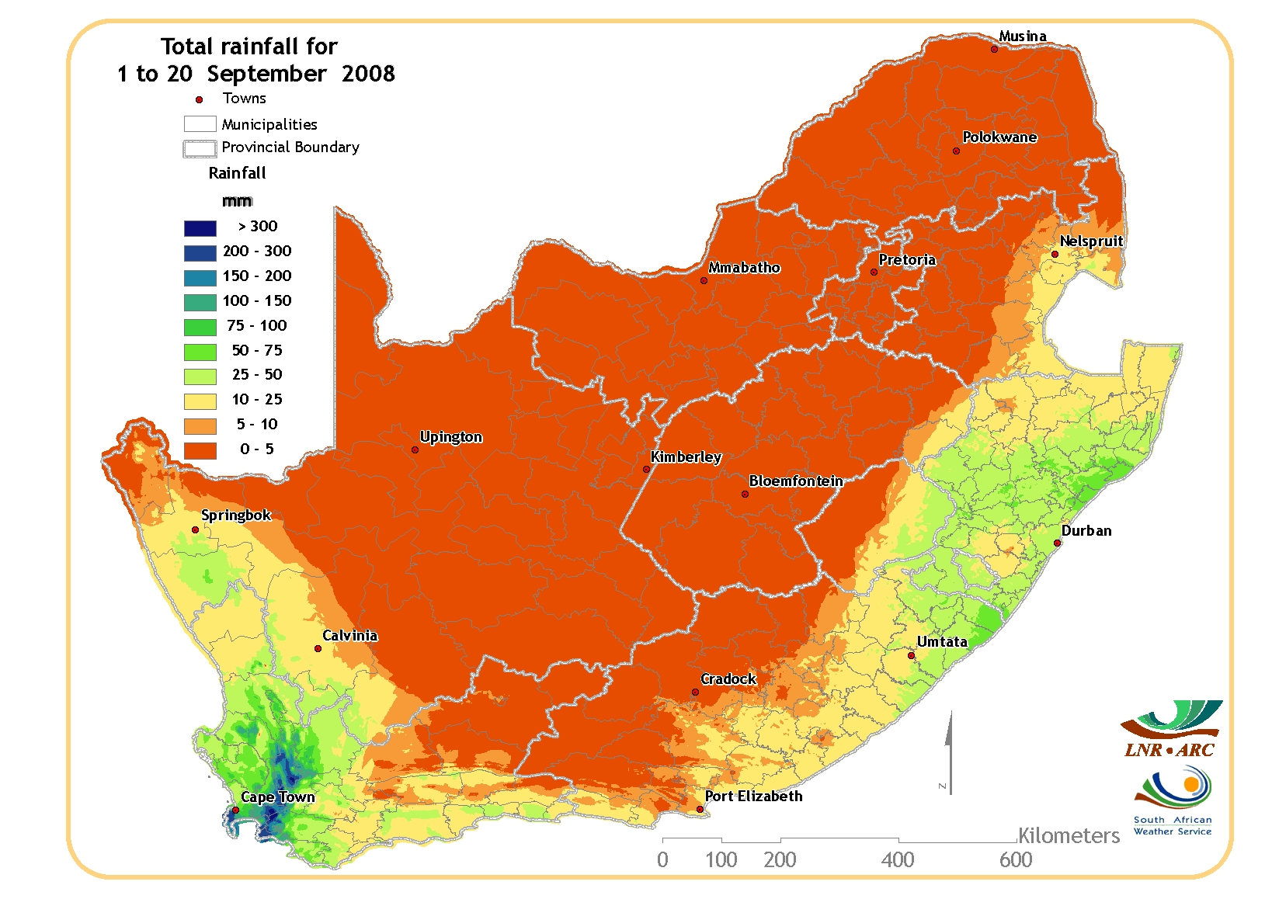 | 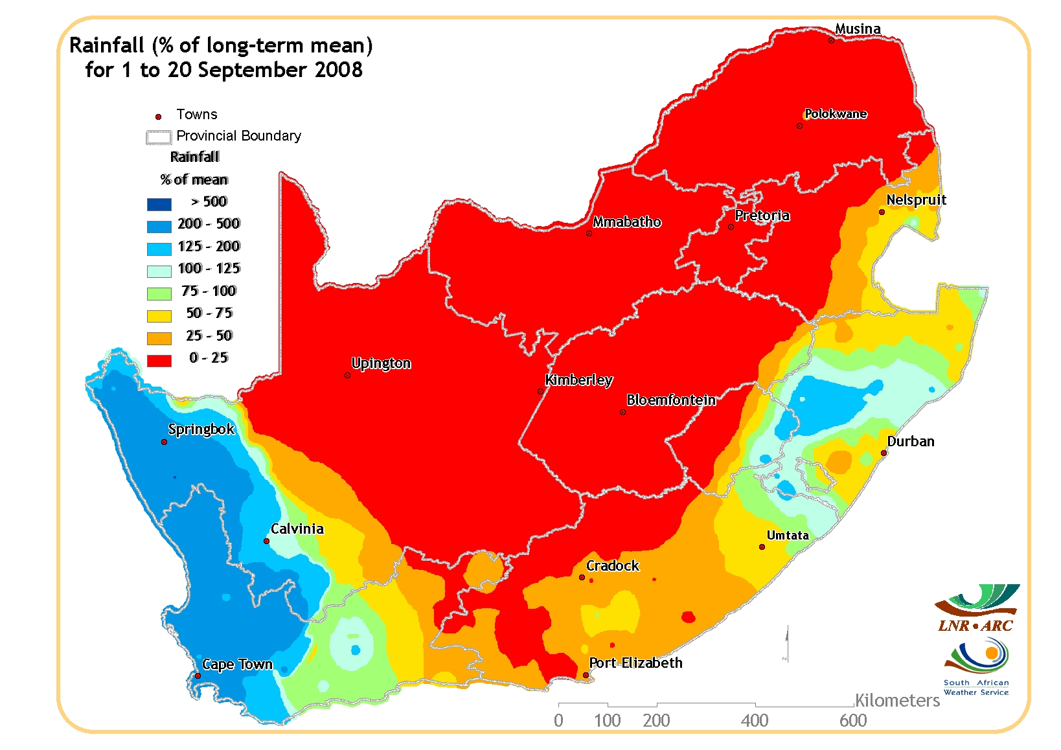
According to the South African Weather Service for the period 1 to 20 September 2008, rainfall occurrences were again restricted to the coastal areas, especially in the Western Cape. The central and eastern parts of the country remained dry for the mentioned period, but some good rainfall amounts are needed to boost the soil moisture levels as the planting season approaches. September usually signals the start of the summer rainfall season.
Comparing the rainfall of September with the long-term mean, it is evident that it was below average for the eastern parts of the country, but above average in the western parts especially the winter rainfall areas of the Swartland.

NDVI difference map for September compared to the long-term mean:

Vegetation conditions for September compared to the long-term mean were normal to below-normal throughout the country. Lower vegetation activity than the long-term mean, is evident in the southern parts of the Western and Eastern Cape as well as the northern parts of KwaZulu-Natal.

8. INPUTS FROM OTHER DATA SUPPLIERS
8.1 National Crop Statistics Consortium
Mr Fanie Ferreira reported on the results obtained from the PICES survey of the winter crops for the Free State Province. He mentioned that the coefficient of variance (cv) of PICES for wheat has improved by 1% from the previous season. The improvement can be attributed to the creation of an extra stratum called a “very high winter stratum” by using the February and March 2007 Landsat satellite imagery. He also mentioned that it is important to note that there has been a shift in the wheat plantings of the Free State from the western to the eastern areas. The reason for this can be debated, but the price of wheat could definitely be a contributing factor (presentation attached as Annexure B).
9. WINTER CROPS (2008 PRODUCTION SEASON)
9.1 Revised area estimate and second production forecast

CROP | AREA PLANTED  2008  HA  A | 2nd Forecast  2008  TONS  B | 1st Forecast  2008  TONS  C | AREA PLANTED  2007  HA  D | FINAL CROP  2007  TONS  E | CHANGE  2008 vs 2007  %  B/C
Commercial:
Wheat | 748 000 | 2 186 500 | 2 185 350 | 632 000 | 1 905 000 | +0,05
Malting barley | 65 045 | 170 924 | 170 924 | 73 360 | 222 500 | -
Canola | 34 000 | 34 000 | 35 000 | 33 200 | 38 150 | -2,86
TOTAL | 847 045 | 2 391 474 | 2 391 274 | 738 560 | 2 165 650 | +0,01

9.2 Discussion

WHEAT: | The production forecast for wheat is 2,187 million tons, which is 0,05% or 1 150 tons higher than the previous forecast of 2,185 million tons. The yield is 2,92 t/ha. The expected production remained unchanged at 805 000 tons in the Western Cape, 714 000 tons in the Free State and 315 000 tons in the Northern Cape.  The area planted to wheat remained unchanged at 748 000 ha. An estimated 350 000 ha or 47% is planted in the Western Cape, 280 000 ha or 37% in the Free State and 50 000 ha or 7% in the Northern Cape.  It can be pointed out that following above-normal rainfall, the production conditions in the major wheat producing areas of the Western Cape remain favourable. However, the difficult production conditions in the southern Cape and the lack of rainfall for the inland wheat producing areas have limited the increase in the potential wheat crop for this season.
OTHER CROPS: | The production forecast for malting barley remained unchanged at 170 924 ton. The area planted also remained unchanged at 65 045 ha, while the expected yield is 2,63 t/ha.  The expected canola crop is 34 000 tons, which is 2,86% less than the 35 000 tons of the previous forecast. The area estimate for canola was adjusted downward to 34 000 ha. The expected yield is 1,0 t/ha.

10. The meeting adjourned at 12:40.
11. NEXT MEETING
The next meeting of the Crop Estimates Committee will be held DV on Thursday, 23 October 2008 at 10:00. The meeting will be held in the Board Room, 7th Floor, Sefala Building, 503 Belvedere Street, Arcadia, Pretoria.

