|  |  |  |  |
| --- | --- | --- | --- |
|  | crop estimates committee |  | |
|  | oesskattingskomitee |  | |
| **From/Van:** Mr Baldwin Netshifhefhe  **Tel:** 012  319 8043  **Fax/Faks:** 012  319 8031  **E-mail/E-pos:** BaldwinN@dalrrd.gov.za  Web page/Webblad: [www.dalrrd.gov.za/statistics](http://www.dalrrd.gov.za/statistics) and economic reports or  [www.sagis.org.za/CEC](http://www.sagis.org.za/CEC): Crop Estimates EMBARGO: 14:30 | | |  |

**The area planted estimate and sixth production forecast for summer crops for 2021 is hereby released.**

**Hiermee word die oppervlakte- en sesde produksieskatting vir somergewasse vir 2021 vrygestel.**

**SUMMER CROPS** – AREA PLANTED AND SIXTH PRODUCTION FORECAST: 2021

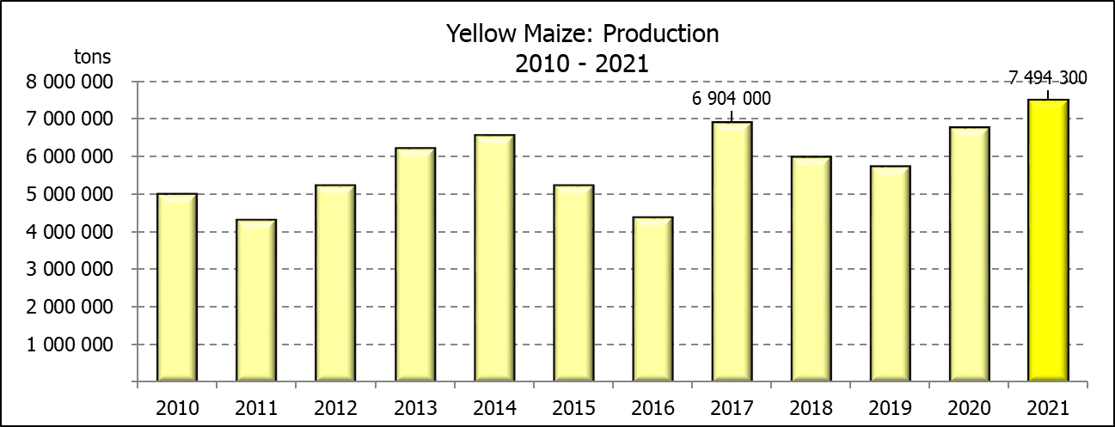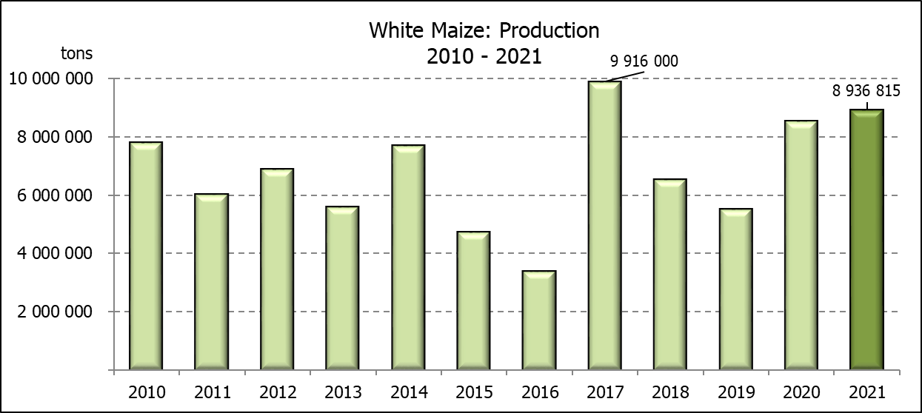**SOMERGEWASSE** – OPPERVLAKTE- EN SESDE PRODUKSIESKATTING: 2021

|  |  |  |  |  |  |  |  |  |  |
| --- | --- | --- | --- | --- | --- | --- | --- | --- | --- |
| CROP/GEWAS | **Area planted/**  **Opp beplant**  **2021** | | **6th forecast/**  **6de skatting**  **2021** | 5th forecast/  5de skatting  2021 | Area planted/  Opp beplant  2020 | | Final crop/  Finale oes  2020 | Change/  Verandering/ | |
|  | **Ha** | | **Tons** | Tons | Ha | | Tons | % | |
|  | **(A)** | | **(B)** | (C) | (D) | | (E) | (B) ÷ (C) | |
| **Commercial/Kommersieël:** | | | | | | | | | |
| White maize/Witmielies | **1  691  900** | | **8 936 815** | 8 936 815 | 1  616  300 | | 8  547 500 | - | |
| Yellow maize/Geelmielies | **1 063  500** | | **7 494 300** | 7 295 800 | 994  500 | | 6 752 500 | +2,72 | |
| Total Maize/Totale Mielies | **2  755  400** | | **16  431 115** | 16  232 615 | 2  610  800 | | 15  300 000 | +1,22 | |
| Sunflower seed/Sonneblomsaad | **477  800** | | **677 240** | 677 240 | 500  300 | | 788 500 | - | |
| Soybeans/Sojabone | **827  100** | | **1  918  150** | 1  918  150 | 705  000 | | 1  245  500 | - | |
| Groundnuts/Grondbone | **38  550** | | **58  900** | 58 900 | 37  500 | | 50  080 | - | |
| Sorghum | **49  200** | | **203  980** | 195 035 | 42  500 | | 158 000 | +4,59 | |
| Dry beans/Droëbone | **47 390** | | **56  577** | 56 577 | 50 150 | | 64 800 | - | |
| **Non-Commercial Maize/Nie-Kommersiële Mielies** | | | | | | | | | |
| Total Maize/Totaal Mielies | **362 900** | **636 440** | | 586 650 | 297 460 | 543 545 | | | +8,49 |
| **Maize/Mielies: Commercial/Kommersieël + Non-Commercial/Nie-Kommersieël** | | | | | | | | | |
| Total Maize RSA/Totaal Mielies RSA | **3  118  300** | **17  067  555** | | 16  819  265 | 2  908  260 | 15  843 545 | | | +1,48 |

Note: Estimate is for calendar year, e.g. production season 2020/21 = 2021

Nota: Skatting is vir kalenderjaar, bv. produksie-seisoen 2020/21 = 2021

**28 July / Julie 2021**

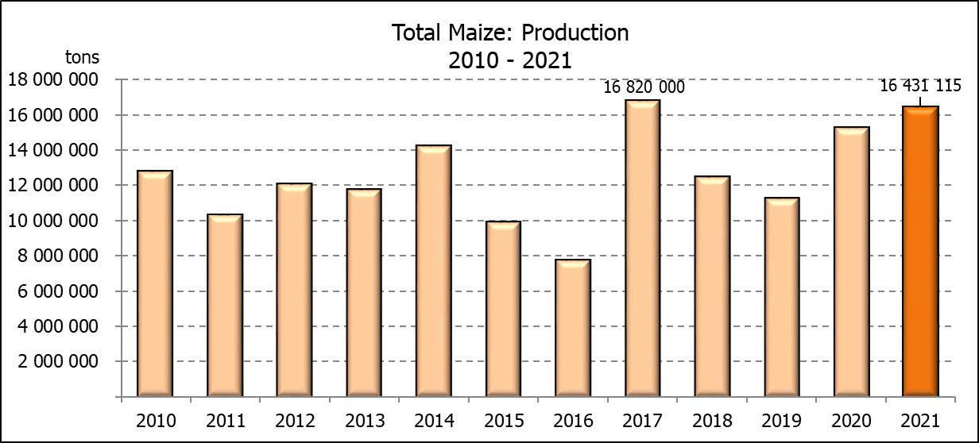

**WHITE AND YELLOW MAIZE** – AREA PLANTED AND SIXTH PRODUCTION FORECAST: 2021

**WIT- EN GEELMIELIES** – OPPERVLAKTE EN SESDE PRODUKSIESKATTING: 2021

|  |  |  |  |  |  |  |  |  |  |  |  |  |
| --- | --- | --- | --- | --- | --- | --- | --- | --- | --- | --- | --- | --- |
| Provinsie/  Province | **Area planted/**  **Oppervlakte beplant**  **2021** | | | **6th forecast/**  **6de skatting**  **2021** | | | Area planted/  Oppervlakte beplant  2020 | | | Final crop/  Finale oes  2020 | | |
|  | **White/**  **Wit**  **Ha** | **Yellow/**  **Geel**  **Ha** | **Total/**  **Totaal**  **Ha** | **White/**  **Wit**  **Tons** | **Yellow/**  **Geel**  **Tons** | **Total/**  **Totaal**  **Tons** | White/  Wit  Ha | Yellow/  Geel  Ha | Total/  Totaal  Ha | White/  Wit  Tons | Yellow/  Geel  Tons | Total/  Totaal  Tons |
| Western Cape/Wes-Kaap | **500** | **3 500** | **4 000** | **4 500** | **31 500** | **36 000** | 400 | 3 400 | 3 800 | 3 600 | 30 600 | 34 200 |
| Northern Cape/Noord-Kaap | **3 400** | **41 000** | **44 400** | **40 290** | **623 200** | **663 490** | 3 400 | 43 100 | 46 500 | 40 300 | 633 900 | 674 200 |
| Free State/Vrystaat | **907 500** | **420 000** | **1 327 500** | **4 673 625** | **2 478 000** | **7 151 625** | 855 000 | 365 000 | 1  220 000 | 4 700 000 | 2 209 000 | 6  909 000 |
| Eastern Cape/Oos-Kaap | **6 000** | **18 000** | **24 000** | **39 000** | **131 400** | **170 400** | 5 500 | 17 000 | 22 500 | 35 200 | 119 000 | 154 200 |
| KwaZulu-Natal | **50 000** | **55 000** | **105 000** | **310 000** | **440 000** | **750 000** | 47 000 | 55 000 | 102 000 | 298 400 | 434 500 | 732 900 |
| Mpumalanga | **165 000** | **360 000** | **525 000** | **1 155 000** | **2  736 000** | **3 891 000** | 160 000 | 353 000 | 513 000 | 872 000 | 2 347 500 | 3 219 500 |
| Limpopo | **16 500** | **21 000** | **37 500** | **112 200** | **172 200** | **284 400** | 15 000 | 18 000 | 33 000 | 105 000 | 126 000 | 231 000 |
| Gauteng | **58 000** | **50 000** | **108 000** | **371 200** | **350 000** | **721 200** | 55 000 | 50 000 | 105 000 | 297 000 | 330 000 | 627 000 |
| North West/Noordwes | **485 000** | **95 000** | **580 000** | **2  231 000** | **532 000** | **2 763 000** | 475 000 | 90 000 | 565 000 | 2  196 000 | 522 000 | 2  718 000 |
| Total/Totaal | **1 691 900** | **1 063  500** | **2  755  400** | **8 936 815** | **7 494 300** | **16 431 115** | 1 616 300 | 994  500 | 2  610  800 | 8  547 500 | 6  752 500 | 15 300 000 |

**SUNFLOWER SEED** – AREA PLANTED AND SIXTH PRODUCTION FORECAST: 2021

**SONNEBLOMSAAD** – OPPERVLAKTE EN SESDE PRODUKSIESKATTING: 2021

|  |  |  |  |  |
| --- | --- | --- | --- | --- |
| Province/  Provinsie | **Area planted/**  **Opp beplant**  **Ha** | **6th forecast/**  **6de skatting**  **Tons** | Area planted/  Opp beplant  Ha | Final crop/  Finale oes  Tons |
|  | **2021** | **2021** | 2020 | 2020 |
| Western Cape/Wes-Kaap | **-** | **-** | - | - |
| Northern Cape/Noord-Kaap | **1 100** | **1 320** | 1 200 | 1 430 |
| Free State/Vrystaat | **235 000** | **352 500** | 260 000 | 444 600 |
| Eastern Cape/Oos-Kaap | **300** | **450** | 300 | 750 |
| KwaZulu-Natal | **-** | **-** | - | - |
| Mpumalanga | **3 500** | **5 250** | 2 800 | 3 920 |
| Limpopo | **76 500** | **76 500** | 65 000 | 65 000 |
| Gauteng | **4 400** | **5 720** | 4 000 | 5 600 |
| North West/Noordwes | **157 000** | **235 500** | 167 000 | 267 200 |
| Total/Totaal | **477 800** | **677 240** | 500 300 | 788 500 |

**SOYBEANS** – AREA PLANTED AND SIXTH PRODUCTION FORECAST: 2021

**SOJABONE** – OPPERVLAKTE EN SESDE PRODUKSIESKATTING: 2021

|  |  |  |  |  |
| --- | --- | --- | --- | --- |
| Province/  Provinsie | **Area planted/**  **Opp beplant**  **Ha** | **6th forecast/**  **6de skatting**  **Tons** | Area planted/  Opp beplant  Ha | Final crop/  Finale oes  Tons |
|  | **2021** | **2021** | 2020 | 2020 |
| Western Cape/Wes-Kaap | - | **-** | - | - |
| Northern Cape/Noord-Kaap | **1 000** | **3 500** | 2 000 | 7 000 |
| Free State/Vrystaat | **365 000** | **766 500** | 315 000 | 519 750 |
| Eastern Cape/Oos-Kaap | **3 100** | **9 300** | 1 500 | 3 000 |
| KwaZulu-Natal | **36 000** | **129 600** | 35 000 | 101 500 |
| Mpumalanga | **290 000** | **652 500** | 260 000 | 416 000 |
| Limpopo | **20 500** | **73 800** | 15 500 | 48 050 |
| Gauteng | **42 000** | **109 200** | 36 000 | 70 200 |
| North West/Noordwes | **69 500** | **173 750** | 40 000 | 80 000 |
| Total/Totaal | **827 100** | **1 918 150** | 705 000 | 1  245 500 |

**GROUNDNUTS** – AREA PLANTED AND SIXTH PRODUCTION FORECAST: 2021

**GRONDBONE** – OPPERVLAKTE EN SESDE PRODUKSIESKATTING: 2021

|  |  |  |  |  |
| --- | --- | --- | --- | --- |
| Province/  Provinsie | **Area planted/**  **Opp beplant**  **Ha** | **6th forecast/**  **6de skatting**  **Tons** | Area planted/  Opp beplant  Ha | Final crop/  Finale oes  Tons |
|  | **2021** | **2021** | 2020 | 2020 |
| Western Cape/Wes-Kaap | **-** | **-** | - | - |
| Northern Cape/Noord-Kaap | **1 500** | **3 750** | 1 200 | 2 580 |
| Free State/Vrystaat | **16 000** | **24 800** | 11 000 | 15 400 |
| Eastern Cape/Oos-Kaap | **-** | **-** | - | - |
| KwaZulu-Natal | **50** | **50** | - | - |
| Mpumalanga | **-** | **-** | - | - |
| Limpopo | **3 000** | **6 900** | 2 900 | 5 220 |
| Gauteng | **-** | **-** | - | - |
| North West/Noordwes | **18 000** | **23 400** | 22 400 | 26 880 |
| Total/Totaal | **38 550** | **58 900** | 37 500 | 50 080 |

**SORGHUM** – AREA PLANTED AND SIXTH PRODUCTION FORECAST: 2021

**SORGHUM** – OPPERVLAKTE EN SESDE PRODUKSIESKATTING: 2021

|  |  |  |  |  |
| --- | --- | --- | --- | --- |
| Province/  Provinsie | **Area planted/**  **Opp beplant**  **Ha** | **6h forecast/**  **6de skatting**  **Tons** | Area planted/  Opp beplant  Ha | Final crop/  Finale oes  Tons |
|  | **2021** | **2021** | 2020 | 2020 |
| Western Cape/Wes-Kaap | **-** | **-** | - | - |
| Northern Cape/Noord-Kaap | **-** | **-** | - | - |
| Free State/Vrystaat | **10 500** | **39 900** | 8 000 | 35 200 |
| Eastern Cape/Oos-Kaap |  | **-** | - | - |
| KwaZulu-Natal | **500** | **2 250** | 1 200 | 4 200 |
| Mpumalanga | **9 400** | **56 400** | 8 500 | 46 340 |
| Limpopo | **17 000** | **59 500** | 16 000 | 41 950 |
| Gauteng | **300** | **1 080** | 300 | 960 |
| North West/Noordwes | **11 500** | **44 850** | 8 500 | 29 350 |
| Total/Totaal | **49 200** | **203 980** | 42 500 | 158 000 |

**DRY BEANS** – AREA PLANTED AND SIXTH PRODUCTION FORECAST: 2021

**DROëBONE** – OPPERVLAKTE EN SESDE PRODUKSIESKATTING: 2021

|  |  |  |  |  |
| --- | --- | --- | --- | --- |
| Province/  Provinsie | **Area planted/**  **Opp beplant**  **Ha** | **6th forecast/**  **6de skatting**  **Tons** | Area planted/  Opp beplant  Ha | Final crop/  Finale oes  Tons |
|  | **2021** | **2021** | 2020 | 2020 |
| Western Cape/Wes-Kaap | **100** | **150** | 100 | 150 |
| Northern Cape/Noord-Kaap | **350** | **700** | 350 | 700 |
| Free State/Vrystaat | **22 000** | **15 400** | 24 000 | 30 000 |
| Eastern Cape/Oos-Kaap | **200** | **300** | 200 | 300 |
| KwaZulu-Natal | **3 000** | **3 900** | 2 900 | 3 480 |
| Mpumalanga | **6 500** | **10 075** | 6 600 | 8 250 |
| Limpopo | **8 000** | **16 000** | 8 400 | 13 440 |
| Gauteng | **840** | **1 092** | 600 | 780 |
| North West/Noordwes | **6 400** | **8 960** | 7 000 | 7 700 |
| Total/Totaal | **47 390** | **56 577** | 50 150 | 64 800 |