|  |  |  |  |
| --- | --- | --- | --- |
|  | crop estimates committee |  | |
|  | oesskattingskomitee |  | |
| **From/Van:** Mr Baldwin Netshifhefhe  **Tel:** 012  319 8043  **Fax/Faks:** 012  319 8031  **E-mail/E-pos:** BaldwinN@daff.gov.za  Web page/Webblad: [www.daff.gov.za/statistics](http://www.daff.gov.za/statistics) and economic reports or [www.sagis.org.za/CEC](http://www.sagis.org.za/CEC): Crop Estimates  EMBARGO: 14:30 | | |  |

**19 December/Desember 2019**

**The area estimate and fifth production forecast for winter cereals for the 2019 is hereby released. /**

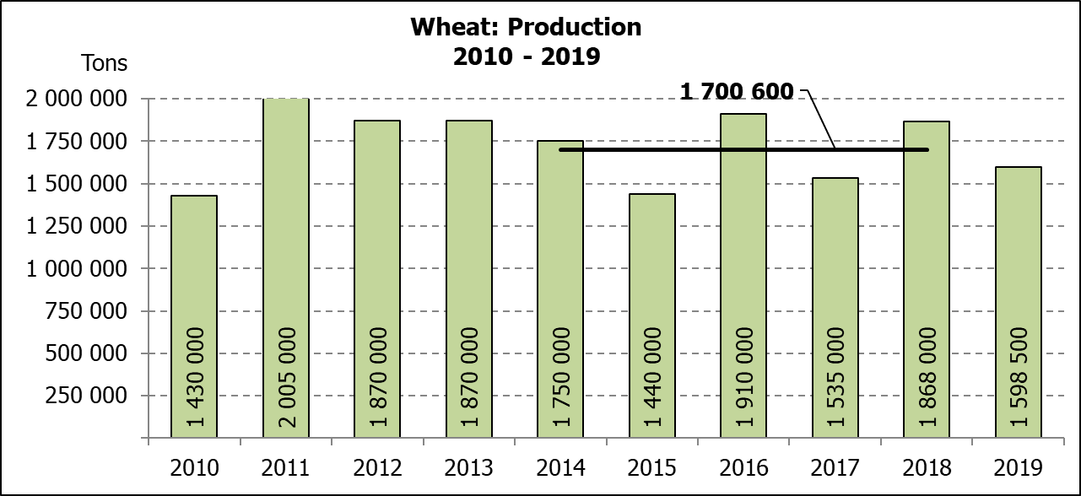**Hiermee word die oppervlakte- en vyfde produksieskatting vir wintergewasse vir 2019 vrygestel.**

**WINTER CEREALS** – AREA PLANTED AND FIFTH PRODUCTION FORECAST: 2019 PRODUCTION SEASON

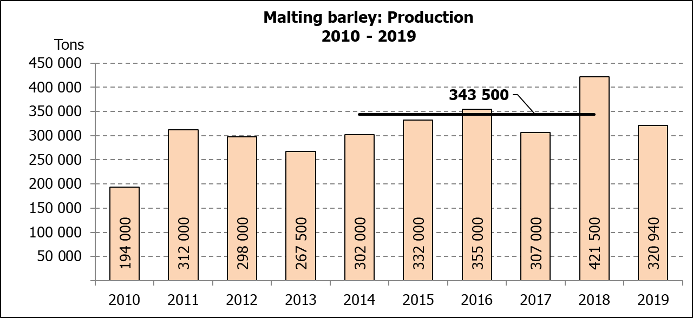**WINTERGEWASSE** – OPPERVLAKTE- EN VYFDE PRODUKSIESKATTING: 2019-PRODUKSIESEISOEN

|  |  |  |  |  |  |  |
| --- | --- | --- | --- | --- | --- | --- |
| CROP/GEWAS | **Area planted/**  **Opp beplant**  **2019** | **5th forecast/**  **5de skatting**  **2019** | 4th forecast/  4de skatting  2019 | Area planted/  Opp beplant  2018 | Final crop/  Finale oes  2018 | Change/  Verandering |
|  | **Ha** | **Tons** | Tons | Ha | Tons | % |
|  | **(A)** | **(B)** | (C) | (D) | (E) | (B) ÷ (C) |
| **Commercial/Kommersieel:** | | | | | | |
| Wheat/Koring | **540 000** | **1  598  500** | 1  618  460 | 503 350 | 1  868  000 | -1,23 |
| Malting barley/Moutgars | **131 960** | **320 940** | 358 760 | 119 000 | 421 500 | -10,54 |
| Canola/Kanola | **74 000** | **96 200** | 96 200 | 77 000 | 104 500 | - |
| Cereal oats/Hawermout | **27 200** | **27 490** | 31 240 | 19 235 | 32 700 | -12,00 |

* Note: Estimate is for calendar year, e.g. production season 2019/20 = 2019

* Nota: Skatting is vir kalenderjaar, bv. produksie-seisoen 2019/20 = 2019

**WHEAT** – AREA PLANTED AND FIFTH PRODUCTION FORECAST: 2019

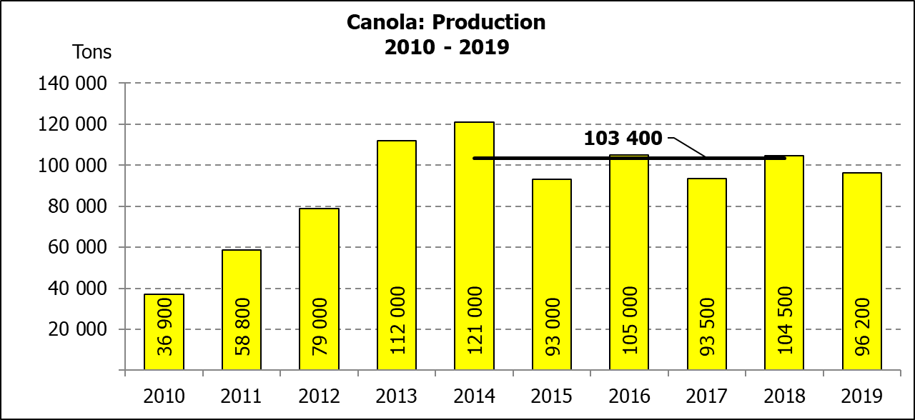**KORING** – OPPERVLAKTE- EN VYFDE PRODUKSIESKATTING: 2019

|  |  |  |  |  |
| --- | --- | --- | --- | --- |
| Province/  Provinsie | **Area planted/**  **Opp beplant**  **Ha** | **5th forecast/**  **5de skatting Tons** | Area planted/  Opp beplant  Ha | Final crop/  Finale oes  Tons |
|  | **2019** | **2019** | 2018 | 2018 |
| Western Cape/Wes-Kaap | **325 000** | **666 250** | 318 000 | 890 500 |
| Northern Cape/Noord-Kaap | **37 500** | **270 000** | 38 000 | 294 500 |
| Free State/Vrystaat | **128 000** | **358 400** | 100  000 | 385 000 |
| Eastern Cape/Oos-Kaap | **3 100** | **15 500** | 1 650 | 10 730 |
| KwaZulu-Natal | **7 500** | **45 750** | 7 000 | 43 400 |
| Mpumalanga | **4 000** | **25 200** | 3 500 | 22 740 |
| Limpopo | **20 000** | **128 000** | 20 000 | 128 000 |
| Gauteng | **1 400** | **8 400** | 1 200 | 7 800 |
| North West/Noordwes | **13 500** | **81 000** | 14 000 | 85 330 |
| Total/Totaal | **540 000** | **1  598 500** | 503 350 | 1  868 000 |

**AREA ESTIMATE AND FIFTH PRODUCTION FORECAST OF WINTER CROPS (2019) /**  
**OPPERVLAKTEKSKATTING EN VYFDE PRODUKSIESKATTING VAN WINTERGEWASSE (2019)**

**19 DECEMBER/DESEMBER 2019**

|  |  |  |
| --- | --- | --- |
| **Winter cereal crops - 2019 production season**  **Wheat:** The expected production of wheat is 1,598 mill. tons, which is 1,23% or 19  960 tons less than the previous forecast of 1,618 mill. tons, whilst the expected yield is 2,96 t/ha.  The expected production in the Western Cape is 666  250 tons (42%), in the Free State 358  400 tons (22%) and in the Northern Cape 270  000 tons (17%).  An estimated 325  000 ha or 60% is planted in the Western Cape, 128  000 ha or 24% in the Free State and 37  500 ha or 7% in the Northern Cape.  **Other crops:** The production forecast for **malting barley** is 320  940 tons, which is 10,54% or 37  820 tons less than the previous forecast of 358  760  tons. The area planted is estimated at 131  960 ha, whilst the expected yield is 2,43 t/ha.  The expected **canola crop** remained unchanged at 96  200 tons. The area estimate for canola is 74  000 ha, with an expected yield of 1,30 t/ha.  The area estimate for **oats (cereals)** for the 2019 season is 27  200 ha and the expected crop is 27  490 tons. The expected yield is 1,01 t/ha.  **Please note that the sixth production forecast for winter cereals (2019) and the preliminary area planted estimate for summer grains (2020) will be released on 29  January  2020.** |  | **Wintergewasse - 2019 produksie-seisoen**  **Koring:** Die verwagte produksie vir koring is 1,598 milj. ton, wat 1,23% of 19  960 ton minder is as die vorige skatting van 1,618 milj. ton, terwyl die verwagte opbrengs 2,96 t/ha is.  Die verwagte produksie in die Wes-Kaap is 666  250 ton (42%), in die Vrystaat 358  400 ton (22%) en in die Noord-Kaap 270  000 ton (17%).  Die beraamde oppervlakte geplant in die Wes-Kaap is 325  000 ha of 60%, die Vrystaat is 128  000 ha of 24% en 37  500  ha of 7% is in die Noord-Kaap.  **Ander gewasse:** Die produksieskatting vir **moutgars** is 320  940 ton, wat 10,54% of 37  820 ton minder is as die vorige skatting van 358  760 ton. Die oppervlakte beplant word beraam op 131  960 ha, terwyl die verwagte opbrengs 2,43  t/ha beloop.  Die verwagte **kanola-oes** is onveranderd gelaat op 96  200 ton. Die oppervlakteskatting vir kanola is 74  000  ha, met ŉ verwagte opbrengs van 1,30 t/ha.  Die oppervlakteskatting vir **hawer (ontbytgraan)** vir die 2019-seisoen is 27  200 ha en die verwagte oes is 27  490 ton. Die verwagte opbrengs is 1,01  t/ha.  **Neem asseblief kennis dat die sesde produksieskatting vir wintergewasse (2019) en die voorlopige oppervlakteskatting vir somergewasse (2020) op 29  Januarie  2020 vrygestel sal word.** |

|  |  |  |
| --- | --- | --- |
| **Information is available on the internet at http://**[**www.daff.gov.za/links/crop estimates**](http://www.daff.gov.za/links/crop) **or** [**http://www.sagis.org.za**](http://www.sagis.org.za)**, as from 14:30 on the date of the relevant meeting of the Crop Estimates Committee.** |  | **Inligting is beskikbaar op die internet by http://**[**www.daff.gov.za/links/crop estimates**](http://www.daff.gov.za/links/crop) **of by** [**http://www.sagis.org.za**](http://www.sagis.org.za)**, vanaf 14:30 op die dag van die toepaslike vergadering van die Oesskattingskomitee.** |