|  |  |  |  |
| --- | --- | --- | --- |
|  | crop estimates committee |  | |
| oesskattingskomitee |
| **From/Van:** Mr Baldwin Netshifhefhe  **Tel:** 012 319 8043  **Fax/Faks:** 012 319 8031  **E-mail/E-pos:** BaldwinN@daff.gov.za  Web page/Webblad: [www.daff.gov.za/statistics](http://www.daff.gov.za/statistics) and economic reports or [www.sagis.org.za/CEC](http://www.sagis.org.za/CEC): Crop Estimates  EMBARGO: 14:30 | | |  |

**The preliminary area planted estimate for summer crops for 2020 is hereby released.**

**Hiermee word die voorlopige oppervlakteskatting vir somergewasse vir 2020 vrygestel.**

**SUMMER CROPS** – PRELIMINARY AREA PLANTED ESTIMATE: 2020

**SOMERGEWASSE** – VOORLOPIGE OPPERVLAKSKATTING: 2020

|  |  |  |  |  |  |
| --- | --- | --- | --- | --- | --- |
| CROP/GEWAS | **Area planted/**  **Opp beplant**  **2020** | Intentions1)/  Voorneme1)  2020 | Area planted/  Opp beplant  2019 | Final estimate/  Finale skatting  2019 | Change/  Verandering/  2019 vs 2018 |
| **Ha** | Ha | Ha | Tons | % |
| **(A)** | (B) | (C) | (D) | (A) ÷ (C) |
| **Commercial/Kommersieël:** | | | | | |
| White maize/Witmielies | **1 514 800** | 1 431 900 | 1 298 400 | **5 538 240** | +16,67 |
| Yellow maize/Geelmielies | **1 020 500** | 1 087 400 | 1 002 100 | **5 719 610** | +1,84 |
| Total Maize/Totale Mielies | **2 535 300** | 2 519 300 | 2 300 500 | **11 257 850** | +10,21 |
| Sunflower seed/Sonneblomsaad | **551 500** | 538 500 | 515 350 | **680 940** | +7,01 |
| Soybeans/Sojabone | **757 000** | 745 500 | 730 500 | **1 170 345** | +3,63 |
| Groundnuts/Grondbone | **37 100** | 48 000 | 20 050 | **20 030** | +85,04 |
| Sorghum | **36 300** | 43 100 | 50 500 | **130 875** | -28,12 |
| Dry beans/Droëbone | **51 450** | 52 500 | 59 300 | **66 355** | -13,24 |
| TOTAL/TOTAAL | **3 968 650** | 3 946 900 | 3 676 200 | **13 326 395** | +7,96 |

1. Soos middel Oktober 2019/ As mid October 2019

Note: Estimate is for calendar year, e.g. production season 2019/20 = 2020

Nota: Skatting is vir kalenderjaar, bv. produksie-seisoen 2019/20 = 2020

**The Crop Estimates Committee comprises officials of the following institutions:**

**Department of Agriculture, Forestry and Fisheries; Provincial Departments of Agriculture; various ARC-Institutes (Soil, Climate and Water; Small Grains Institute; and**

**Grain Crops Institute); BFAP and Statistics SA.**

**29 January / Januarie 2020**

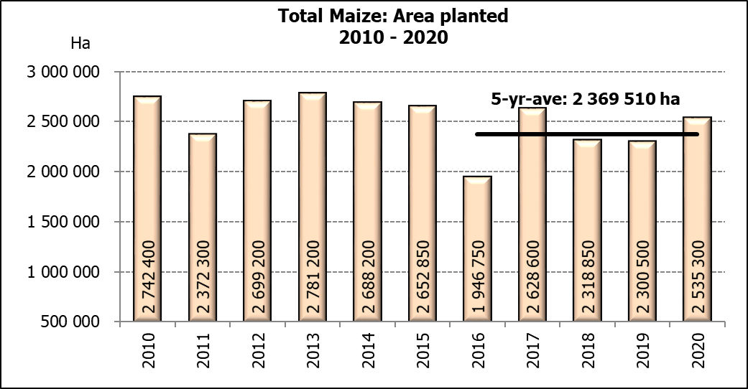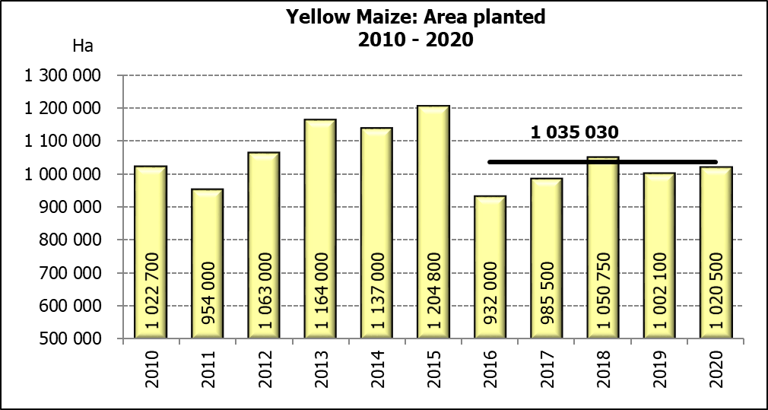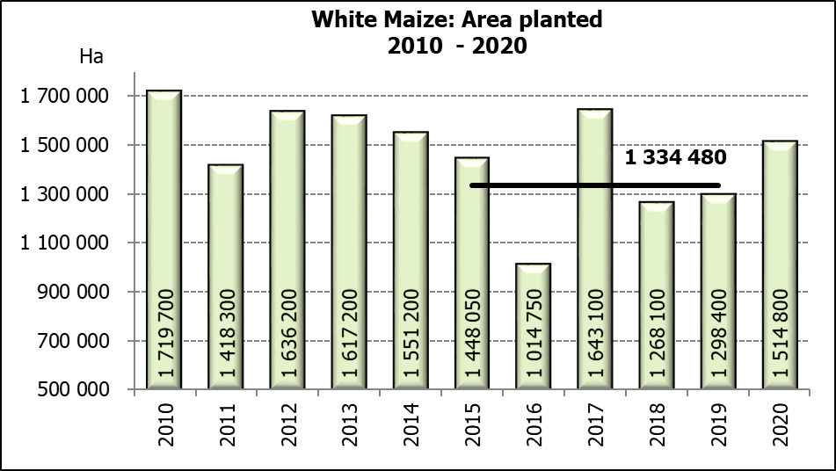

**WHITE AND YELLOW MAIZE** – PRELIMINARY AREA PLANTED ESTIMATE: 2020

**WIT- EN GEELMIELIES** – VOORLOPIGE OPPERVLAKTESKATTING: 2020

|  |  |  |  |  |  |  |  |  |  |
| --- | --- | --- | --- | --- | --- | --- | --- | --- | --- |
| Province/  Provinsie | Preliminary area planted  Voorlopige oppervlakte beplant  2020 | | | Area planted/  Oppervlakte beplant  2019 | | | Final estimate1)/  Finale skatting1)  2019 | | |
| White/  Wit  Ha | Yellow/  Geel  Ha | Totaal/  Total  Ha | White/  Wit  Ha | Yellow/  Geel  Ha | Totaal/  Total  Ha | White/  Wit  Tons | Geel/  Yellow  Tons | Totaal/  Total  Tons |
| Western Cape/Wes-Kaap | **400** | **3 400** | **3 800** | 400 | 3 400 | 3 800 | 3 600 | 30 600 | 34 200 |
| Northern Cape/Noord-Kaap | **3 400** | **43 100** | **46 500** | 3 400 | 43 500 | 46 900 | 39 440 | 630 750 | 670 190 |
| Free State/Vrystaat | **800 000** | **395 000** | **1 195 000** | 650 000 | 380 000 | 1 030 000 | 2 795 000 | 1 748 000 | 4 543 000 |
| Eastern Cape/Oos-Kaap | **4 000** | **16 000** | **20 000** | 3 800 | 10 200 | 14 000 | 22 800 | 69 360 | 92 160 |
| KwaZulu-Natal | **45 000** | **51 000** | **96 000** | 45 000 | 54 000 | 99 000 | 270 000 | 399 600 | 669 600 |
| Mpumalanga | **162 000** | **356 000** | **518 000** | 145 000 | 338 000 | 483 000 | 797 500 | 1 977 300 | 2 774 800 |
| Limpopo | **20 000** | **16 000** | **36 000** | 12 800 | 18 000 | 30 800 | 83 200 | 117 000 | 200 200 |
| Gauteng | **55 000** | **55 000** | **110 000** | 48 000 | 60 000 | 108 000 | 259 200 | 348 000 | 607 200 |
| North West/Noordwes | **425 000** | **85 000** | **510 000** | 390 000 | 95 000 | 485 000 | 1 267 500 | 399 000 | 1 666 500 |
| Total/Totaal | **1 514 800** | **1 020 500** | **2 535 300** | 1 298 400 | 1 002 100 | 2 300 500 | 5 538 240 | 5 719 610 | 11 257 850 |

1. 26 November 2019

**SUNFLOWER SEED** – PRELIMINARY AREA PLANTED ESTIMATE: 2020

**SONNEBLOMSAAD** – VOORLOPIGE OPPERVLAKTESKATTING: 2020

|  |  |  |  |
| --- | --- | --- | --- |
| Province/  Provinsie | **Prel area planted**  **Voorl opp beplant**  **Ha** | Area planted/  Opp beplant  Ha | Final estimate/  Finale skatting  Tons |
| **2020** | 2019 | 2019 |
| Western Cape/Wes-Kaap | **-** | - | - |
| Northern Cape/Noord-Kaap | **900** | 950 | 1 140 |
| Free State/Vrystaat | **270 000** | 270 000 | 391 500 |
| Eastern Cape/Oos-Kaap | **100** | 100 | 250 |
| KwaZulu-Natal | **-** | - | - |
| Mpumalanga | **2 500** | 4 500 | 4 500 |
| Limpopo | **65 000** | 61 000 | 61 000 |
| Gauteng | **3 000** | 3 800 | 3 800 |
| North West/Noordwes | **210 000** | 175 000 | 218 750 |
| Total/Totaal | **551 500** | 515 350 | 680 940 |

**SOYBEANS** – PRELIMINARY AREA PLANTED ESTIMATE: 2020

**SOJABONE** – VOORLOPIGE OPPERVLAKTESKATTING: 2020

|  |  |  |  |
| --- | --- | --- | --- |
| Province/  Provinsie | **Prel area planted**  **Voorl opp beplant**  **Ha** | Area planted/  Opp beplant  Ha | Final estimate/  Finale skatting  Tons |
| **2020** | 2019 | 2019 |
| Western Cape/Wes-Kaap | **-** | 100 | 10 |
| Northern Cape/Noord-Kaap | **1 500** | 1 550 | 5 425 |
| Free State/Vrystaat | **350 000** | 301 000 | 391 300 |
| Eastern Cape/Oos-Kaap | **2 500** | 1 150 | 1 380 |
| KwaZulu-Natal | **42 000** | 33 000 | 99 000 |
| Mpumalanga | **280 000** | 310 000 | 511 500 |
| Limpopo | **11 000** | 16 200 | 46 980 |
| Gauteng | **32 000** | 31 500 | 66 150 |
| North West/Noordwes | **38 000** | 36 000 | 48 600 |
| Total/Totaal | **757 000** | 730 500 | 1 170 345 |

**PRELIMINARY AREA ESTIMATE OF SUMMER CROPS (2020 PRODUCTION SEASON)/  
VOORLOPIGE OPPERVLAKTESKATTING VIR SOMERGEWASSE (2019 PRODUKSIE-SEISOEN)**

**29 JANUARY / JANUARIE 2020**

|  |  |  |
| --- | --- | --- |
| **Summer field crops – 2020**  The preliminary area estimate of today is mainly based on the results of a non-probability survey conducted by the Directorate: Statistics and Economic Analysis of the Department of Agriculture, Forestry and Fisheries.  The revised area planted and production figures, which will be released by the Crop Estimates Committee on 26 February 2020, will mainly be based on information obtained from the Producer Independent Crop Estimation System (PICES) survey for the Free State, KwaZulu-Natal, Mpumalanga, Limpopo, Gauteng and North West provinces.  **Commercial maize**: The preliminary area estimate for maize is 2,535 mill. ha, which is 10,21% or 234 800 ha more than the 2,300 mill. ha planted for the previous season, and also 0,64% or 16 000 ha more than the intentions to plant figure of 2,519 mill. ha released in October 2019.  The preliminary area estimate for white maize is 1,515 mill. ha, which represents an increase of 16,67% or 216 400 ha compared to the 1,298 mill. ha planted last season. In the case of yellow maize the area estimate is 1,020 mill. ha, which is 1,84% or 18 400 ha more than the 1,002 mill. ha planted last season.  **Other summer crops**:  Please note that only provisional national area planted figures of groundnuts, sorghum and dry beans for the current production season are being released today.  **Sunflower seed**: The preliminary area estimate for sunflower seed is 551 500 ha, which is 7,01% or 36 150 ha more than the 515 350 ha planted the previous season.  It is estimated that 757 000 ha have been planted to **soybeans**, which represents an increase of 3,63% or 26 500 ha compared to the 730 500 ha planted last season.  For **groundnuts**, the area estimate is 37 100 ha, which is 85,04% or 17 050 ha more than the 20 050 ha planted for the previous season.  The area estimate for **sorghum** decreased by 28,12%, from 50 500 ha to 36 300 ha against the previous season.  For **dry beans**, the area estimate is 51 450 ha, which is 13,24% or 7 850 ha less than the 59 300 ha planted for the previous season.  **Please note that the revised area estimate and first production forecast for summer field crops for 2020 will be released on 26 February 2020.** |  | **Somergewasse – 2020**  Die voorlopige oppervlakteskatting van vandag is hoofsaaklik gebaseer op die resultate van ’n nie-ewekansige opname onderneem deur die Direktoraat: Statistiek en Ekonomiese Analise van die Departement van Landbou, Bosbou en Visserye.  Die hersiene aangeplante oppervlakte en produksiesyfers sal deur die Oesskattingskomitee op 26 Februarie 2020 vrygestel word en sal hoofsaaklik gebaseer wees op inligting verkry vanaf die “PICES”-opname vir die Vrystaat, KwaZulu-Natal, Mpumalanga, Limpopo, Gauteng en Noordwes provinsies.  **Kommersiële mielies:** Die voorlopige skatting van die oppervlakte onder mielies beloop 2,535 milj. ha, wat 10,21% of 234 800 ha meer is as die 2,300 milj. ha wat verlede seisoen aangeplant is, en ook 0,64% of 16 000 ha meer as die voornemens om te plant syfer van 2,519 milj. ha soos vrygestel in Oktober 2019.  Die voorlopige oppervlak onder witmielies is 1,515 milj. ha, wat ’n toename van 16,67% of 216 400 ha verteenwoordig vergeleke met die 1,298 milj. ha die vorige seisoen. In die geval van geelmielies is die oppervlakteskatting 1,020 milj. ha, wat 1,84% of 18 400 ha meer is as die 1,002 milj. ha geplant die vorige seisoen.  **Ander somergewasse:**  Let asb. daarop dat net die nasionale aangeplante area vir die voorlopige oppervlakte van die grondbone, sorghum en droëbone vir die huidige produksieseisoen vandag vrygestel word.  **Sonneblomsaad:** Die voorlopige oppervlakteskatting vir sonneblomsaad is 551 500 ha, wat 7,01% of 36 150 ha meer is as die 515 350 ha aangeplant die vorige seisoen.  Die geskatte oppervlakte beplant met **sojabone** is 757 000 ha, wat ’n toename van 3,63% of 26 500 ha verteenwoordig vergeleke met die 730 500 ha geplant die vorige seisoen.  Vir **grondbone** is die oppervlakteskatting 37 100 ha, wat 85,04% of 17 050 ha meer is as die 20 050 ha geplant vir die vorige seisoen.  Die oppervlakteskatting vir **sorghum** het afgeneem met 28,12%, van 50 500 ha tot 36 300 ha teenoor die vorige seisoen.  Vir **droëbone** is die geskatte oppervlakte beplant 51 450 ha, wat 13,24% of 7 850 ha minder is as die 59 300 ha geplant vir die vorige seisoen.  **Neem asseblief kennis dat die hersiene oppervlakte- en eerste produksieskatting vir somergewasse vir 2020, op 26 Februarie 2020 vrygestel sal word.** |

**The area estimate and sixth production forecast for winter cereals for the 2019 is hereby released. /**

**Hiermee word die oppervlakteskatting en sesde produksieskatting vir wintergewasse vir 2019 vrygestel.**

**WINTER CEREALS** – AREA PLANTED ESTIMATE AND SIXTH PRODUCTION FORECAST: 2019

**WINTERGEWASSE** – OPPERVLAKTE- EN SESDE PRODUKSIESKATTING: 2019

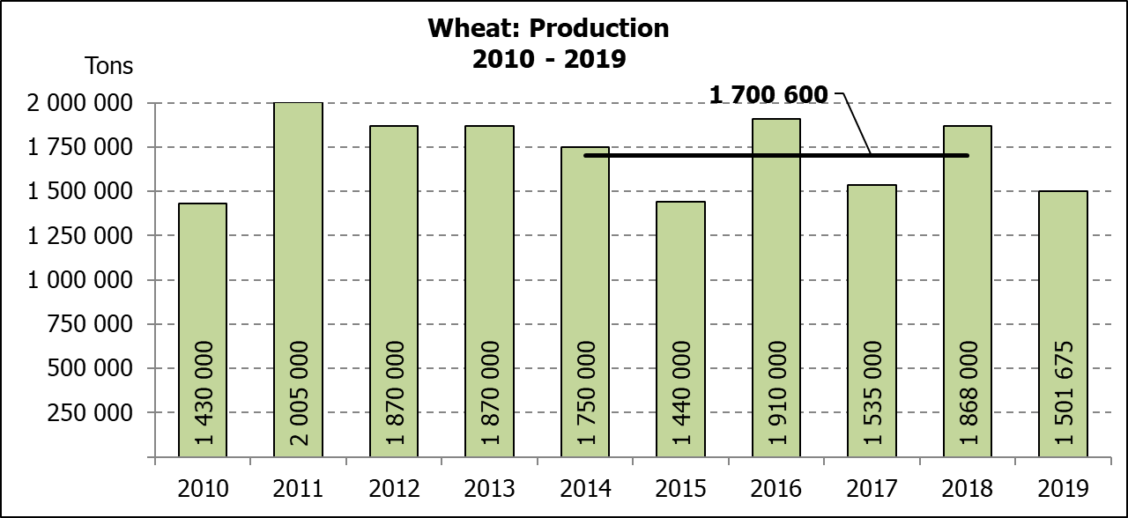

|  |  |  |  |  |  |  |
| --- | --- | --- | --- | --- | --- | --- |
| CROP/GEWAS | **Area planted/**  **Opp beplant**  **2019** | **6th forecast/**  **6de skatting**  **2019** | 5th forecast/  5de skatting  2019 | Area planted/  Opp beplant  2018 | Final crop/  Finale oes  2018 | Change/  Verandering |
| **Ha** | **Tons** | Tons | Ha | Tons | % |
| **(A)** | **(B)** | (C) | (D) | (E) | (B) ÷ (C) |
| **Commercial/Kommersieel:** | | | | | | |
| Wheat/Koring | **540 000** | **1 501 675** | 1 598 500 | 503 350 | 1 868 000 | -6,06 |
| Malting barley/Moutgars | **131 960** | **345 080** | 320 940 | 119 000 | 421 500 | +7,52 |
| Canola/Kanola | **74 000** | **96 200** | 96 200 | 77 000 | 104 500 | - |
| Cereal oats/Hawermout | **21 000** | **17 250** | 27 490 | 19 235 | 32 700 | -37,25 |

* Note: Estimate is for calendar year, e.g. production season 2019/20 = 2019

* Nota: Skatting is vir kalenderjaar, bv. produksie-seisoen 2019/20 = 2019

**WHEAT** – AREA PLANTED ESTIMATE AND SIXTH PRODUCTION FORECAST: 2019

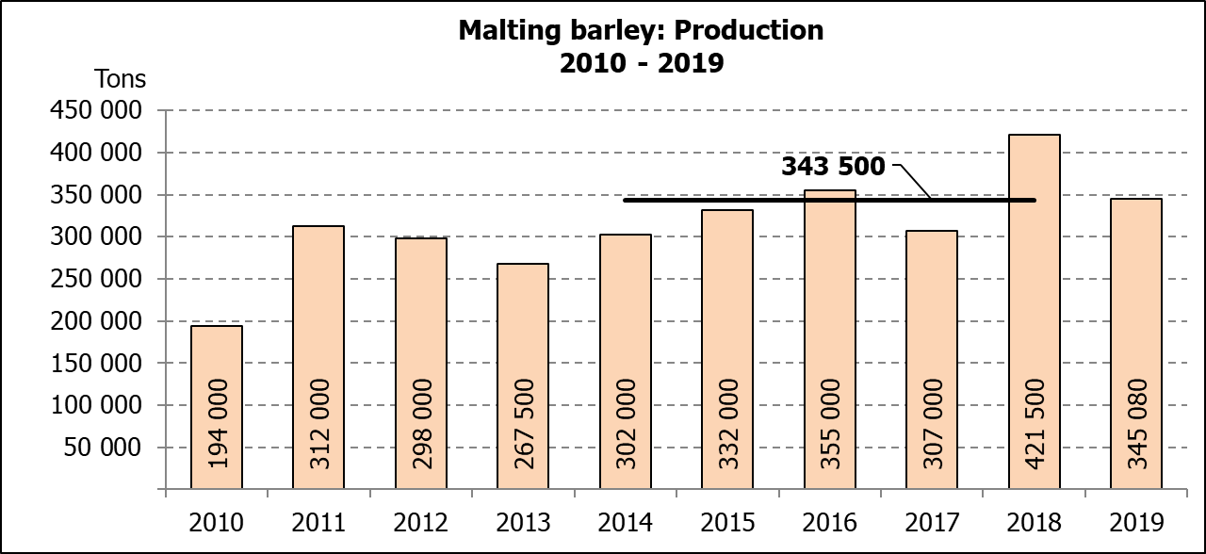

**KORING** – OPPERVLAKTE- EN SESDE PRODUKSIESKATTING: 2019

|  |  |  |  |  |
| --- | --- | --- | --- | --- |
| Province/  Provinsie | **Area planted/**  **Opp beplant**  **Ha** | **6th forecast/**  **6de skatting**  **Tons** | Area planted/  Opp beplant  Ha | Final crop/  Finale oes  Tons |
| **2019** | **2019** | 2018 | 2018 |
| Western Cape/Wes-Kaap | **325 000** | **633 750** | 318 000 | 890 500 |
| Northern Cape/Noord-Kaap | **37 500** | **262 500** | 38 000 | 294 500 |
| Free State/Vrystaat | **128 000** | **313 600** | 100 000 | 385 000 |
| Eastern Cape/Oos-Kaap | **3 100** | **15 500** | 1 650 | 10 730 |
| KwaZulu-Natal | **7 500** | **45 750** | 7 000 | 43 400 |
| Mpumalanga | **4 000** | **25 200** | 3 500 | 22 740 |
| Limpopo | **20 000** | **118 000** | 20 000 | 128 000 |
| Gauteng | **1 400** | **8 400** | 1 200 | 7 800 |
| North West/Noordwes | **13 500** | **78 975** | 14 000 | 85 330 |
| Total/Totaal | **540 000** | **1 501 675** | 503 350 | 1 868 000 |

**AREA ESTIMATE AND SIXTH PRODUCTION FORECAST OF WINTER CROPS (2019) /  
OPPERVLAKTESKATTING EN SESDE PRODUKSIESKATTING VAN WINTERGEWASSE (2019)**

**29 JANUARY / JANUARIE 2020**

|  |  |  |
| --- | --- | --- |
| **Winter cereal crops - 2019 production season**  **Wheat:** The expected production of wheat is 1,502 mill. tons, which is 6,06% or 96 825 tons less than the previous forecast of 1,598 mill. tons, whilst the expected yield is 2,78 t/ha.  The expected production in the Western Cape is 633 750 tons (42%), in the Free State 313 600 tons (21%) and in the Northern Cape 262 500 tons (17%).  An estimated 325 000 ha or 60% is planted in the Western Cape, 128 000 ha or 24% in the Free State and 37 500 ha or 7% in the Northern Cape.  **Other crops:** The production forecast for **malting barley** is 345 080 tons, which is 7,52% or 24 140 tons more than the previous forecast of 320 940 tons. The area planted is estimated at 131 960 ha, whilst the expected yield is 2,62 t/ha.  The expected **canola crop** remained unchanged at 96 200 tons. The area estimate for canola is 74 000 ha, with an expected yield of 1,30 t/ha.  The area estimate for **oats (cereals)** for the 2019 season is 21 000 ha and the expected crop is 17 250 tons. The expected yield is 0,82 t/ha.  **Please note that the final production estimate for winter cereals for 2019 will be released on 26 February 2020.** |  | **Wintergewasse - 2019 produksie-seisoen**  **Koring:** Die verwagte produksie vir koring is 1,502 milj. ton, wat 6,06% of 96 825 ton minder is as die vorige skatting van 1,598 milj. ton, terwyl die verwagte opbrengs 2,78 t/ha is.  Die verwagte produksie in die Wes-Kaap is 633 750 ton (42%), in die Vrystaat 313 600 ton (21%) en in die Noord-Kaap 262 500 ton (17%).  Die beraamde oppervlakte geplant in die Wes-Kaap is 325 000 ha of 60%, die Vrystaat is 128 000 ha of 24% en 37 500 ha of 7% is in die Noord-Kaap.  **Ander gewasse:** Die produksieskatting vir **moutgars** is 345 080 ton, wat 7,52% of 24 140 ton meer is as die vorige skatting van 320 940 ton. Die oppervlakte beplant word beraam op 131 960 ha, terwyl die verwagte opbrengs 2,62 t/ha beloop.  Die verwagte **kanola-oes** is onveranderd gelaat op 96 200 ton. Die oppervlakteskatting vir kanola is 74 000 ha, met ŉ verwagte opbrengs van 1,30 t/ha.  Die oppervlakteskatting vir **hawer (ontbytgraan)** vir die 2019-seisoen is 21 000 ha en die verwagte oes is 17 250 ton. Die verwagte opbrengs is 0,82 t/ha.  **Neem asseblief kennis dat die finale produksieskatting vir wintergewasse vir 2019 op 26 Februarie 2020 vrygestel sal word.** |

|  |  |  |
| --- | --- | --- |
| **Information is available on the internet at http://**[**www.daff.gov.za/links/crop estimates**](http://www.daff.gov.za/links/crop%20estimates) **or** [**http://www.sagis.org.za**](http://www.sagis.org.za)**, as from 14:30 on the date of the relevant meeting of the Crop Estimates Committee.** |  | **Inligting is beskikbaar op die internet by http://**[**www.daff.gov.za/links/crop estimates**](http://www.daff.gov.za/links/crop%20estimates) **of by** [**http://www.sagis.org.za**](http://www.sagis.org.za)**, vanaf 14:30 op die dag van die toepaslike vergadering van die Oesskattingskomitee.** |

**CONFIDENTIALITY ISSUES that CEC members are committed to adhere to on the day of the meeting**

* Personal items such as laptops, handbags, cell phones, etc. are not allowed in the venue during the meeting
* No member is allowed to leave the meeting before 12:00 in order to prevent disclosure of the information
* The embargo time for the release of crop estimates information is 15:30
* No member is allowed to discuss crop estimates information with anyone other than a member of the Committee before the embargo time
* Only the Chairperson, or a member appointed by the Chairperson, may release the figures to the media
* Members must regard the detail of any information that was collected for and/or discussed during the meeting, as confidential
* Individual information received for crop estimate purposes is treated strictly confidential, and is not divulged for any other purposes