|  |  |  |  |
| --- | --- | --- | --- |
|  | crop estimates committee |  | |
|  | oesskattingskomitee |  | |
| **From/Van:** Rodney D. Dredge  **Tel:** 012  319 6507  **Fax/Faks:** 012  319 6211  **E-mail/E-pos:** [CDESS@daff.gov.za](mailto:CDESS@daff.gov.za)  Web page/Webblad: [www.daff.gov.za/crop estimates](http://www.daff.gov.za/crop) or [www.sagis.org.za/CEC](http://www.sagis.org.za/CEC): Crop Estimates  EMBARGO: 14:30 | | |  |

**The sixth production forecast for summer crops for the 2009/10 production season is hereby released. /**

**Hiermee word die sesde produksieskatting vir somergewasse vir die 2009/10 produksie-seisoen vrygestel.**

**SUMMER CROPS** – AREA PLANTED AND SIXTH PRODUCTION FORECAST: 2009/10 PRODUCTION SEASON

**SOMERGEWASSE** – OPPERVLAKTE- EN SESDE PRODUKSIESKATTING: 2009/10-PRODUKSIESEISOEN

|  |  |  |  |  |  |  |
| --- | --- | --- | --- | --- | --- | --- |
| CROP/GEWAS | **Area planted/**  **Opp beplant**  **2009/10** | **6th forecast/**  **6e skatting**  **2009/10** | 5th forecast/  5e skatting  2009/10 | Area planted/  Opp beplant  2008/09 | Finale oes/  Final crop  2008/09 | Change/  Verande-ring |
|  | **Ha** | **Tons** | Tons | Ha | Tons | % |
|  | **(A)** | **(B)** | (C) | (D) | (E) | (B) ÷ (C) |
| Commercial/Kommersieël: | | | | | | |
| White maize/Witmielies | **1  719  700** | **7 999 250** | 7 999 250 | 1  489  000 | 6 775 000 | - |
| Yellow maize/Geelmielies | **1 022  700** | **5 317 800** | 5 317 800 | 938  500 | 5 275 000 | - |
| Maize/Mielies | **2  742 400** | **13 317 050** | 13 317 050 | 2  427 500 | 12 050 000 | - |
| Sunflower seed/Sunflower seed | **397 700** | **528 765** | 528 765 | 635 800 | 801 000 | - |
| Soya-beans/Sojabone | **311 450** | **567 200** | 567 200 | 237 750 | 516 000 | - |
| Groundnuts/Grondbone | **57 450** | **87 880** | 87 880 | 54  550 | 99 500 | - |
| Sorghum | **86 675** | **241 593** | 241 593 | 85 500 | 276 500 | - |
| Dry beans/Droëbone | **44 100** | **52 255** | 52 255 | 43  800 | 67 030 | - |
| TOTAL/TOTAAL | **3 639 775** | **14 794 743** | 14 794 743 | 3 484 900 | 13 810 030 | - |

22 July/Julie 2010

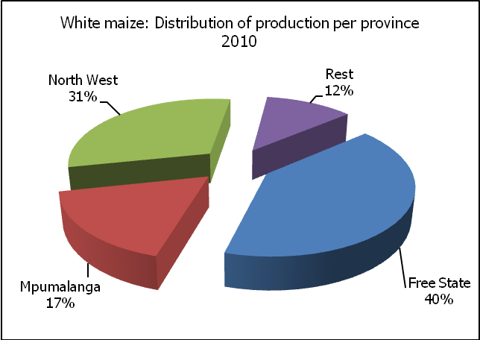

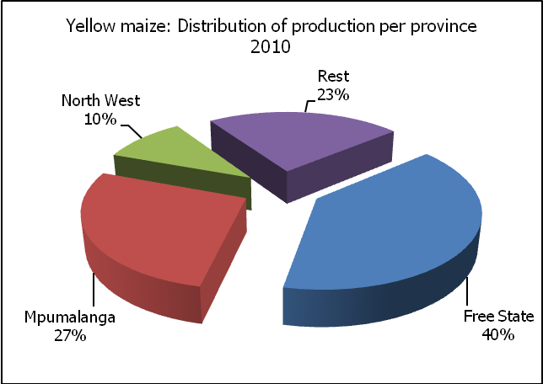

**WHITE AND YELLOW MAIZE** – AREA PLANTED AND SIXTH PRODUCTION FORECAST: 2009/10 PRODUCTION SEASON

**WIT- EN GEELMIELIES** – OPPERVLAKTE- EN SESDE PRODUKSIESKATTING: 2009/10-PRODUKSIESEISOEN

|  |  |  |  |  |  |  |  |  |  |  |  |  |
| --- | --- | --- | --- | --- | --- | --- | --- | --- | --- | --- | --- | --- |
| Provinsie/  Province | **Area planted/**  **Oppervlakte beplant**  **2009/10** | | | **6th forecast/**  **6e skatting**  **2009/10** | | | Area planted/  Oppervlakte beplant  2008/09 | | | Final crop/  Finale oes  2008/09 | | |
|  | **White/**  **Wit**  **Ha** | **Yellow/**  **Geel**  **Ha** | **Total/**  **Totaal**  **Ha** | **White/**  **Wit**  **Tons** | **Yellow/**  **Geel**  **Tons** | **Total/**  **Totaal**  **Tons** | White/  Wit  Ha | Yellow/  Geel  Ha | Total/  Totaal  Ha | White/  Wit  Tons | Yellow/  Geel  Tons | Total/  Totaal  Tons |
| Western Cape/Wes-Kaap | **500** | **2 000** | **2 500** | **3 500** | **16 000** | **19 500** | 1 500 | 3 500 | 5 000 | 15 000 | 35 000 | 50 000 |
| Northern Cape/Noord-Kaap | **2 000** | **51 000** | **53 000** | **23 000** | **599 250** | **622 250** | 2 500 | 48 000 | 50 500 | 28 750 | 605 000 | 633 750 |
| Free State/Vrystaat | **690 000** | **466 000** | **1 156 000** | **3 243 000** | **2 097 000** | **5 340 000** | 565 000 | 390 000 | 955 000 | 2 627 250 | 1 900 000 | 4 527 250 |
| Eastern Cape/Oos-Kaap | **3 200** | **13 200** | **16 400** | **14 400** | **66 000** | **80 400** | 3 000 | 13 000 | 16 000 | 15 900 | 76 500 | 92 400 |
| KwaZulu-Natal | **46 000** | **42 000** | **88 000** | **273 700** | **258 300** | **532 000** | 40 000 | 42 000 | 82 000 | 248 000 | 273 000 | 521 000 |
| Mpumalanga | **232 000** | **250 000** | **482 000** | **1 380 400** | **1 450 000** | **2 830 400** | 215 000 | 262 000 | 477 000 | 1 290 000 | 1 580 000 | 2  870 000 |
| Limpopo | **26 000** | **18 500** | **44 500** | **123 500** | **83 250** | **206 750** | 33 000 | 15 000 | 48 000 | 171 550 | 75 000 | 246 550 |
| Gauteng | **85 000** | **40 000** | **125 000** | **493 000** | **216 000** | **709 000** | 69 000 | 30 000 | 99 000 | 358 800 | 175 500 | 534 300 |
| North West/Noordwes | **635 000** | **140 000** | **775 000** | **2 444 750** | **532 000** | **2 976 750** | 560 000 | 135 000 | 695 000 | 2 019 750 | 555 000 | 2 574 750 |
| Total/Totaal | **1 719 700** | **1 022 700** | **2 742 400** | **7 999 250** | **5 317 800** | **13 317 050** | 1 489 000 | 938 500 | 2 427 500 | 6 775 000 | 5 275 000 | 12 050 000 |

**SUNFLOWER SEED** – AREA PLANTED AND SIXTH PRODUCTION FORECAST: 2009/10 PRODUCTION SEASON

**SONNEBLOMSAAD** – OPPERVLAKTE- EN SESDE PRODUKSIESKATTING: 2009/10 PRODUKSIESEISOEN

|  |  |  |  |  |
| --- | --- | --- | --- | --- |
| Province/  Provinsie | **Area planted/**  **Opp beplant**  **Ha** | **6th forecast/**  **6e skatting**  **Tons** | Area planted/  Opp beplant  Ha | Final crop/  Finale oes  Tons |
|  | **2009/10** | **2009/10** | 2008/09 | 2008/09 |
| Western Cape/Wes-Kaap | **200** | **200** | 700 | 700 |
| Northern Cape/Noord-Kaap | **850** | **1 700** | 500 | 1 000 |
| Free State/Vrystaat | **175 000** | **245 000** | 280 000 | 363 000 |
| Eastern Cape/Oos-Kaap | **150** | **165** | 600 | 780 |
| KwaZulu-Natal | **-** | **-** | - | - |
| Mpumalanga | **8 000** | **12 800** | 27 000 | 37 700 |
| Limpopo | **75 000** | **75 000** | 90 000 | 90 000 |
| Gauteng | **3 500** | **4 900** | 7 000 | 9 820 |
| North West/Noordwes | **135 000** | **189 000** | 230 000 | 298 000 |
| Total/Totaal | **397 700** | **528 765** | 635 800 | 801 000 |

**SOYA-BEANS** – AREA PLANTED AND SIXTH PRODUCTION FORECAST: 2009/10 PRODUCTION SEASON

**SOJABONE** – OPPERVLAKTE- EN SESDE PRODUKSIESKATTING: 2009/10 PRODUKSIESEISOEN

|  |  |  |  |  |
| --- | --- | --- | --- | --- |
| Province/  Provinsie | **Area planted/**  **Opp beplant**  **Ha** | **6th forecast/**  **6e skatting**  **Tons** | Area planted/  Opp beplant  Ha | Final crop/  Finale oes  Tons |
|  | **2009/10** | **2009/10** | 2008/09 | 2008/09 |
| Western Cape/Wes-Kaap | **-** | **-** | - | - |
| Northern Cape/Noord-Kaap | **650** | **1 950** | 750 | 2 250 |
| Free State/Vrystaat | **95 000** | **152 000** | 55 000 | 99 000 |
| Eastern Cape/Oos-Kaap | **800** | **1 200** | 800 | 1 600 |
| KwaZulu-Natal | **30 000** | **75 000** | 27 000 | 75 600 |
| Mpumalanga | **145 000** | **239 250** | 125 000 | 262 500 |
| Limpopo | **18 000** | **50 400** | 16 000 | 44 000 |
| Gauteng | **12 000** | **20 400** | 6 700 | 12 525 |
| North West/Noordwes | **10 000** | **27 000** | 6 500 | 18 525 |
| Total/Totaal | **311 450** | **567 200** | 237 750 | 516 000 |

**GROUNDNUTS** – AREA PLANTED AND SIXTH PRODUCTION FORECAST: 2009/10 PRODUCTION SEASON

**GRONDBONE** – OPPERVLAKTE- EN SESDE PRODUKSIESKATTING: 2009/10 PRODUKSIESEISOEN

|  |  |  |  |  |
| --- | --- | --- | --- | --- |
| Province/  Provinsie | **Area planted/**  **Opp beplant**  **Ha** | **6th forecast/**  **6e skatting**  **Tons** | Area planted/  Opp beplant  Ha | Final crop/  Finale oes  Tons |
|  | **2009/10** | **2009/10** | 2008/09 | 2008/09 |
| Western Cape/Wes-Kaap | **-** | **-** | - | - |
| Northern Cape/Noord-Kaap | **10 000** | **27 000** | 10 000 | 31 000 |
| Free State/Vrystaat | **25 000** | **35 000** | 21 500 | 33 690 |
| Eastern Cape/Oos-Kaap | **-** |  | - |  |
| KwaZulu-Natal | **200** | **300** | - | - |
| Mpumalanga | **-** | **-** | - | - |
| Limpopo | **2 200** | **3 520** | 3 000 | 6 750 |
| Gauteng | **50** | **60** | 50 | 60 |
| North West/Noordwes | **20 000** | **22 000** | 20 000 | 28 000 |
| Total/Totaal | **57 450** | **87 880** | 54 550 | 99 500 |

**SORGHUM** – AREA PLANTED AND SIXTH PRODUCTION FORECAST: 2009/10 PRODUCTION SEASON

**SORGHUM** – OPPERVLAKTE- EN SESDE PRODUKSIESKATTING: 2009/10 PRODUKSIESEISOEN

|  |  |  |  |  |
| --- | --- | --- | --- | --- |
| Province/  Provinsie | **Area planted/**  **Opp beplant**  **Ha** | **6th forecast/**  **6e skatting**  **Tons** | Area planted/  Opp beplant  Ha | Final crop/  Finale oes  Tons |
|  | **2009/10** | **2009/10** | 2008/09 | 2008/09 |
| Western Cape/Wes-Kaap | - | **-** | - | - |
| Northern Cape/Noord-Kaap | **25** | **63** | - | - |
| Free State/Vrystaat | **50 000** | **130 000** | 55 000 | 170 500 |
| Eastern Cape/Oos-Kaap | **-** | **-** | - | - |
| KwaZulu-Natal | **150** | **480** | 300 | 900 |
| Mpumalanga | **15 000** | **52 500** | 16 500 | 66 000 |
| Limpopo | **15 000** | **41 250** | 8 000 | 23 000 |
| Gauteng | **1 000** | **3 000** | 700 | 2 100 |
| North West/Noordwes | **5 500** | **14 300** | 5 000 | 14 000 |
| Total/Totaal | **86 675** | **241 593** | 85 500 | 276 500 |

**DRY BEANS** – AREA PLANTED AND SIXTH PRODUCTION FORECAST: 2009/10 PRODUCTION SEASON

**DROëBONE** – OPPERVLAKTE- EN SESDE PRODUKSIESKATTING: 2009/10 PRODUKSIESEISOEN

|  |  |  |  |  |
| --- | --- | --- | --- | --- |
| Province/  Provinsie | **Area planted/**  **Opp beplant**  **Ha** | **6th forecast/**  **6e skatting**  **Tons** | Area planted/  Opp beplant  Ha | Final crop/  Finale oes  Tons |
|  | **2009/10** | **2009/10** | 2008/09 | 2008/09 |
| Western Cape/Wes-Kaap | **100** | **300** | 100 | 280 |
| Northern Cape/Noord-Kaap | **600** | **1 200** | 100 | 250 |
| Free State/Vrystaat | **16 000** | **14 400** | 18 000 | 28 800 |
| Eastern Cape/Oos-Kaap | **400** | **480** | 200 | 300 |
| KwaZulu-Natal | **3 000** | **4 500** | 3 000 | 4 800 |
| Mpumalanga | **10 500** | **12 075** | 10 500 | 15 750 |
| Limpopo | **5 500** | **9 350** | 4 500 | 6 750 |
| Gauteng | **3 500** | **4 550** | 3 400 | 5 100 |
| North West/Noordwes | **4 500** | **5 400** | 4 000 | 5 000 |
| Total/Totaal | **44 100** | **52 255** | 43 800 | 67 030 |