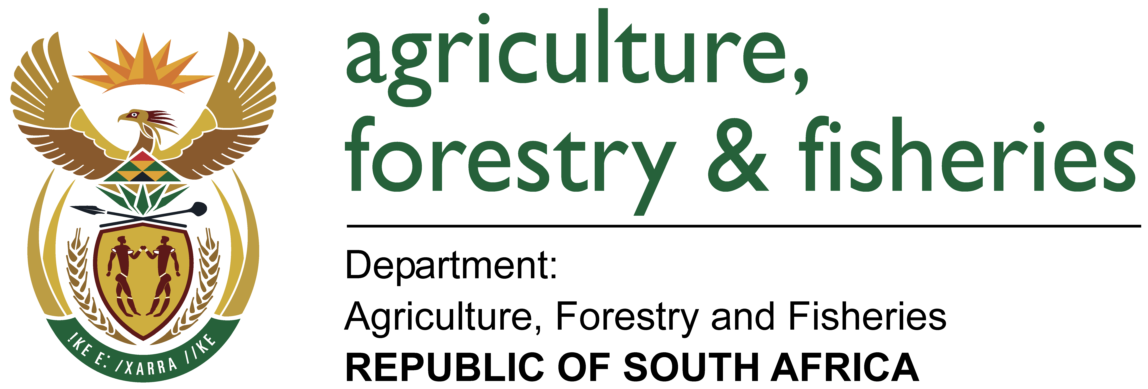
NUUSBRIEF: NASIONALE VEESTATISTIEK

Van: Baldwin Netshifhefhe
Direktoraat: Statistiek en Ekonomiese Analise
Tel: 012 319 8043 Faks: 012 319 8035/1 E-pos: BaldwinN@daff.gov.za
Verw: 26.1.2.3.1

Augustus 2016
Geagte medewerker
Hiermee word die geskatte veegetalle in die RSA vir Februarie 2016 vrygestel.
Provinsie | Beeste |  | Skape |  | Varke |  | Bokke
Provinsie | Aug 15 | Feb 16 | Aug 15 | Feb 16 | Aug 15 | Feb 16 | Aug 15 | Feb 16
Provinsie | Duisende
Wes-Kaap | 558 | 553 | 2 800 | 2 778 | 169 | 171 | 214 | 216
Noord-Kaap | 502 | 510 | 5 956 | 5 893 | 27 | 27 | 508 | 514
Vrystaat | 2 279 | 2 271 | 4 727 | 4 692 | 122 | 124 | 234 | 235
Oos-Kaap | 3 321 | 3 284 | 6 967 | 6 924 | 93 | 94 | 2 221 | 2 249
KwaZulu-Natal | 2 684 | 2 657 | 747 | 729 | 150 | 152 | 806 | 811
Mpumalanga | 1 399 | 1 379 | 1 739 | 1 717 | 124 | 126 | 88 | 90
Limpopo | 1 016 | 1 009 | 254 | 245 | 358 | 362 | 1 081 | 1 094
Gauteng | 248 | 244 | 99 | 97 | 164 | 166 | 40 | 40
Noordwes | 1 688 | 1 663 | 649 | 635 | 316 | 318 | 680 | 683
Totaal | 13 695 | 13 570 | 23 938 | 23 710 | 1 523 | 1 540 | 5 872 | 5 932

Die bees- en skaapgetalle het onderskeidelik met 0,91% en 0,95% afgeneem vanaf Augustus 2015 tot Februarie 2016, terwyl die vark- en bokgetalle onderskeidelik toegeneem het met 1,14% en 1,03%.

BEESTE:
Die meeste beeste word in die Oos-Kaap aangetref, naamlik 3,284 milj. (24%), gevolg deur KwaZulu-Natal met 2,657 milj. (20%) en die Vrystaat met 2,271 milj. (17%). Die oorblywende provinsies verteenwoordig gesamentlik 39% (5,357 milj.) van die totale getal beeste in Suid-Afrika.
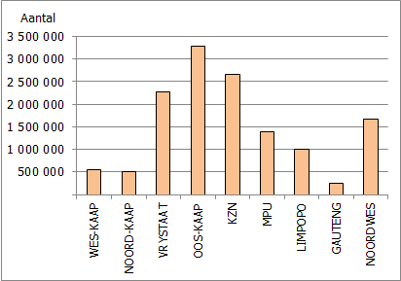

BOKKE:
Die grootste getal bokke, 2,249 milj. (38%) word in die Oos-Kaap aangetref, gevolg deur Limpopo met 1,094 milj. (18%) en KwaZulu-Natal met 810 850 (14%). Die oorblywende provinsies verteenwoordig gesamentlik 30% of 1,779 milj. van die totale getal bokke in Suid-Afrika.

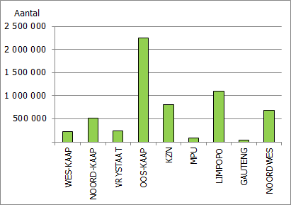
SKAPE:
Die Oos-Kaap het die meeste skape, naamlik 6,924 milj. (29%), gevolg deur die Noord-Kaap met 5,893 milj. (25%) en die Vrystaat met 4,692 milj. (20%). Die oorblywende provinsies verteenwoordig 26% (6,201 milj.) van die totale getal skape in Suid-Afrika.

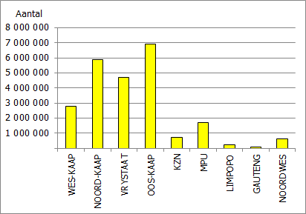

VARKE:
Limpopo het die grootste getal varke, naamlik 362 180 (24%). Noordwes en Wes-Kaap provinsies volg met onderskeidelik 317 870 (21%) en 171 400 (11%) varke. Die oorblywende provinsies verteenwoordig gesamentlik 45% of sowat 688 560 van die totale getal varke in Suid-Afrika.
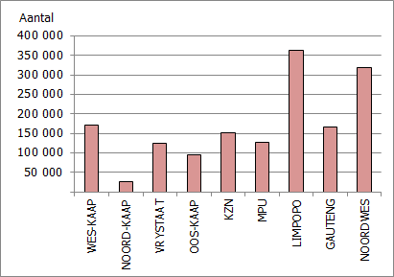

Dit sal waardeer word indien u die meegaande veeskattingsvraelys sal invul vir al die onvoltooide maande tot en met Augustus 2016 en dit voor 20 September 2016 in die ingeslote koevert sal terugstuur, όf alternatiewelik deur dit terug te faks na 012-319 8035/1 όf dit te e-pos na RonaB@daff.gov.za
Die Direktoraat wil u graag bedank vir u volgehoue samewerking.
per pro. Direkteur: Statistiek en Ekonomiese Analise

NEWSLETTER: NATIONAL LIVESTOCK STATISTICS

From: Baldwin Netshifhefhe
Directorate: Statistics and Economic Analysis
Tel: 012 319 8043 Fax: 012 319 8035/1 E-mail: BaldwinN@daff.gov.za
Ref: 26.1.2.3.1

August 2016
Dear Co-operator
The estimated livestock numbers in the RSA for February 2016 is hereby released.
Province | Cattle |  | Sheep |  | Pigs |  | Goats
Province | Aug 15 | Feb 16 | Aug 15 | Feb 16 | Aug 15 | Feb 16 | Aug 15 | Feb 16
Province | Thousands
Western Cape | 558 | 553 | 2 800 | 2 778 | 169 | 171 | 214 | 216
Northern Cape | 502 | 510 | 5 956 | 5 893 | 27 | 27 | 508 | 514
Free State | 2 279 | 2 271 | 4 727 | 4 692 | 122 | 124 | 234 | 235
Eastern Cape | 3 321 | 3 284 | 6 967 | 6 924 | 93 | 94 | 2 221 | 2 249
KwaZulu-Natal | 2 684 | 2 657 | 747 | 729 | 150 | 152 | 806 | 811
Mpumalanga | 1 399 | 1 379 | 1 739 | 1 717 | 124 | 126 | 88 | 90
Limpopo | 1 016 | 1 009 | 254 | 245 | 358 | 362 | 1 081 | 1 094
Gauteng | 248 | 244 | 99 | 97 | 164 | 166 | 40 | 40
North West | 1 688 | 1 663 | 649 | 635 | 316 | 318 | 680 | 683
Total | 13 695 | 13 570 | 23 938 | 23 710 | 1 523 | 1 540 | 5 872 | 5 932

Die numbers for cattle and sheep decreased by 0,91% and 0,95% respectively from August 2015 to February 2016, while the numbers for pigs and goats increased by 1,14% and 1,03% respectively.

CATTLE:
Most cattle are found in the Eastern Cape, namely 3,284 million (24%), followed by KwaZulu-Natal with 2,657 million (20%) and then the Free State with 2,271 million (17%). The remaining provinces represent 39% (5,357 million) of the total number of cattle in South Africa.

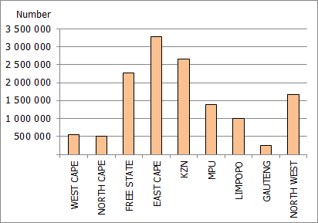
GOATS:
The largest number of goats, 2,249 million (38%) are found in the Eastern Cape. Limpopo Province follows with 1,094 million (18%) and then KwaZulu-Natal with 810 850 (14%). The remaining provinces represent 30% or 1,779 million of the total number of goats in South Africa.

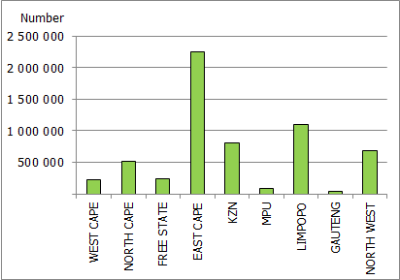
SHEEP:
The Eastern Cape has the most sheep, namely 6,924 million (29%), followed by the Northern Cape with 5,893 million (25%) and then the Free State with 4,692 million (20%). The remaining provinces represent 26% (6,201 million) of the total number of sheep in South Africa.

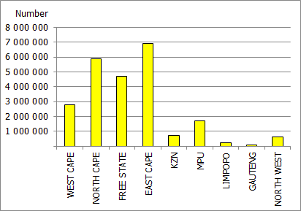
PIGS:
Limpopo has the largest number of pigs, namely 362 180 (23%). North West and Western Cape provinces follow with respectively 317 870 (21%) and 171 400 (11%) pigs. The remaining provinces represent 45% or about 688 560 of the total pig population in South Africa.

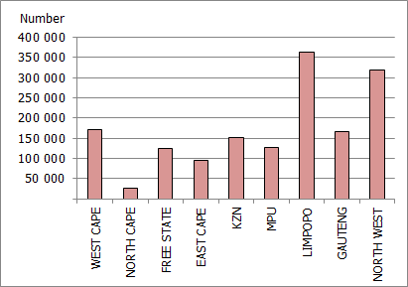

It would be appreciated if you could fill the enclosed livestock questionnaire for all the incomplete months up to August 2016 and send it back before 20 September 2016 in the envelope provided, or alternatively, fax it to 012-319 8035/1 or e-mail it to RonaB@daff.gov.za
The Directorate appreciates your continued support.
per pro. Director: Statistics and Economic Analysis

