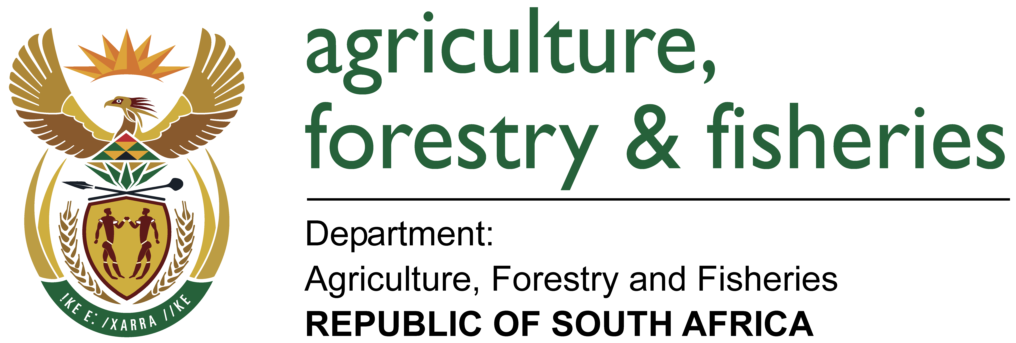
NUUSBRIEF: NASIONALE VEESTATISTIEK

Van: Rona Beukes
Direktoraat: Statistiek en Ekonomiese Analise
Tel: 012 319 8032 Faks: 012 319 8035/1 E-pos: RonaB@daff.gov.za
Verw: 26.1.2.3.1

Februarie 2016
Geagte medewerker
Hiermee word die geskatte veegetalle in die RSA vir November 2015 vrygestel.
Provinsie | Beeste |  | Skape |  | Varke |  | Bokke
Provinsie | Aug 15 | Nov 15 | Aug 15 | Nov 15 | Aug 15 | Nov 15 | Aug 15 | Nov 15
Provinsie | Duisende
Wes-Kaap | 558 | 569 | 2 800 | 2 816 | 169 | 170 | 214 | 217
Noord-Kaap | 502 | 507 | 5 956 | 6 015 | 27 | 28 | 508 | 506
Vrystaat | 2 279 | 2 312 | 4 727 | 4 794 | 122 | 120 | 234 | 230
Oos-Kaap | 3 321 | 3 369 | 6 967 | 7 114 | 93 | 93 | 2 221 | 2 244
KwaZulu-Natal | 2 684 | 2 732 | 747 | 738 | 150 | 152 | 806 | 814
Mpumalanga | 1 399 | 1 422 | 1 739 | 1 743 | 124 | 124 | 88 | 89
Limpopo | 1 016 | 1 018 | 254 | 251 | 358 | 360 | 1 081 | 1 074
Gauteng | 248 | 252 | 99 | 102 | 164 | 168 | 40 | 41
Noordwes | 1 688 | 1 702 | 649 | 637 | 316 | 322 | 680 | 670
Totaal | 13 695 | 13 883 | 23 938 | 24 210 | 1 523 | 1 537 | 5 872 | 5 885

Die bees-, skaap-, vark- en bokgetalle het onderskeidelik met 1,37%, 1,14%, 0,95% en 0,22% vanaf Augustus 2015 tot November 2015 toegeneem.

BEESTE:
Die meeste beeste word in die Oos-Kaap aangetref, naamlik 3,369 milj. (24%), gevolg deur KwaZulu-Natal met 2,732 milj. (20%) en die Vrystaat met 2,312 milj. (17%). Die oorblywende provinsies verteenwoordig gesamentlik 39% (5,470 milj.) van die totale getal beeste in Suid-Afrika.

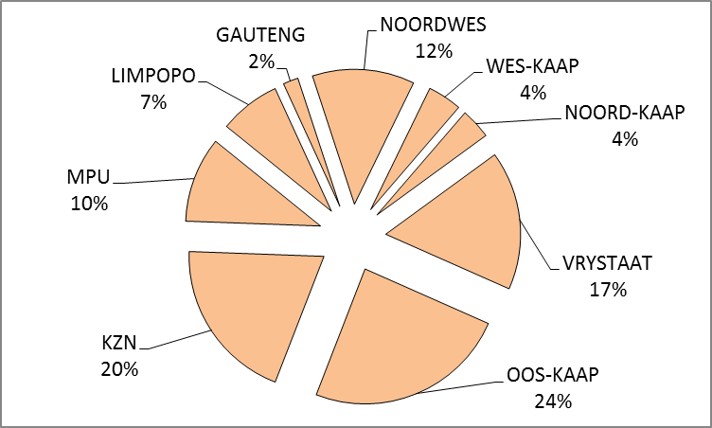
BOKKE:
Die grootste getal bokke, 2,244 milj. (38%) word in die Oos-Kaap aangetref, gevolg deur Limpopo met 1,074 milj. (18%) en KwaZulu-Natal met 814 500 (14%). Die oorblywende provinsies verteenwoordig gesamentlik 30% of 1,752 milj. van die totale getal bokke in Suid-Afrika.

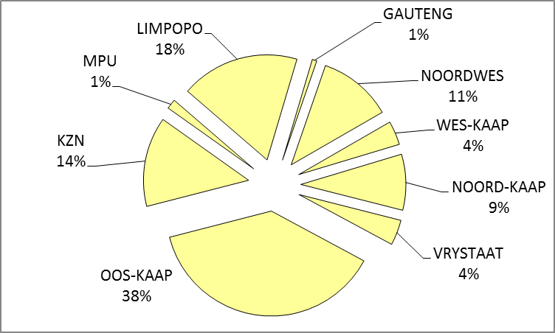
SKAPE:
Die Oos-Kaap het die meeste skape, naamlik 7,114 milj. (29%), gevolg deur die Noord-Kaap met 6,015 milj. (25%) en die Vrystaat met 4,794 milj. (20%). Die oorblywende provinsies verteenwoordig 26% (6,287milj.) van die totale getal skape in Suid-Afrika.

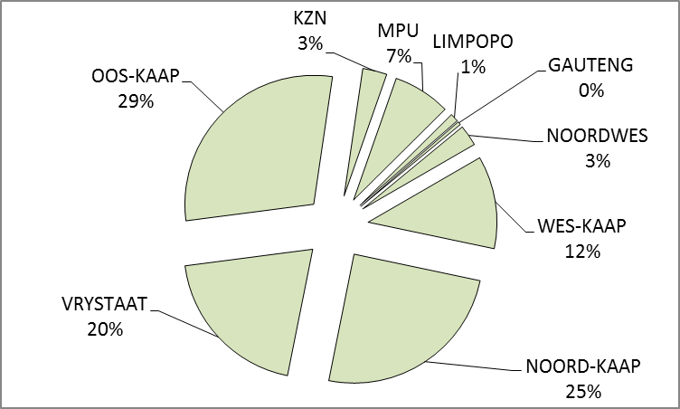

VARKE:
Limpopo het die grootste getal varke, naamlik 360 000 (23%). Noordwes en Wes-Kaap provinsies volg met onderskeidelik 322 000 (21%) en 169 700 (11%) varke. Die oorblywende provinsies verteenwoordig gesamentlik 45% of sowat 685 500 van die totale getal varke in Suid-Afrika.

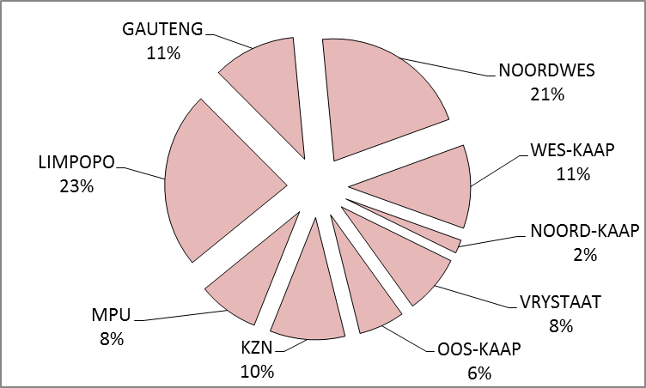

Dit sal waardeer word indien u die meegaande veeskattingsvraelys sal voltooi en dit voor 29 April 2016 in die ingeslote koevert sal terugstuur, όf alternatiewelik deur dit terug te faks na 012-319 8035/1 όf dit te e-pos na RonaB@daff.gov.za
Die Direktoraat wil u graag bedank vir u volgehoue samewerking.
per pro. Direkteur: Statistiek en Ekonomiese Analise

NEWSLETTER: NATIONAL LIVESTOCK STATISTICS

From: Rona Beukes
Directorate: Statistics and Economic Analysis
Tel: 012 319 8032 Fax: 012 319 8035/1 E-mail: RonaB@daff.gov.za
Ref: 26.1.2.3.1

February 2016
Dear Co-operator
The estimated livestock numbers in the RSA for November 2015 is hereby released.
Province | Cattle |  | Sheep |  | Pigs |  | Goats
Province | Aug 15 | Nov 15 | Aug 15 | Nov 15 | Aug 15 | Nov 15 | Aug 15 | Nov 15
Province | Thousands
Western Cape | 558 | 569 | 2 800 | 2 816 | 169 | 170 | 214 | 217
Northern Cape | 502 | 507 | 5 956 | 6 015 | 27 | 28 | 508 | 506
Free State | 2 279 | 2 312 | 4 727 | 4 794 | 122 | 120 | 234 | 230
Eastern Cape | 3 321 | 3 369 | 6 967 | 7 114 | 93 | 93 | 2 221 | 2 244
KwaZulu-Natal | 2 684 | 2 732 | 747 | 738 | 150 | 152 | 806 | 814
Mpumalanga | 1 399 | 1 422 | 1 739 | 1 743 | 124 | 124 | 88 | 89
Limpopo | 1 016 | 1 018 | 254 | 251 | 358 | 360 | 1 081 | 1 074
Gauteng | 248 | 252 | 99 | 102 | 164 | 168 | 40 | 41
North West | 1 688 | 1 702 | 649 | 637 | 316 | 322 | 680 | 670
Total | 13 695 | 13 883 | 23 938 | 24 210 | 1 523 | 1 537 | 5 872 | 5 885

Die numbers for cattle, sheep, pigs and goats increased by 1,37%, 1,14%, 0,95% and 0,22%, respectively, from August 2015 to November 2015.

CATTLE:
Most cattle are found in the Eastern Cape, namely 3,369 million (24%), followed by KwaZulu-Natal with 2,732 million (20%) and then the Free State with 2,312 million (17%). The remaining provinces represent 39% (5,470 million) of the total number of cattle in South Africa.

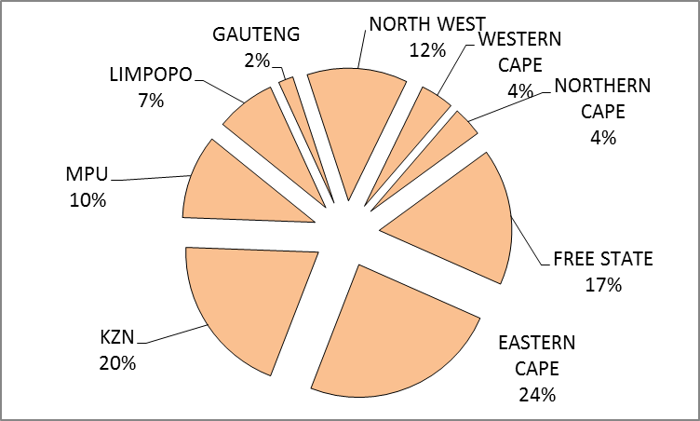
GOATS:
The largest number of goats, 2,244 million (38%) are found in the Eastern Cape. Limpopo Province follows with 1,074 million (18%) and then KwaZulu-Natal with 814 500 (14%). The remaining provinces represent 30% or 1,752 million of the total number of goats in South Africa.

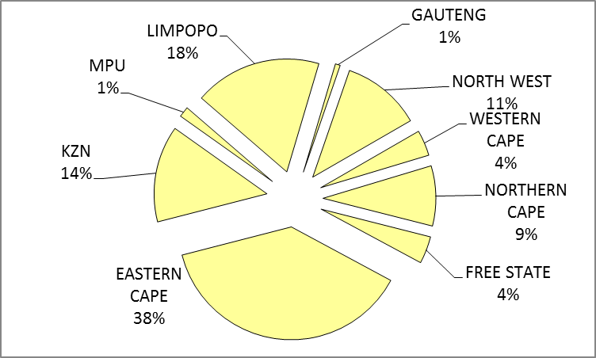
SHEEP:
The Eastern Cape has the most sheep, namely 7,114 million (29%), followed by the Northern Cape with 6,015 million (25%) and then the Free State with 4,794 million (20%). The remaining provinces represent 26% (6,287 million) of the total number of sheep in South Africa.

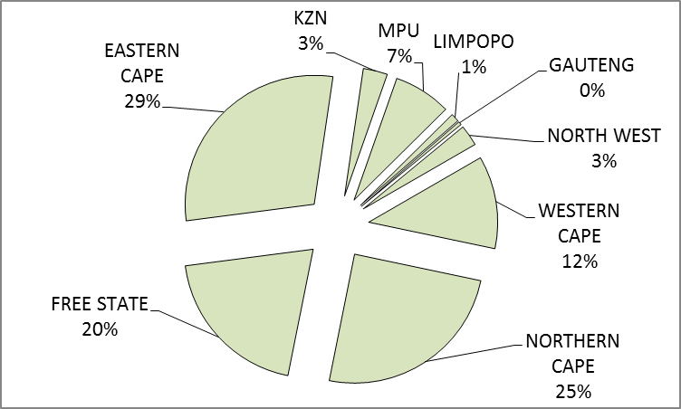
PIGS:
Limpopo has the largest number of pigs, namely 360 000 (23%). North West and Western Cape provinces follow with respectively 322 000 (21%) and 169 700 (11%) pigs. The remaining provinces represent 45% or about 685 500 of the total pig population in South Africa.

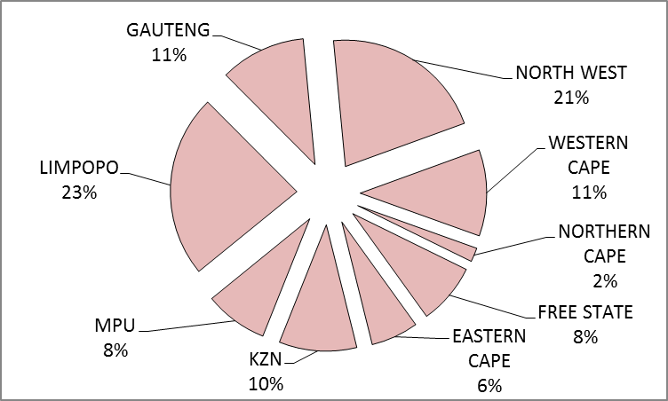

It would be appreciated if you could complete the enclosed livestock questionnaire and send it back before 29 April 2016 in the envelope provided, or alternatively, fax it to 012-319 8035/1 or e-mail it to RonaB@daff.gov.za
The Directorate appreciates your continued support.
per pro. Director: Statistics and Economic Analysis

