

**Nuusbrief: Nasionale Veestatistiek**

**Van**: Baldwin Netshifhefhe **Direktoraat**: Statistiek en Ekonomiese Analise

**Tel**: 012 319 8043 **Faks**: 012 319 8035/1 **E-pos**: [BaldwinN@dalrrd.gov.za / SelebogoL@dalrrd.gov.za](mailto:BaldwinN@dalrrd.gov.za%20/%20SelebogoL@dalrrd.gov.za)

Geagte medewerker AUGUSTUS 2023

**Geskatte Veegetalle in die RSA (Augustus 2022 en Mei 2023)**

|  |  |  |  |  |  |  |  |  |
| --- | --- | --- | --- | --- | --- | --- | --- | --- |
| **Provinsie** | **Beeste** | | **Skape** | | **Varke** | | **Bokke** | |
| **Aug-22** | **Mei-23** | **Aug-22** | **Mei-23** | **Aug-22** | **Mei-23** | **Aug-22** | **Mei-23** |
| **Duisende** | | | | | | | |
| **Wes-Kaap** | 468 | 468 | 2 538 | 2 532 | 142 | 142 | 201 | 204 |
| **Noord-Kaap** | 419 | 417 | 5 149 | 5 177 | 15 | 15 | 445 | 442 |
| **Vrystaat** | 2 062 | 2 041 | 4 314 | 4 262 | 95 | 101 | 212 | 212 |
| **Oos-Kaap** | 3 045 | 3 061 | 6 434 | 6 417 | 77 | 77 | 1 990 | 1 990 |
| **KwaZulu-Natal** | 2 311 | 2 315 | 615 | 615 | 143 | 143 | 656 | 656 |
| **Mpumalanga** | 1 230 | 1 230 | 1 513 | 1 520 | 101 | 97 | 74 | 74 |
| **Limpopo** | 838 | 838 | 192 | 223 | 322 | 322 | 896 | 877 |
| **Gauteng** | 245 | 245 | 84 | 84 | 154 | 153 | 18 | 18 |
| **Noordwes** | 1 580 | 1 581 | 593 | 593 | 273 | 273 | 648 | 648 |
| **Totaal** | **12 197** | **12 196** | **21 432** | **21 423** | **1 323** | **1 323** | **5 139** | **5 121** |

Die getalle vir beeste, skape en bokke het met ongeveer 0.01%, 0.04% en 0.35% onderskeidelik afgeneem, terwyl vir varke byna diselfde gebly het, tussen Augustus 2022 en Mei 2023.

**Mrt - Mei 23**

REEN:

Die gemiddelde reënval wat aangemeld is, was onder, tot normaal. Verskeie provinsies het oorstromings, hael en haelbuie en donderstorms aangemeld.

WEIDINGS/VELD:

Die toestand van veld was redelik tot goed. Veldbrande is in GP, ​​KZN en WC aangeteken.

VEE:

Gemiddeld was vee redelik. Sterftes wat aangemeld is, was as gevolg van weerlig in NW, hael in EC en knopvelsiekte in LIM. Afrika-perdesiekte en Afrika-varkpes is in GP aangemeld.

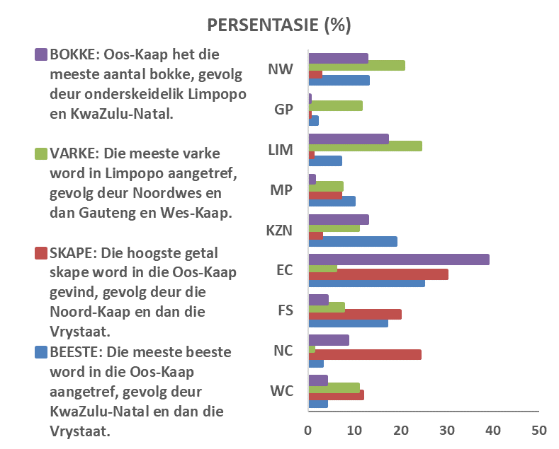

Die Departement waardeer die volgehoue ​​deelname en ondersteuning van dataverskaffers.

Maak asseblief seker dat die vraelys vir die volgende siklus voltooi is en gestuur word aan [**Livestock@dalrrd.gov.za**](mailto:Livestock@dalrrd.gov.za) of [**SelebogoL@dalrrd.gov.za**](mailto:SelebogoL@dalrrd.gov.za)voor **31 Oktober 2023**. Alternatiewelik, stuur dit deur die koevert soos voorsien.



**per pro. Direkteur: Statistiek en Ekonomiese Analise**



**Newsletter: National Livestock Statistics**

**From**: Baldwin Netshifhefhe **Directorate**: Statistics and Economic Analysis

**Tel**: 012 319 8043 **Fax**: 012 319 8035/1 **E-mail**: [BaldwinN@dalrrd.gov.za / SelebogoL@dalrrd.gov.za](mailto:BaldwinN@dalrrd.gov.za%20/%20SelebogoL@dalrrd.gov.za)

Dear Co-operator AUGUST 2023

**Estimated Livestock Numbers in the RSA (August 2022 and May 2023)**

|  |  |  |  |  |  |  |  |  |
| --- | --- | --- | --- | --- | --- | --- | --- | --- |
| **Province** | **Cattle** | | **Sheep** | | **Pigs** | | **Goats** | |
| **Aug-22** | **May-23** | **Aug-22** | **May-23** | **Aug-22** | **May-23** | **Aug-22** | **May-23** |
| **Thousands** | | | | | | | |
| **Western Cape** | 468 | 468 | 2 538 | 2 532 | 142 | 142 | 201 | 204 |
| **Northern Cape** | 419 | 417 | 5 149 | 5 177 | 15 | 15 | 445 | 442 |
| **Free State** | 2 062 | 2 041 | 4 314 | 4 262 | 95 | 101 | 212 | 212 |
| **Eastern Cape** | 3 045 | 3 061 | 6 434 | 6 417 | 77 | 77 | 1 990 | 1 990 |
| **KwaZulu-Natal** | 2 311 | 2 315 | 615 | 615 | 143 | 143 | 656 | 656 |
| **Mpumalanga** | 1 230 | 1 230 | 1 513 | 1 520 | 101 | 97 | 74 | 74 |
| **Limpopo** | 838 | 838 | 192 | 223 | 322 | 322 | 896 | 877 |
| **Gauteng** | 245 | 245 | 84 | 84 | 154 | 153 | 18 | 18 |
| **North-West** | 1 580 | 1 581 | 593 | 593 | 273 | 273 | 648 | 648 |
| **Total** | **12 197** | **12 196** | **21 432** | **21 423** | **1 323** | **1 323** | **5 139** | **5 121** |

The numbers for cattle, sheep and goats decreased by approximately 0.01%, 0.04% and 0.35% respectively, while for pigs stayed almost the same, between August 2022 and May 2023.

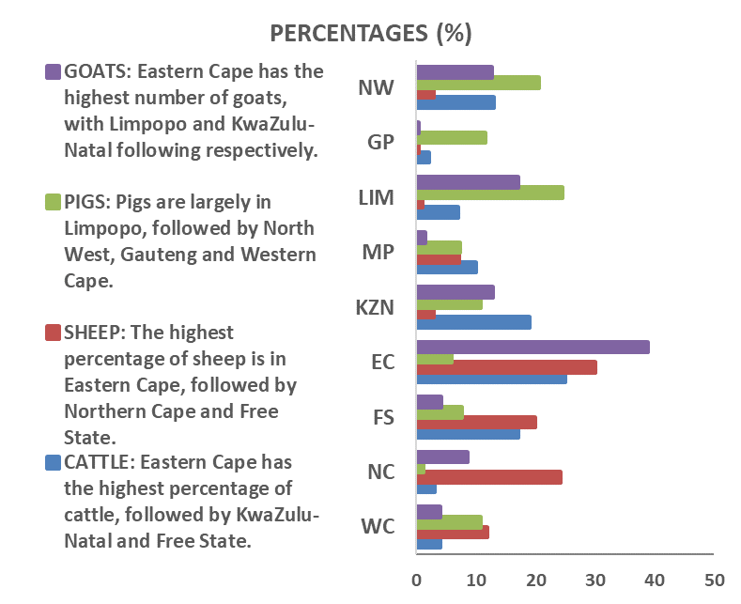

**Mar - May 23**

RAIN:

The average rainfall reported was below, to normal. Several provinces reported flooding, hail and hailstorms and thunderstorms.

PASTURES/VELD:

The condition of veld was reasonable to good. Veldfires were recorded in GP, KZN and WC.

LIVESTOCK:

On average, livestock was reasonable. Mortalities reported were due to lightning in NW, hail in EC and lumpy skin disease in LIM. African horse sickness and African Swine Fever reported in GP.

The Department appreciates the continued participation and support from data providers.

Please, ensure the questionnaire for the next cycle is completed and emailed to[**Livestock@daff.gov.za**](mailto:Livestock@daff.gov.za) **or** [**SelebogoL@dalrrd.gov.za**](mailto:SelebogoL@dalrrd.gov.za)before **31 October 2023. Alternatively,** send it through the post or any possible means.



***per pro.* Director: Statistics and Economic Analysis**