 | crop estimates committee
 | oesskattingskomitee
From/Van: Mr Baldwin Netshifhefhe  Tel: 012 319 8043/32  Fax/Faks: 012 319 8031  E-mail/E-pos: BaldwinN@dalrrd.gov.za  Web page/Webblad: www.dalrrd.gov.za/old website/statistics and economic reports or  www.sagis.org.za/CEC: Crop Estimates EMBARGO: 14:30 |  |  | 

The revised area planted estimate and first production forecast for summer crops for 2024 is hereby released.
Hiermee word die hersiene oppervlakte- en eerste produksieskatting vir somergewasse vir 2024 vrygestel.

SUMMER CROPS – REVISED AREA PLANTED AND FIRST PRODUCTION FORECAST: 2024
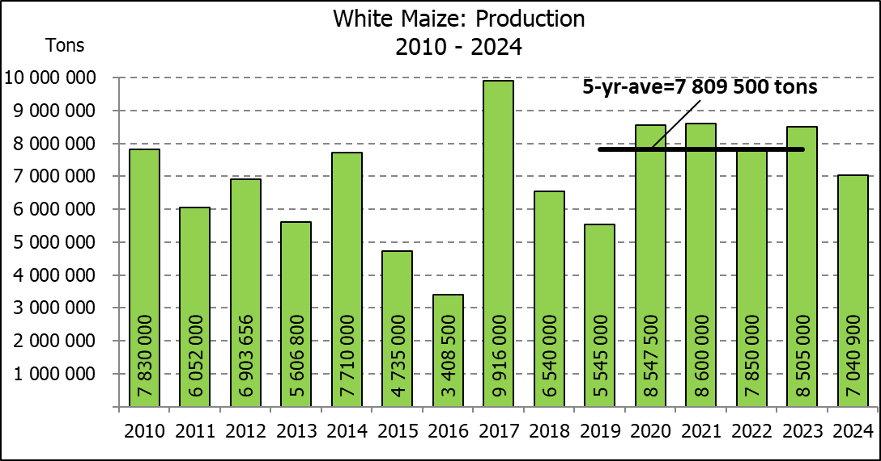
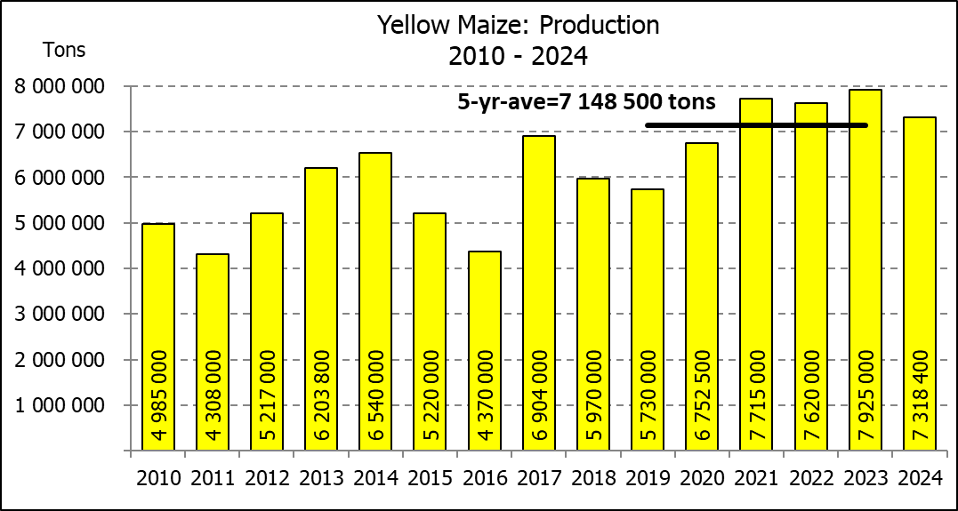
SOMERGEWASSE – HERSIENE OPPERVLAKTE- EN EERSTE PRODUKSIESKATTING: 2024
CROP/GEWAS | Area planted/  Opp beplant  2024 | 1stforecast/  1ste skatting  2024 | Area planted/  Opp beplant  2023 | Final crop/  Finale oes  2023 | Change/  Verandering/
CROP/GEWAS | Ha | Tons | Ha | Tons | %
CROP/GEWAS | (A) | (B) | (C) | (D) | (B) ÷ (D)
Commercial/Kommersieël:
White maize/Witmielies | 1 557 750 | 7 040 900 | 1 521 300 | 8 505 000 | -17,21
Yellow maize/Geelmielies | 1 081 500 | 7 318 400 | 1 064 800 | 7 925 000 | -7,65
Total Maize/Totale Mielies | 2 639 250 | 14 359 300 | 2 586 100 | 16 430 000 | -12,60
Sunflower seed/Sonneblomsaad | 559 500 | 671 100 | 555 700 | 720 000 | -6,79
Soybeans/Sojabone | 1 122 500 | 2 139 480 | 1 148 300 | 2 770 000 | -22,76
Groundnuts/Grondbone | 41 200 | 64 395 | 31 300 | 53 000 | +21,50
Sorghum | 42 100 | 110 780 | 34 000 | 94 360 | +17,40
Dry beans/Droëbone | 39 550 | 59 880 | 36 650 | 50 260 | +19,14
TOTAL/TOTAAL | 4 444 100 | 17 404 935 | 4 392 050 | 20 117 620 | -13,48
Note: Estimate is for calendar year, e.g. production season 2023/24 = 2024
Nota: Skatting is vir kalenderjaar, bv. produksie-seisoen 2023/24 = 2024
The Crop Estimates Committee comprises officials of the following institutions:
Department of Agriculture, Land Reform and Rural Development; Provincial Departments of Agriculture; various ARC-Institutes (Soil, Climate and Water; Small Grains Institute; and
Grain Crops Institute); BFAP and Statistics SA.

28 February / Februarie 2024
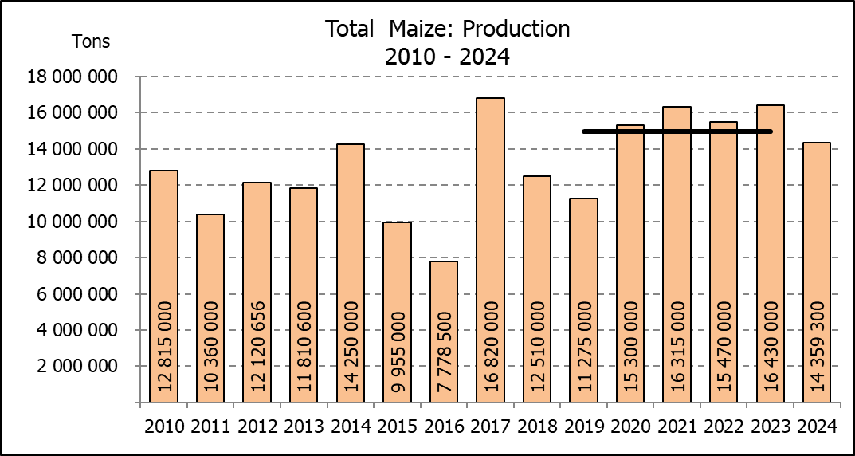

WHITE AND YELLOW MAIZE – REVISED AREA PLANTED AND FIRST PRODUCTION FORECAST: 2024
WIT- EN GEELMIELIES – HERSIENE OPPERVLAKTE EN EERSTE PRODUKSIESKATTING: 2024

Provinsie/  Province | Area planted/  Oppervlakte beplant  2024 |  |  | 1st forecast/  1ste skatting  2024 |  |  | Area planted/  Oppervlakte beplant  2023 |  |  | Final crop/  Finale oes  2023
Provinsie/  Province | White/  Wit  Ha | Yellow/  Geel  Ha | Total/  Totaal  Ha | White/  Wit  Tons | Yellow/  Geel  Tons | Total/  Totaal  Tons | White/  Wit  Ha | Yellow/  Geel  Ha | Total/  Totaal  Ha | White/  Wit  Tons | Yellow/  Geel  Tons | Total/  Totaal  Tons
Western Cape/Wes-Kaap | 250 | 3 500 | 3 750 | 2 300 | 32 200 | 34 500 | 250 | 3 500 | 3 750 | 2 375 | 33 000 | 35 375
Northern Cape/Noord-Kaap | 1 500 | 42 000 | 43 500 | 18 150 | 676 200 | 694 350 | 1 000 | 43 500 | 44 500 | 12 500 | 696 000 | 708 500
Free State/Vrystaat | 835 000 | 415 000 | 1 250 000 | 3 882 750 | 2 407 000 | 6 289 750 | 780 000 | 401 000 | 1 181 000 | 4 446 000 | 2 696 000 | 7 142 000
Eastern Cape/Oos-Kaap | 6 000 | 27 000 | 33 000 | 42 000 | 216 000 | 258 000 | 5 750 | 25 000 | 30 750 | 40 250 | 192 500 | 232 750
KwaZulu-Natal | 47 000 | 67 000 | 114 000 | 291 400 | 569 500 | 860 900 | 49 000 | 65 000 | 114 000 | 298 900 | 537 000 | 835 900
Mpumalanga | 160 000 | 360 000 | 520 000 | 976 000 | 2 448 000 | 3 424 000 | 156 500 | 352 000 | 508 500 | 1 032 900 | 2 596 000 | 3 628 900
Limpopo | 11 000 | 15 000 | 26 000 | 72 600 | 121 500 | 194 100 | 16 800 | 22 800 | 39 600 | 114 075 | 187 000 | 301 075
Gauteng | 57 000 | 62 000 | 119 000 | 347 700 | 434 000 | 781 700 | 56 000 | 52 000 | 108 000 | 364 000 | 392 500 | 756 500
North West/Noordwes | 440 000 | 90 000 | 530 000 | 1 408 000 | 414 000 | 1 822 000 | 456 000 | 100 000 | 556 000 | 2 194 000 | 595 000 | 2 789 000
Total/Totaal | 1 557 750 | 1 081 500 | 2 639 250 | 7 040 900 | 7 318 400 | 14 359 300 | 1 521 300 | 1 064 800 | 2 586 100 | 8 505 000 | 7 925 000 | 16 430 000

SUNFLOWER SEED – REVISED AREA PLANTED AND FIRST PRODUCTION FORECAST: 2024
SONNEBLOMSAAD – HERSIENE OPPERVLAKTE EN EERSTE PRODUKSIESKATTING: 2024

Province/  Provinsie | Area planted/  Opp beplant  Ha | 1st forecast/  1ste skatting  Tons | Area planted/  Opp beplant  Ha | Final crop/  Finale oes  Tons
Province/  Provinsie | 2024 | 2024 | 2023 | 2023
Western Cape/Wes-Kaap | - | - | - | -
Northern Cape/Noord-Kaap | 2 000 | 5 000 | 2 500 | 6 250
Free State/Vrystaat | 280 000 | 378 000 | 290 000 | 402 000
Eastern Cape/Oos-Kaap | 700 | 1 400 | 700 | 1 400
KwaZulu-Natal | 300 | 600 | 300 | 600
Mpumalanga | 3 500 | 5 250 | 5 000 | 7 140
Limpopo | 95 000 | 76 000 | 100 000 | 75 000
Gauteng | 3 000 | 3 600 | 2 200 | 2 860
North West/Noordwes | 175 000 | 201 250 | 155 000 | 224 750
Total/Totaal | 559 500 | 671 100 | 555 700 | 720 000
SOYBEANS – REVISED AREA PLANTED AND FIRST PRODUCTION FORECAST: 2024
SOJABONE – HERSIENE OPPERVLAKTE EN EERSTE PRODUKSIESKATTING: 2024
Province/  Provinsie | Area planted/  Opp beplant  Ha | 1st forecast/  1ste skatting  Tons | Area planted/  Opp beplant  Ha | Final crop/  Finale oes  Tons
Province/  Provinsie | 2024 | 2024 | 2023 | 2023
Western Cape/Wes-Kaap | - | - | - | -
Northern Cape/Noord-Kaap | 1 200 | 4 440 | 1 000 | 3 750
Free State/Vrystaat | 520 000 | 936 000 | 565 000 | 1 330 000
Eastern Cape/Oos-Kaap | 5 300 | 14 840 | 4 300 | 12 900
KwaZulu-Natal | 47 000 | 169 200 | 44 000 | 163 000
Mpumalanga | 320 000 | 624 000 | 305 000 | 671 000
Limpopo | 21 000 | 71 400 | 26 000 | 88 500
Gauteng | 56 000 | 84 000 | 48 000 | 105 600
North West/Noordwes | 152 000 | 235 600 | 155 000 | 395 250
Total/Totaal | 1 122 500 | 2 139 480 | 1 148 300 | 2 770 000

GROUNDNUTS – REVISED AREA PLANTED AND FIRST PRODUCTION FORECAST: 2024
GRONDBONE – HERSIENE OPPERVLAKTE EN EERSTE PRODUKSIESKATTING: 2024

Province/  Provinsie | Area planted/  Opp beplant  Ha | 1st forecast/  1ste skatting  Tons | Area planted/  Opp beplant  Ha | Final crop/  Finale oes  Tons
Province/  Provinsie | 2024 | 2024 | 2023 | 2023
Western Cape/Wes-Kaap | - | - | - | -
Northern Cape/Noord-Kaap | 4 200 | 12 600 | 2 000 | 5 300
Free State/Vrystaat | 17 000 | 26 350 | 12 300 | 21 000
Eastern Cape/Oos-Kaap | - | - | - | -
KwaZulu-Natal | 300 | 750 | - | -
Mpumalanga | - | - | - | -
Limpopo | 1 700 | 3 995 | 2 000 | 4 700
Gauteng | - | - | - | -
North West/Noordwes | 18 000 | 20 700 | 15 000 | 22 000
Total/Totaal | 41 200 | 64 395 | 31 300 | 53 000

SORGHUM – REVISED AREA PLANTED AND FIRST PRODUCTION FORECAST: 2024
SORGHUM – HERSIENE OPPERVLAKTE EN EERSTE PRODUKSIESKATTING: 2024

Province/  Provinsie | Area planted/  Opp beplant  Ha | 1st forecast/  1ste skatting  Tons | Area planted/  Opp beplant  Ha | Final crop/  Finale oes  Tons
Province/  Provinsie | 2024 | 2024 | 2023 | 2023
Western Cape/Wes-Kaap | - | - | - | -
Northern Cape/Noord-Kaap | - | - | - | -
Free State/Vrystaat | 11 500 | 25 875 | 5 200 | 14 820
Eastern Cape/Oos-Kaap | 100 | 400 | - | -
KwaZulu-Natal | 100 | 400 | 100 | 400
Mpumalanga | 8 300 | 36 105 | 8 500 | 35 275
Limpopo | 18 000 | 39 600 | 15 500 | 33 325
Gauteng | 100 | 400 | 100 | 420
North West/Noordwes | 4 000 | 8 000 | 4 600 | 10 120
Total/Totaal | 42 100 | 110 780 | 34 000 | 94 360

DRY BEANS – REVISED AREA PLANTED AND FIRST PRODUCTION FORECAST: 2024
DROëBONE – HERSIENE OPPERVLAKTE EN EERSTE PRODUKSIESKATTING: 2024

Province/  Provinsie | Area planted/  Opp beplant  Ha | 1st forecast/  1ste skatting  Tons | Area planted/  Opp beplant  Ha | Final crop/  Finale oes  Tons
Province/  Provinsie | 2024 | 2024 | 2023 | 2023
Western Cape/Wes-Kaap | 100 | 200 | 100 | 180
Northern Cape/Noord-Kaap | 500 | 1 100 | 450 | 990
Free State/Vrystaat | 13 500 | 16 200 | 14 000 | 13 300
Eastern Cape/Oos-Kaap | 200 | 400 | 200 | 360
KwaZulu-Natal | 2 100 | 2 520 | 2 100 | 3 150
Mpumalanga | 2 600 | 4 290 | 5 000 | 7 000
Limpopo | 12 200 | 24 400 | 8 000 | 16 000
Gauteng | 850 | 1 020 | 800 | 880
North West/Noordwes | 7 500 | 9 750 | 6 000 | 8 400
Total/Totaal | 39 550 | 59 880 | 36 650 | 50 260

CONFIDENTIALITY ISSUES that CEC members are committed to adhere to on the day of the meeting
- Personal items such as laptops, handbags, cell phones, etc. are not allowed in the venue during the meeting
- No member is allowed to leave the meeting before 12:00 in order to prevent disclosure of the information
- The embargo time for the release of crop estimates information is 14:30
- No member is allowed to discuss crop estimates information with anyone other than a member of the Committee before the embargo time
- Only the Chairperson, or a member appointed by the Chairperson, may release the figures to the media
- Members must regard the detail of any information that was collected for and/or discussed during the meeting, as confidential
- Individual information received for crop estimate purposes is treated strictly confidential, and is not divulged for any other purposes

REVISED AREA ESTIMATE AND FIRST PRODUCTION FORECAST OF SUMMER CROPS (2024 PRODUCTION SEASON)/
HERSIENE OPPERVLAKTE- EN EERSTE PRODUKSIESKATTING VIR SOMERGEWASSE (2024 PRODUKSIE-SEISOEN)
28 FEBRUARY / FEBRUARIE 2024

Summer field crops – 2024  Commercial maize: The revised area estimate for maize is 2 639 250 ha, which is 2,06% or 53 150 ha more than the 2 586 100 ha planted for the previous season, and 0,06% or 1 500 ha more than the preliminary area estimate of 2 637 750 ha released in January 2024.  The expected commercial maize crop is 14 359 300 tons, which is 12,60% or 2,071 mill. tons less than the 16 430 000 tons of the previous season (2023). The yield for maize is 5,44 t/ha.  The area planted figures are mainly based on information obtained from the Producer Independent Crop Estimation System (PICES), conducted by the National Crop Statistics Consortium (NCSC) for Free State, KwaZulu-Natal, Mpumalanga, Limpopo, Gauteng and North West provinces.  Please note that information from the objective yield survey by the NCSC for the Mpumalanga province will be available in April 2024; and for the Free State and North West provinces in May 2024. The current yield figures are mainly obtained from producers in the different provinces.  The area estimate for white maize is 1 557 750 ha, which represents an increase of 2,40% or 36 450 ha compared to the 1 521 300 ha planted last season. The production forecast of white maize is 7 040 900 tons, which is 17,21% or 1,464 mill. tons less than the 8 505 000 tons of last season. The yield for white maize is 4,52 t/ha.  In the case of yellow maize, the area estimate is 1 081 500 ha, which is 1,57% or 16 700 ha more than the 1 064 800 ha planted last season. The yellow maize production forecast is 7 318 400 tons, which is 7,65% or 606 600 tons less than the 7 925 000 tons of last season. The yield for yellow maize is 6,77 t/ha.  Other summer crops:  Sunflower seed: The revised area estimate for sunflower seed is 559 500 ha, which is 0,68% or 3 800 ha more than the 555 700 ha planted the previous season. The production forecast for sunflower seed is 671 100 tons, which is 6,79% or 48 900 tons less than the 720 000 tons of the previous season. The expected yield is 1,20 t/ha.  Other crops: It is estimated that 1 122 500 ha have been planted to soybeans, which represents a decrease of 2,25% or 25 800 ha compared to the 1 148 300 ha planted last season. The production forecast is 2 139 480 tons, which is 22,76% or 630 520 tons less than the 2 770 000 tons of the previous season. The expected yield is 1,91 t/ha.  For groundnuts, the area estimate is 41 200 ha, which is 31,63% or 9 900 ha more than the 31 300 ha planted for the previous season. The expected crop is 64 395 tons – which is 21,50% or 11 395 tons more than the 53 000 tons of last season. The expected yield is 1,56 t/ha.  The area estimate for sorghum increased by 23,82% or 8 100 ha, from 34 000 ha to 42 100 ha against the previous season. The production forecast for sorghum is 110 780 tons, which is 17,40% or 16 420 tons more than the 94 360 tons of the previous season. The expected yield is 2,63 t/ha.  For dry beans, the area estimate is 39 550 ha, which is 7,91% or 2 900 ha more the 36 650 ha planted for the previous season. The production forecast is 59 880 tons, which is 19,14% or 9 620 tons more than the 50 260 tons of the previous season. The expected yield is 1,51 t/ha.  Please note that the second production forecast for summer field crops for 2024 will be released on 26 March 2024. |  | Somergewasse – 2024  Kommersiële mielies: Die hersiene skatting van die oppervlakte onder mielies beloop 2 639 250 ha, wat 2,06% of 53 150 ha meer is as die 2 586 100 ha wat verlede seisoen aangeplant is, en 0,06% of 1 500 ha meer as die voorlopige oppervlakteskatting van 2 637 750 ha soos vrygestel in Januarie 2024.  Die verwagte kommersiële mielie-oes is 14 359 300 ton, wat 12,60% of 2,071 milj. ton minder is as die 16 430 000 ton van die vorige seisoen (2023). Die opbrengs van mielies is 5,44 t/ha.  Die oppervlakte beplant syfers is hoofsaaklik verkry vanaf die Produsente Onafhanklike Oesskattingstelsel (PICES), soos deur die Nasionale Oesskattingskonsortium gerapporteer vir Vrystaat, KwaZulu-Natal, Mpumalanga, Limpopo, Gauteng en Noordwes provinsies.  Neem kennis dat inligting van die objektiewe opbrengs-opname van die Konsortium vir die Mpumalanga provinsie, in April 2024 gerapporteer word en vir die Vrystaat en Noordwes provinsies in Mei 2024. Die huidige opbrengs syfers is hoofsaaklik verkry vanaf produsente in die verskillende provinsies.  Die oppervlak onder witmielies is 1 557 750 ha, wat ‘n toename van 2,40% of 36 450 ha verteenwoordig vergeleke met die 1 521 300 ha die vorige seisoen. Die produksieskatting van witmielies is 7 040 900 ton, wat 17,21% of 1,464 milj. ton minder is as die 8 505 000 ton van die vorige seisoen. Die opbrengs van witmielies is 4,52 t/ha.  In die geval van geelmielies is die oppervlakteskatting 1 081 500 ha, wat 1,57% of 16 700 ha meer is as die 1 064 800 ha geplant die vorige seisoen. Die produksieskatting van geelmielies is 7 318 400 ton, wat 7,65% of 606 600 ton minder is as die 7 925 000 ton van die vorige seisoen. Die opbrengs van geelmielies is 6,77 t/ha.  Ander somergewasse:  Sonneblomsaad: Die hersiene oppervlakteskatting vir sonneblomsaad is 559 500 ha, wat 0,68% of 3 800 ha meer is as die 555 700 ha aangeplant die vorige seisoen. Die produksieskatting vir sonneblomsaad is 671 100 ton, wat 6,79% of 48 900 ton minder is as die 720 000 ton van die vorige seisoen. Die verwagte opbrengs is 1,20 t/ha.  Ander gewasse: Die geskatte oppervlakte beplant met sojabone is 1 122 500 ha, wat ’n afname van 2,25% of 25 800 ha verteenwoordig vergeleke met die 1 148 300 ha geplant die vorige seisoen. Die produksieskatting is 2 139 480 ton, wat 22,76% of 630 520 ton minder is as die 2 770 000 ton van die vorige seisoen. Die verwagte opbrengs is 1,91 t/ha.  Vir grondbone is die oppervlakteskatting 41 200 ha, wat 31,63% of 9 900 ha meer is as die 31 300 ha geplant vir die vorige seisoen. Die verwagte grondbone-oes is 64 395 ton – 21,50% of 11 395 ton meer as die 53 000 ton van die vorige seisoen. Die verwagte opbrengs is 1,56 t/ha.  Die oppervlakteskatting vir sorghum het toegeneem met 23,82% of 8 100 ha, van 34 000 ha tot 42 100 ha teenoor die vorige seisoen. Die produksieskatting van sorghum is 110 780 ton – 17,40% of 16 420 ton meer as die 94 360 ton van die vorige seisoen. Die verwagte opbrengs is 2,63 t/ha.  Vir droëbone is die geskatte oppervlakte beplant 39 550 ha, wat 7,91% of 2 900 ha meer is as die 36 650 ha geplant vir die vorige seisoen. Die produksieskatting is 59 880 ton, wat 19,14% of 9 620 ton meer is as die 50 260 ton van die vorige seisoen. Die verwagte opbrengs is 1,51 t/ha.  Neem asseblief kennis dat die tweede produksieskatting vir somergewasse vir 2024, op 26 Maart 2024 vrygestel sal word.
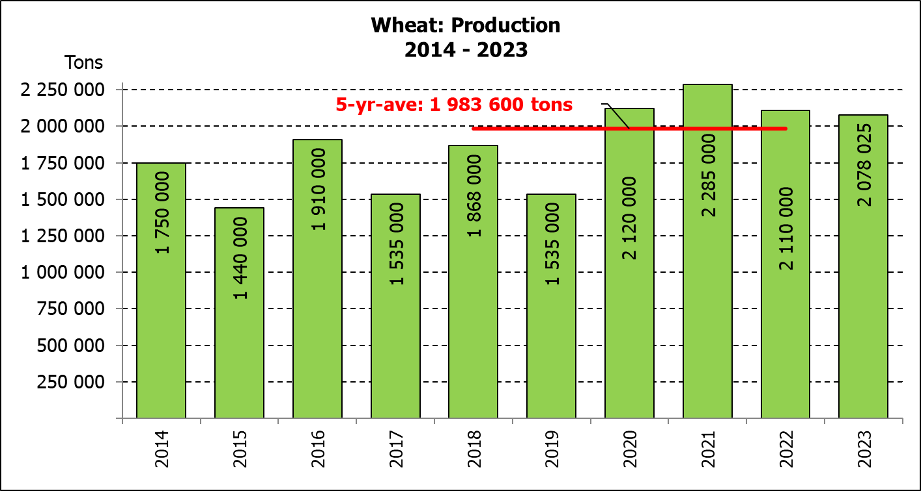
The area estimate and final production estimate for winter cereals for the 2023 is hereby released. /
Hiermee word die oppervlakte- en finale produksieskatting vir wintergewasse vir 2023 vrygestel.

WINTER CEREALS – AREA PLANTED AND FINAL PRODUCTION ESTIMATE: 2023 PRODUCTION SEASON
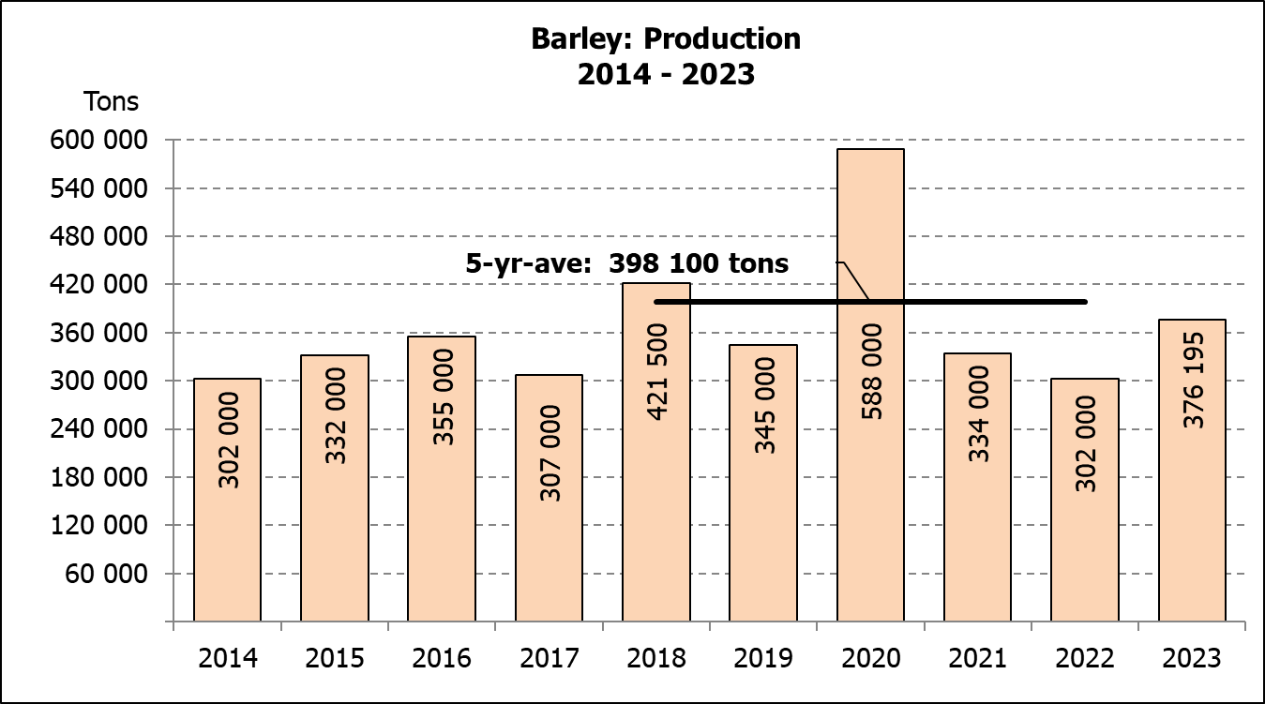
WINTERGEWASSE - OPPERVLAKTE- EN FINALE PRODUKSIESKATTING: 2023 PRODUKSIE-SEISOEN
CROP/GEWAS | Area planted/  Opp beplant  2023 | Final estimate/  Finale skatting  2023 | 6th forecast/  6de skatting  2023 | Area planted/  Opp beplant  2022 | Final crop/  Finale oes  2022 | Change/  Verandering
CROP/GEWAS | Ha | Tons | Tons | Ha | Tons | %
CROP/GEWAS | (A) | (B) | (C) | (D) | (E) | (B) ÷ (C)
Commercial/Kommersieel:
Wheat/Koring | 537 950 | 2 078 025 | 2 089 225 | 566 800 | 2 110 000 | -0,54
Malting barley/Moutgars | 107 600 | 376 195 | 376 195 | 101 000 | 302 000 | -
Canola/Kanola | 131 200 | 237 450 | 237 450 | 123 510 | 210 000 | -
Cereal oats/Hawermout | 27 500 | 40 250 | 40 250 | 27 000 | 27 550 | -
Sweet lupines/Soetlupine | 16 000 | 16 000 | 16 000 | 21 000 | 15 750 | -
* Note: Estimate is for calendar year, e.g. production season 2023/24 = 2023
* Nota: Skatting is vir kalenderjaar, bv. produksie-seisoen 2023/24 = 2023

WHEAT – AREA PLANTED AND FINAL PRODUCTION ESTIMATE: 2023
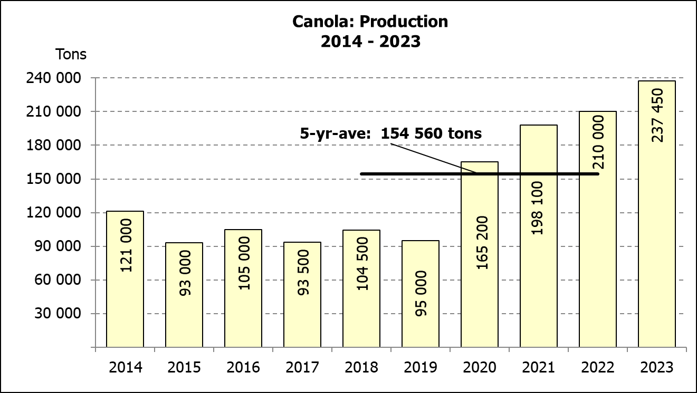
KORING – OPPERVLAKTE- EN FINALE PRODUKSIESKATTING: 2023
Province/  Provinsie | Area planted/  Opp beplant  Ha | Final estimate/  Finale skatting  Tons | Area planted/  Opp beplant  Ha | Final crop/  Finale oes  Tons
Province/  Provinsie | 2023 | 2023 | 2022 | 2022
Western Cape/Wes-Kaap | 365 000 | 1 095 000 | 360 000 | 918 000
Northern Cape/Noord-Kaap | 40 000 | 296 000 | 47 000 | 338 500
Free State/Vrystaat | 72 000 | 288 000 | 96 000 | 436 800
Eastern Cape/Oos-Kaap | 6 300 | 40 950 | 6 000 | 40 200
KwaZulu-Natal | 8 500 | 56 950 | 9 200 | 60 730
Mpumalanga | 4 200 | 28 560 | 4 000 | 27 600
Limpopo | 30 000 | 198 000 | 29 000 | 187 000
Gauteng | 950 | 6 365 | 1 100 | 7 370
North West/Noordwes | 11 000 | 68 200 | 14 500 | 93 800
Total/Totaal | 537 950 | 2 078 025 | 566 800 | 2 110 000

AREA ESTIMATE AND FINAL PRODUCTION ESTIMATE OF WINTER CROPS (2023) /
OPPERVLAKTE- EN FINALE PRODUKSIESKATTING VAN WINTERGEWASSE (2023)
28 FEBRUARY/FEBRUARIE 2024
Winter cereal crops - 2023 production season  Wheat: The production forecast for wheat is 2,078 mill. tons, which is 0,54% or 11 200 tons less than the previous forecast of 2,089 mill. tons. The area planted is estimated at 537 950 ha, while the expected yield is  3,86 t/ha.  The expected production in the Western Cape is 1,095 mill. tons (53%), in the Northern Cape 296 000 tons (14%) and in the Free State 288 000 tons (14%).  The estimated area estimate for wheat in the Western Cape is 365 000 ha or 68%, 72 000 ha or 13% in the Free State and 40 000 ha or 7% in the Northern Cape.  Other crops: The production forecast for barley remained unchanged at 376 195 tons. The area planted is estimated at 107 600 ha, while the expected yield is 3,50 t/ha.  The expected canola crop remained unchanged at 237 450 tons. The area estimate for canola is 131 200 ha, with an expected yield  of 1,81 t/ha.  The expected crop for oats for the 2023 season is 40 250 tons and the area planted is 27 500 ha. The expected yield is 1,46 t/ha.  In the case of sweet lupines, the production forecast remained unchanged at 16 000 tons. The area estimate of sweet lupines is 16 000 ha, with an expected yield of 1,00 t/ha.  Please note that the intentions to plant winter cereals for 2024 will be released on 25 April 2024. |  | Wintergewasse - 2023 produksie-seisoen  Koring: Die produksieskatting vir koring is 2,078 milj. ton, wat 0,54% of 11 200 ton minder is as die vorige skatting van 2,089 milj. ton. Die oppervlakte beplant word beraam op 537 950 ha, terwyl die verwagte opbrengs 3,86 t/ha beloop.  Die vewagte produksie in die Wes-Kaap is 1,095 milj. ton (53%), in die Noord-Kaap 296 000 ton (14%) en in die Vrystaat 288 000 ton (14%).  Die geraamde oppervlakteskatting vir koring in die Wes-Kaap is 365 000 ha of 68%, 72 000 ha of 13% in die Vrystaat en 40 000 ha of 7% in  die Noord-Kaap.  Ander gewasse: Die produksieskatting vir gars is onveranderd gelaat op 376 195 ton. Die oppervlakte beplant word beraam op 107 600 ha, terwyl die verwagte opbrengs 3,50 t/ha beloop.  Die verwagte kanola-oes is onveranderd gelaat op 237 450 ton. Die oppervlakteskatting vir kanola is 131 200 ha, met ŉ verwagte opbrengs van 1,81 t/ha.  Die verwagte oes vir hawer vir die 2023-seisoen is 40 250 ton en die oppervlakteskatting is 27 500 ha. Die verwagte opbrengs is 1,46 t/ha.  In die geval van soetlupine is die produksieskatting is onveranderd gelaat op 16 000 ton. Die oppervlakte beplant met soetlupine is 16 000 ha, met ‘n verwagte opbrengs van 1,00 t/ha.  Neem asseblief kennis dat die voornemens om wintergewasse te plant vir 2024 op 25 April 2024 vrygestel sal word.
Information is available on the internet at http://www.daff.gov.za/links/crop estimates or http://www.sagis.org.za, as from 14:30 on the date of the relevant meeting of the Crop Estimates Committee. |  | Inligting is beskikbaar op die internet by http://www.daff.gov.za/links/crop estimates of by http://www.sagis.org.za, vanaf 14:30 op die dag van die toepaslike vergadering van die Oesskattingskomitee.
CONFIDENTIALITY ISSUES that CEC members are committed to adhere to on the day of the meeting
- Personal items such as laptops, handbags, cell phones, etc. are not allowed in the venue during the meeting.
- No member is allowed to leave the meeting before 12:00 in order to prevent disclosure of the information. The embargo time for the release of crop estimates information is 14:30.
- No member is allowed to discuss crop estimates information with anyone other than a member of the Committee before the embargo time. Only the Chairperson, or a member appointed by the Chairperson, may release the figures to the media.
- Members must regard the detail of any information that was collected for and/or discussed during the meeting, as confidential. Individual information received for crop estimate purposes is treated strictly confidential, and is not divulged for any other purposes.

