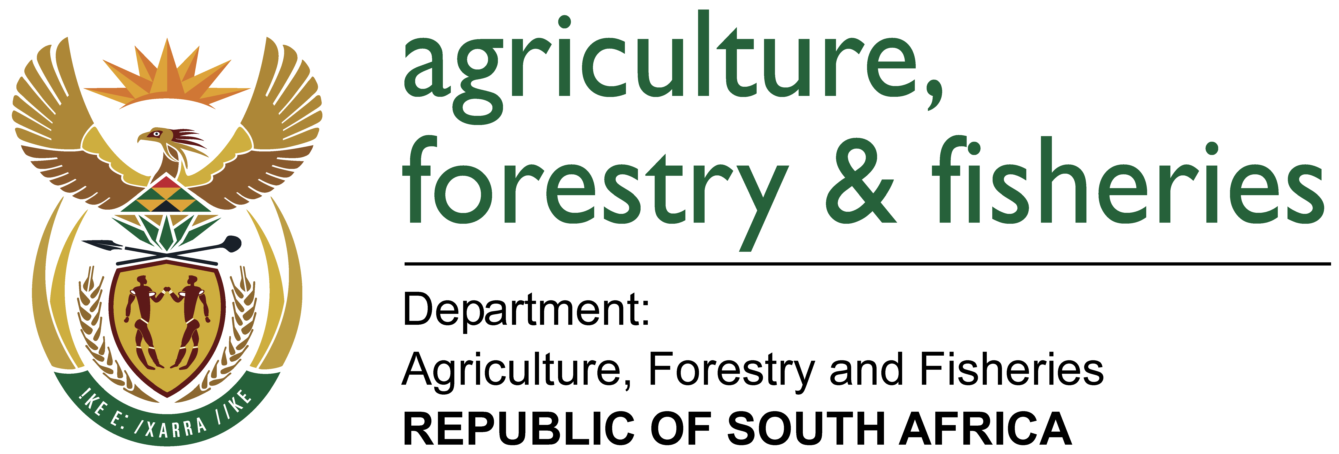

Nuusbrief: Nasionale Veestatistiek

Van: Baldwin Netshifhefhe
Direktoraat: Statistiek en Ekonomiese Analise
Tel: 012 319 8043 Faks: 012 319 8035/1 E-pos: BaldwinN@daff.gov.za / SelebogoL@daff.gov.za

Geagte medewerker MEI 2017

Geskatte Veegetalle in die RSA (Augustus 2016 en Februarie 2017)

Provinsie | Beeste |  | Skape |  |  |  | Varke |  | Bokke
Provinsie | Aug-16 | Feb-17 | Aug-16 |  | Feb-17 |  | Aug-16 | Feb-17 | Aug-16 | Feb-17
Provinsie | Duisende
Wes-Kaap | 552 | 528 |  | 2 757 | 2 709 | 168 |  | 164 | 213 | 210
Noord-Kaap | 492 | 501 |  | 5 768 | 5 716 | 25 |  | 24 | 495 | 489
Vrystaat | 2 232 | 2 220 |  | 4 517 | 4 536 | 121 |  | 119 | 232 | 230
Oos-Kaap | 3 268 | 3 222 |  | 6 866 | 6 815 | 91 |  | 89 | 2 184 | 2 122
KwaZulu-Natal | 2 633 | 2 518 |  | 727 | 721 | 149 |  | 150 | 728 | 705
Mpumalanga | 1 373 | 1 313 |  | 1 692 | 1 675 | 122 |  | 118 | 64 | 66
Limpopo | 987 | 980 |  | 235 | 227 | 361 |  | 356 | 997 | 984
Gauteng | 246 | 246 |  | 95 | 90 | 159 |  | 154 | 32 | 30
Noordwes | 1 616 | 1 618 |  | 630 | 619 | 316 |  | 316 | 673 | 680
Totaal | 13 399 | 13 146 |  | 23 287 | 23 108 | 1 512 |  | 1 490 | 5 618 | 5 516

Die bees-, skaap-, vark- en bokgetalle het onderskeidelik afgeneem met 1.89%, 0.77%, 1.46% en 1.82% vanaf Augustus 2016 tot Februarie 2017.
BEESTE:
Die Oos-Kaap Provinsie het 3,222 milj. beeste, terwyl 2,518 milj. in KwaZulu-Natal Provinsie en 2,220 milj. in die Vrystaat Provinsie aangetref word. Die oorblywende provinsies verteenwoordig gesamentlik sowat 5,186 milj. van die totale getal beeste in Suid-Afrika.
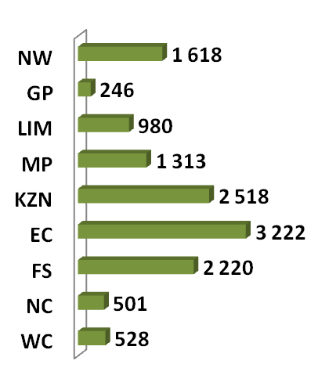
BOKKE:
Die grootste getal bokke, 2,122 milj. word in die Oos-Kaap Provinsie aangetref, die Limpopo Provinsie volg met 983 864 milj. en KwaZulu-Natal Provinsie met 705 169. Die oorblywende provinsies verteenwoordig gesamentlik sowat 1,704 milj. van die totale getal bokke in Suid-Afrika.
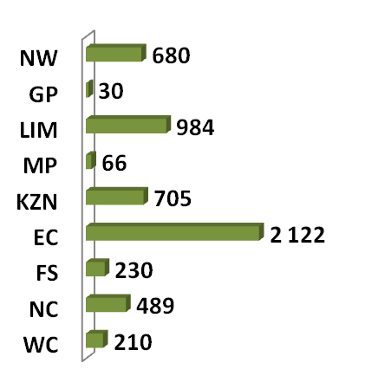
SKAPE:
Oos-Kaap Provinsie het die meeste skape met 6,815 milj., gevolg deur die Noord-Kaap Provinsie met 5,716 milj. en die Vrystaat Provinsie met 4,536 milj. Die oorblywende provinsies verteenwoordig sowat 6,041 milj. van die totale getal skape in Suid-Afrika.
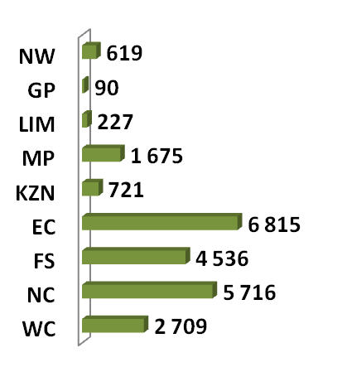
VARKE:
Die Limpopo Provinsie het die grootste getal varke, naamlik 356 122. Die Noordwes en Wes-Kaap Provinsies volg met onderskeidelik 315 792 en 164 384 varke. Die oorblywende provinsies verteenwoordig gesamentlik sowat 653 702 van die totale getal varke in Suid-Afrika.
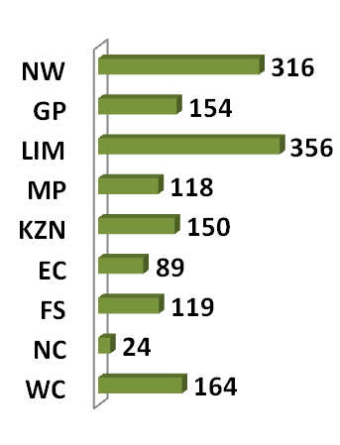

Dit sal waardeer word indien u die meegaande veeskattingsvraelys sal voltooi en dit voor 31 Julie 2017 in die ingeslote koevert sal terugstuur. Of e-pos na Livestock@daff.gov.za

Die Direktoraat wil u graag bedank vir u volgehoue samewerking

per pro. Direkteur: Statistiek en Ekonomiese Analise

Newsletter: National Livestock Statistics
From: Baldwin Netshifhefhe
Directorate: Statistics and Economic Analysis
Tel: 012 319 8043 Fax: 012 319 8035/1 E-mail: BaldwinN@daff.gov.za / SelebogoL@daff.gov.za

Dear Co-operator MAY 2017

Estimated Livestock Numbers in the RSA (August 2016 and February 2017)

Province | Cattle |  | Sheep |  |  |  | Pigs |  | Goats
Province | Aug-16 | Feb-17 | Aug-16 |  | Feb-17 |  | Aug-16 | Feb-17 | Aug-16 | Feb-17
Province | Thousands
Western Cape | 552 | 528 |  | 2 757 | 2 709 | 168 |  | 164 | 213 | 210
Northern Cape | 492 | 501 |  | 5 768 | 5 716 | 25 |  | 24 | 495 | 489
Free State | 2 232 | 2 220 |  | 4 517 | 4 536 | 121 |  | 119 | 232 | 230
Eastern Cape | 3 268 | 3 222 |  | 6 866 | 6 815 | 91 |  | 89 | 2 184 | 2 122
KwaZulu-Natal | 2 633 | 2 518 |  | 727 | 721 | 149 |  | 150 | 728 | 705
Mpumalanga | 1 373 | 1 313 |  | 1 692 | 1 675 | 122 |  | 118 | 64 | 66
Limpopo | 987 | 980 |  | 235 | 227 | 361 |  | 356 | 997 | 984
Gauteng | 246 | 246 |  | 95 | 90 | 159 |  | 154 | 32 | 30
North West | 1 616 | 1 618 |  | 630 | 619 | 316 |  | 316 | 673 | 680
Total | 13 399 | 13 146 |  | 23 287 | 23 108 | 1 512 |  | 1 490 | 5 618 | 5 516

The numbers for cattle, sheep, pigs and goats decreased by approximately 1.89%, 0.77%, 1.46% and 1.82% respectively, between August 2016 and February 2017.
GOATS:
Of the total Goat numbers 2,122 mill. are found in the Eastern Cape Province, Limpopo Province follows with 983 864 mill. and KwaZulu-Natal Province with 705 169. The remaining provinces share approximately 1,704 mill.
CATTLE:
Eastern Cape Province leads with 3,222 mill. Cattle, followed by 2,518 mill. in KwaZulu-Natal Province and 2,220 mill. in the Free State Province. The remaining provinces share 5,186 mill. of the total cattle population in South Africa.

SHEEP:
The provincial distribution of Sheep is as follows: 6,815 mill. in the Eastern Cape Province, 5,716 mill. in the Northern Cape Province and 4,536 mill. in the Free State Province. The remaining total, 6,041 mill. is shared amongst the other provinces in South Africa.
PIGS:
Most of the Pig population is in the Limpopo Province at 356 122, the North West and Western Cape Provinces follow with 315 792 and 164 384 pigs, respectively. The remaining provinces share approximately 653 702 of the total pig population in South Africa.

It would be appreciated if you could complete the enclosed livestock questionnaire and send it back before 31 July 2017, in the envelope provided. Alternatively, send to this email: Livestock@daff.gov.za
The Directorate appreciates your continued support.
per pro. Director: Statistics and Economic Analysis

