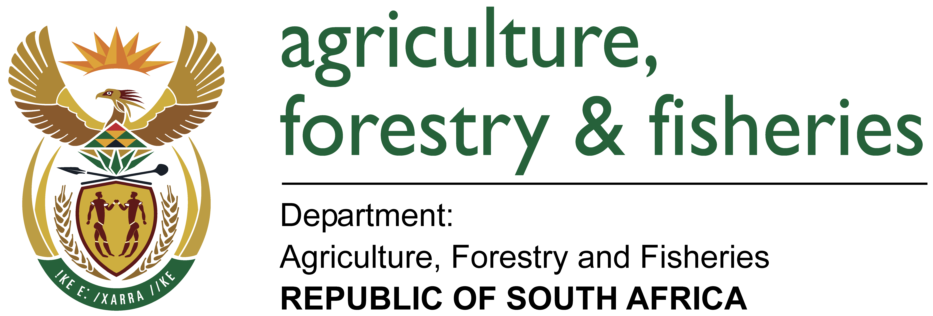

Nuusbrief: Nasionale Veestatistiek

Van: Baldwin Netshifhefhe
Direktoraat: Statistiek en Ekonomiese Analise
Tel: 012 319 8043 Faks: 012 319 8035/1 E-pos: BaldwinN@daff.gov.za / SelebogoL@daff.gov.za

Geagte medewerker NOVEMBER 2017

Geskatte Veegetalle in die RSA (Augustus 2016 en Augustus 2017)

Provinsie | Beeste |  | Skape |  |  |  | Varke |  | Bokke
Provinsie | Aug-16 | Aug-17 | Aug-16 |  | Aug-17 |  | Aug-16 | Aug-17 | Aug-16 | Aug-17
Provinsie | Duisende
Wes-Kaap | 552 | 518 |  | 2 757 | 2 695 | 168 |  | 167 | 213 | 209
Noord-Kaap | 492 | 479 |  | 5 768 | 5 582 | 25 |  | 23 | 495 | 482
Vrystaat | 2 232 | 2 179 |  | 4 517 | 4 521 | 121 |  | 116 | 232 | 223
Oos-Kaap | 3 268 | 3 149 |  | 6 866 | 6 622 | 91 |  | 89 | 2 184 | 2 097
KwaZulu-Natal | 2 633 | 2 496 |  | 727 | 692 | 149 |  | 147 | 728 | 712
Mpumalanga | 1 373 | 1 326 |  | 1 692 | 1 652 | 122 |  | 118 | 86 | 83
Limpopo | 987 | 981 |  | 235 | 225 | 361 |  | 353 | 997 | 971
Gauteng | 246 | 246 |  | 95 | 92 | 159 |  | 156 | 32 | 29
Noordwes | 1 616 | 1 580 |  | 630 | 608 | 316 |  | 311 | 673 | 669
Totaal | 13 399 | 12 954 |  | 23 287 | 22 689 | 1 512 |  | 1 480 | 5 640 | 5 475

Die bees-, skaap-, vark- en bokgetalle het onderskeidelik afgeneem met 3.32%, 2.57%, 2.12% en 2.93% vanaf Augustus 2016 tot Aug 2017.
BEESTE:
Die Oos-Kaap Provinsie het 3,149 milj. beeste, terwyl 2,496 milj. in KwaZulu-Natal Provinsie en 2,179 milj. in die Vrystaat Provinsie aangetref word. Die oorblywende provinsies verteenwoordig gesamentlik sowat 5,130 milj. van die totale getal beeste in Suid-Afrika.
BOKKE:
Die grootste getal bokke, 2,097 milj. word in die Oos-Kaap Provinsie aangetref, die Limpopo Provinsie volg met 971 388 milj. en KwaZulu-Natal Provinsie met 712 129. Die oorblywende provinsies verteenwoordig gesamentlik sowat 1,694 milj. van die totale getal bokke in Suid-Afrika.
SKAPE:
Oos-Kaap Provinsie het die meeste skape met 6,622 milj., gevolg deur die Noord-Kaap Provinsie met 5,582 milj. en die Vrystaat Provinsie met 4,521 milj. Die oorblywende provinsies verteenwoordig sowat 5,964 milj. van die totale getal skape in Suid-Afrika.
VARKE:
Die Limpopo Provinsie het die grootste getal varke, naamlik 352 762. Die Noordwes en Wes-Kaap Provinsies volg met onderskeidelik 310 657 en 166 914 varke. Die oorblywende provinsies verteenwoordig gesamentlik sowat 650 506 van die totale getal varke in Suid-Afrika.

Dit sal waardeer word indien u die meegaande veeskattingsvraelys sal voltooi en dit voor 31 Januarie 2018 in die ingeslote koevert sal terugstuur. Of e-pos na Livestock@daff.gov.za

Die Direktoraat wil u graag bedank vir u volgehoue samewerking

per pro. Direkteur: Statistiek en Ekonomiese Analise

Newsletter: National Livestock Statistics
From: Baldwin Netshifhefhe
Directorate: Statistics and Economic Analysis
Tel: 012 319 8043 Fax: 012 319 8035/1 E-mail: BaldwinN@daff.gov.za / SelebogoL@daff.gov.za

Dear Co-operator NOVEMBER 2017

Estimated Livestock Numbers in the RSA (August 2016 and August 2017)

Province | Cattle |  | Sheep |  |  |  | Pigs |  | Goats
Province | Aug-16 | Aug-17 | Aug-16 |  | Aug-17 |  | Aug-16 | Aug-17 | Aug-16 | Aug-17
Province | Thousands
Western Cape | 552 | 518 |  | 2 757 | 2 695 | 168 |  | 167 | 213 | 209
Northern Cape | 492 | 479 |  | 5 768 | 5 582 | 25 |  | 23 | 495 | 482
Free State | 2 232 | 2 179 |  | 4 517 | 4 521 | 121 |  | 116 | 232 | 223
Eastern Cape | 3 268 | 3 149 |  | 6 866 | 6 622 | 91 |  | 89 | 2 184 | 2 097
KwaZulu-Natal | 2 633 | 2 496 |  | 727 | 692 | 149 |  | 147 | 728 | 712
Mpumalanga | 1 373 | 1 326 |  | 1 692 | 1 652 | 122 |  | 118 | 86 | 83
Limpopo | 987 | 981 |  | 235 | 225 | 361 |  | 353 | 997 | 971
Gauteng | 246 | 246 |  | 95 | 92 | 159 |  | 156 | 32 | 29
North West | 1 616 | 1 580 |  | 630 | 608 | 316 |  | 311 | 673 | 669
Total | 13 399 | 12 954 |  | 23 287 | 22 689 | 1 512 |  | 1 480 | 5 640 | 5 475

The numbers for cattle, sheep, pigs and goats decreased by approximately 3.32%, 2.57%, 2.12% en 2.93% respectively, between August 2016 and August 2017.
GOATS:
Of the total Goat numbers 2,097 mill. are found in the Eastern Cape Province, Limpopo Province follows with 971 388 mill. and KwaZulu-Natal Province with 712 129. The remaining provinces share approximately 1,694 mill.
CATTLE:
Eastern Cape Province leads with 3,149 mill. Cattle, followed by 2,496 mill. in KwaZulu-Natal Province and 2,179 mill. in the Free State Province. The remaining provinces share 5,130 mill. of the total cattle population in South Africa.
SHEEP:
The provincial distribution of Sheep is as follows: 6,622 mill. in the Eastern Cape Province, 5,582 mill. in the Northern Cape Province and 4,521 mill. in the Free State Province. The remaining total, 5,964 mill. is shared amongst the other provinces in South Africa.

PIGS:
Most of the Pig population is in the Limpopo Province at 352 762, the North West and Western Cape Provinces follow with 310 657 and 166 914 pigs, respectively. The remaining provinces share approximately 650 506 of the total pig population in South Africa.

It would be appreciated if you could complete the enclosed livestock questionnaire and send it back before 31 January 2018, in the envelope provided. Alternatively, send to this email: Livestock@daff.gov.za
The Directorate appreciates your continued support.
per pro. Director: Statistics and Economic Analysis

