

Nuusbrief: Nasionale Veestatistiek

Van: Baldwin Netshifhefhe Direktoraat: Statistiek en Ekonomiese Analise
Tel: 012 319 8043 Faks: 012 319 8035/1 E-pos: BaldwinN@daff.gov.za / SelebogoL@daff.gov.za

Geagte medewerker NOVEMBER 2020

Geskatte Veegetalle in die RSA (Augustus 2019 en Augustus 2020)

Provinsie | Beeste |  | Skape |  |  |  | Varke |  | Bokke
Provinsie | Aug-19 | Aug-20 | Aug-19 |  | Aug-20 |  | Aug-19 | Aug-20 | Aug-19 | Aug-20
Provinsie | Duisende
Wes-Kaap | 488 | 466 |  | 2 623 | 2 545 | 152 |  | 144 | 207 | 202
Noord-Kaap | 433 | 419 |  | 5 305 | 5 182 | 19 |  | 17 | 469 | 448
Vrystaat | 2 109 | 2 054 |  | 4 518 | 4 330 | 111 |  | 109 | 217 | 215
Oos-Kaap | 3 082 | 3 050 |  | 6 531 | 6 513 | 84 |  | 81 | 2 005 | 1 991
KwaZulu-Natal | 2 481 | 2 380 |  | 656 | 628 | 144 |  | 143 | 680 | 662
Mpumalanga | 1 243 | 1 248 |  | 1 554 | 1 527 | 110 |  | 104 | 79 | 77
Limpopo | 898 | 860 |  | 204 | 199 | 330 |  | 329 | 902 | 902
Gauteng | 246 | 246 |  | 87 | 84 | 156 |  | 155 | 23 | 21
Noordwes | 1 578 | 1 576 |  | 607 | 596 | 283 |  | 275 | 668 | 651
Totaal | 12 558 | 12 299 |  | 22 085 | 21 604 | 1 389 |  | 1 357 | 5 250 | 5 169

Die bees-, skaap-, vark- en bokgetalle het onderskeidelik afgeneem met 2.06%, 2.18%, 2.30% en 1.54% vanaf Augustus 2019 tot Augustus 2020.

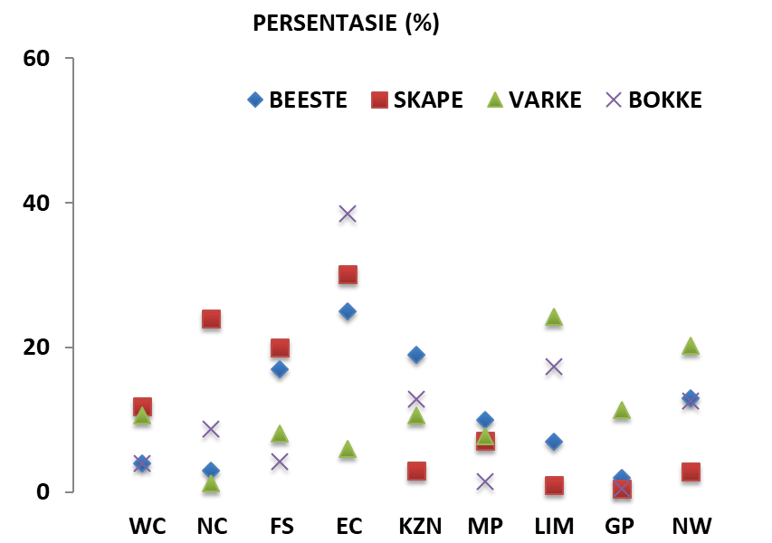
BEESTE: Die meeste beeste word in die Oos-Kaap aangetref, gevolg deur KwaZulu-Natal en dan die Vrystaat.

SKAPE: Die hoogste getal skape word in die Oos-Kaap gevind, gevolg deur die Noord-Kaap en dan die Vrystaat.

VARKE: Die meeste varke word in Limpopo aangetref, gevolg deur Noordwes en dan die Gauteng and Wes-Kaap.

BOKKE: Oos-Kaap het die meeste aantal bokke, gevolg deur onderskeidelik Limpopo en KwaZulu-Natal.

NOTAS (JUN 2020 – AUG 2020)

Reën: Die gemiddelde reën gedurende hierdie periode was onder normale provinsies.
Vee: die meeste toestande vir vee was redelik tot billik. Limpopo en Mpumalanga het voortgegaan met die monitering van bek- en klouseer. Verder het Limpopo veediefstal en bosluise en parasiete ervaar.
Weiding / veld: In die meeste dele van die land was die toestande gemiddeld swak tot redelik. KZN, Vrystaat, Limpopo en Mpumalanga het veldbrande aangeteken.
Dit sal waardeer word indien u die meegaande veeskattingsvraelys sal voltooi en dit voor 29 Januarie 2021 in die ingeslote koevert sal terugstuur. Of e-pos na Livestock@daff.gov.za

Die Direktoraat wil u graag bedank vir u volgehoue samewerking.

per pro. Direkteur: Statistiek en Ekonomiese Analise

Newsletter: National Livestock Statistics

From: Baldwin Netshifhefhe Directorate: Statistics and Economic Analysis
Tel: 012 319 8043 Fax: 012 319 8035/1 E-mail: BaldwinN@daff.gov.za / SelebogoL@daff.gov.za

Dear Co-operator NOVEMBER 2020

Estimated Livestock Numbers in the RSA (August 2019 and August 2020)

Province | Cattle |  | Sheep |  |  |  | Pigs |  | Goats
Province | Aug-19 | Aug-20 | Aug-19 |  | Aug-20 |  | Aug-19 | Aug-20 | Aug-19 | Aug-20
Province | Thousands
Western Cape | 488 | 466 |  | 2 623 | 2 545 | 152 |  | 144 | 207 | 202
Northern Cape | 433 | 419 |  | 5 305 | 5 182 | 19 |  | 17 | 469 | 448
Free State | 2 109 | 2 054 |  | 4 518 | 4 330 | 111 |  | 109 | 217 | 215
Eastern Cape | 3 082 | 3 050 |  | 6 531 | 6 513 | 84 |  | 81 | 2 005 | 1 991
KwaZulu-Natal | 2 481 | 2 380 |  | 656 | 628 | 144 |  | 143 | 680 | 662
Mpumalanga | 1 243 | 1 248 |  | 1 554 | 1 527 | 110 |  | 104 | 79 | 77
Limpopo | 898 | 860 |  | 204 | 199 | 330 |  | 329 | 902 | 902
Gauteng | 246 | 246 |  | 87 | 84 | 156 |  | 155 | 23 | 21
North West | 1 578 | 1 576 |  | 607 | 596 | 283 |  | 275 | 668 | 651
Total | 12 558 | 12 299 |  | 22 085 | 21 604 | 1 389 |  | 1 357 | 5 250 | 5 169
The numbers for cattle, sheep, pigs and goats decreased by approximately 2.06%, 2.18%, 2.30% and 1.54% respectively between August 2019 and August 2020.
CATTLE: Eastern Cape has the highest percentage of cattle, followed by KwaZulu-Natal and Free State.

SHEEP: The highest percentage of sheep is in Eastern Cape, followed by Northern Cape and Free State.

PIGS: Pigs are largely in Limpopo, followed by North West, Gauteng and Western Cape.

GOATS: Eastern Cape has the highest number of goats, with Limpopo and KwaZulu-Natal following respectively.

NOTES (JUN 2020 – AUG 2020)

Rain: The average rain experienced during this period was below normal for different provinces.
Livestock: Conditions for livestock in most provinces were reasonable to fair. Limpopo and Mpumalanga continued to implement monitoring for Foot and Mouth diseases. In addition, Limpopo experienced stock theft, and tick and parasites.
Pasture/veld: Conditions were on average poor to reasonable in most parts of the country. KZN, Free State, Limpopo and Mpumalanga recorded veld fires.

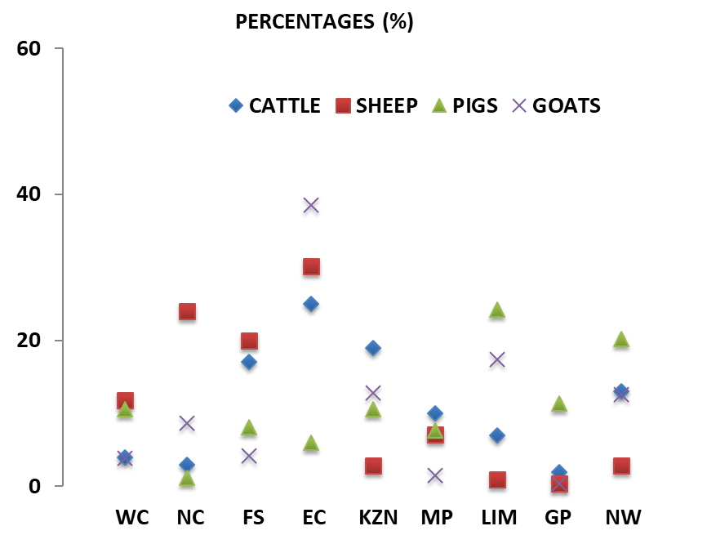
The Department will appreciate if you could complete the enclosed livestock questionnaire and send it back before 29 January 2021, in the envelope provided. Alternatively, send to this email: Livestock@daff.gov.za
The Directorate appreciates your continued support.
per pro. Director: Statistics and Economic Analysis

