November 2015
Geagte medewerker

Nuusbrief: Nasionale Veestatistiek
Geskatte Veegetalle in die RSA (Augustus 2014 en Augustus 2015)

Provinsie | Beeste |  | Skape |  |  |  | Varke |  | Bokke
Provinsie | Aug-14 | Aug-15 | Aug-14 |  | Aug-15 |  | Aug-14 | Aug-15 | Aug-14 | Aug-15
Provinsie | Duisende
Wes-Kaap | 564 | 558 |  | 2 818 | 2 800 | 173 |  | 169 | 220 | 214
Noord-Kaap | 503 | 502 |  | 5 995 | 5 956 | 27 |  | 27 | 513 | 507
Vrystaat | 2 304 | 2 279 |  | 4 773 | 4 727 | 125 |  | 122 | 234 | 234
Oos-Kaap | 3 338 | 3 321 |  | 6 987 | 6 967 | 94 |  | 92 | 2 273 | 2 221
KwaZulu-Natal | 2 741 | 2 683 |  | 755 | 747 | 154 |  | 150 | 808 | 806
Mpumalanga | 1 438 | 1 399 |  | 1 772 | 1 739 | 125 |  | 124 | 88 | 88
Limpopo | 1 055 | 1 016 |  | 258 | 254 | 368 |  | 358 | 1 102 | 1 081
Gauteng | 254 | 248 |  | 99 | 99 | 179 |  | 164 | 40 | 40
Noordwes | 1 719 | 1 688 |  | 666 | 649 | 317 |  | 316 | 694 | 680
Totaal | 13 915 | 13 694 |  | 24 123 | 23 938 | 1 562 |  | 1 552 | 5 971 | 5 871

Die bees-, skaap-, vark- en bokgetalle het onderskeidelik afgeneem met 1.59%, 0.77%, 0.64% en 1.67% vanaf Augustus 2014 tot Augustus 2015.
BEESTE:
Die Oos-Kaap Provinsie het 3,321 milj. beeste, terwyl 2,683 milj. in KwaZulu-Natal Provinsie en 2,279 milj. in die Vrystaat Provinsie aangetref word. Die oorblywende provinsies verteenwoordig gesamentlik sowat 5,411 milj. van die totale getal beeste in Suid-Afrika.

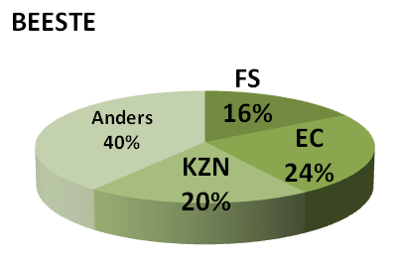
BOKKE:
Die grootste getal bokke, 2,221 milj. word in die Oos-Kaap Provinsie aangetref, die Limpopo Provinsie volg met 1,081 milj. en KwaZulu-Natal Provinsie met 805 907. Die oorblywende provinsies verteenwoordig gesamentlik sowat 1,763 milj. van die totale getal bokke in Suid-Afrika.

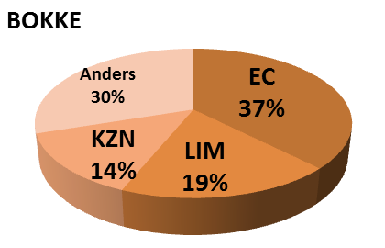
SKAPE:
Oos-Kaap Provinsie het die meeste skape met 6,967 milj., gevolg deur die Noord-Kaap Provinsie met 5,956 milj. en die Vrystaat Provinsie met 4,727 milj. Die oorblywende provinsies verteenwoordig sowat 6,288 milj. van die totale getal skape in Suid-Afrika.

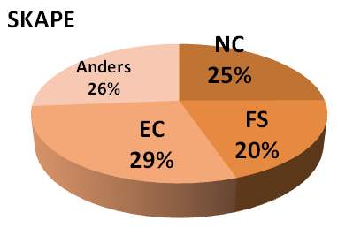
VARKE:
Die Limpopo Provinsie het die grootste getal varke, naamlik 358 387. Die Noordwes en Wes-Kaap Provinsies volg met onderskeidelik 315 792 en 168 968 varke. Die oorblywende provinsies verteenwoordig gesamentlik sowat 678 853 van die totale getal varke in Suid-Afrika.

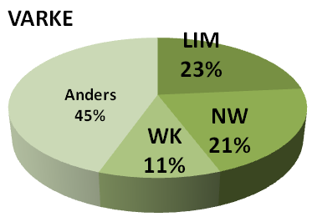

Dit sal waardeer word indien u die meegaande veeskattingsvraelys sal voltooi en dit voor 29 Januarie 2016 in die ingeslote koevert sal terugstuur. Of e-pos na selebogol@daff.gov.za

Die Direktoraat wil u graag bedank vir u volgehoue samewerking

per pro. Direkteur: Statistiek en Ekonomiese Analise

November 2015
Dear Co-operator

Newsletter: National Livestock Statistics
Estimated Livestock Numbers in the RSA (August 2014 and August 2015)

Province | Cattle |  | Sheep |  |  |  | Pigs |  | Goats
Province | Aug-14 | Aug-15 | Aug-14 |  | Aug-15 |  | Aug-14 | Aug-15 | Aug-14 | Aug-15
Province | Thousands
Western Cape | 564 | 558 |  | 2 818 | 2 800 | 173 |  | 169 | 220 | 214
Northern Cape | 503 | 502 |  | 5 995 | 5 956 | 27 |  | 27 | 513 | 507
Free State | 2 304 | 2 279 |  | 4 773 | 4 727 | 125 |  | 122 | 234 | 234
Eastern Cape | 3 338 | 3 321 |  | 6 987 | 6 967 | 94 |  | 92 | 2 273 | 2 221
KwaZulu-Natal | 2 741 | 2 683 |  | 755 | 747 | 154 |  | 150 | 808 | 806
Mpumalanga | 1 438 | 1 399 |  | 1 772 | 1 739 | 125 |  | 124 | 88 | 88
Limpopo | 1 055 | 1 016 |  | 258 | 254 | 368 |  | 358 | 1 102 | 1 081
Gauteng | 254 | 248 |  | 99 | 99 | 179 |  | 164 | 40 | 40
North West | 1 719 | 1 688 |  | 666 | 649 | 317 |  | 316 | 694 | 680
Total | 13 915 | 13 694 |  | 24 123 | 23 938 | 1 562 |  | 1 552 | 5 971 | 5 871

The numbers for cattle, sheep, pigs and goats decreased by approximately 1.59%, 0.77%, 0.64% and 1.67% respectively, between August 2014 and August 2015.
GOATS:
Of the total goat numbers 2,221 mill. are found in the Eastern Cape Province, Limpopo Province follows with 1,081 mill. and KwaZulu-Natal Province with 805 907. The remaining provinces share approximately 1,763 mill.

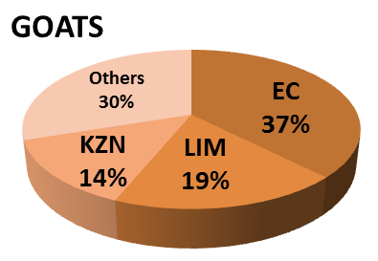
CATTLE:
Eastern Cape Province leads with 3,321 mill. cattle, followed by 2,683 mill. in KwaZulu-Natal Province and 2,279 mill. in the Free State Province. The remaining provinces share 5,411 mill. of the total cattle population in South Africa.

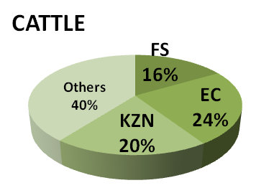

SHEEP:
The provincial distribution of sheep is as follows: 6,967 mill. in the Eastern Cape Province, 5,956 mill. in the Northern Cape Province and 4,727 mill. in the Free State Province. The remaining total, 6,288 mill. is shared amongst the other provinces in South Africa.

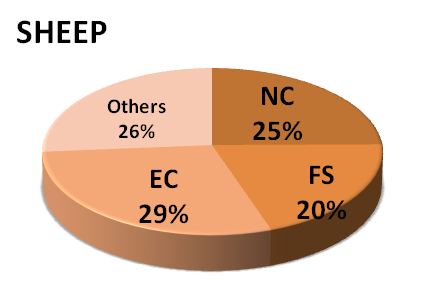
PIGS:
Most of the pig population is in the Limpopo Province at 358 387, the North West and Western Cape Provinces follow with 315 792 and 168 968 pigs, respectively. The remaining provinces share approximately 678 853 of the total pig population in South Africa.

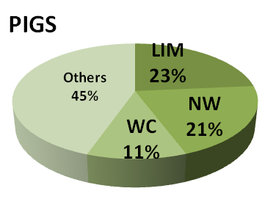

It would be appreciated if you could complete the enclosed livestock questionnaire and send it back before 29 January 2016, in the envelope provided. Alternatively, send to this email: selebogol@daff.gov.za
The Directorate appreciates your continued support.
per pro. Director: Statistics and Economic Analysis

