Junie 2014
Geagte medewerker
Nuusbrief: Nasionale Veestatistiek
Geskatte Veegetalle in die RSA (Augustus 2013 en Februarie 2014)

Provinsie | Beeste |  | Skape |  |  |  | Varke |  | Bokke
Provinsie | Aug-13 | Feb-14 | Aug-13 |  | Feb-14 |  | Aug-13 | Feb-14 | Aug-13 | Feb-14
Provinsie | Duisende
Wes-Kaap | 575 | 556 |  | 2 924 | 2 770 | 173 |  | 175 | 222 | 220
Noord-Kaap | 498 | 511 |  | 6 188 | 5 944 | 27 |  | 27 | 515 | 512
Vrystaat | 2 298 | 2 302 |  | 4 822 | 4 736 | 126 |  | 126 | 242 | 242
Oos-Kaap | 3 284 | 3 320 |  | 7 026 | 7 067 | 96 |  | 93 | 2 263 | 2 288
KwaZulu-Natal | 2 726 | 2 757 |  | 757 | 761 | 156 |  | 155 | 819 | 810
Mpumalanga | 1 453 | 1 433 |  | 1 772 | 1 762 | 128 |  | 124 | 91 | 89
Limpopo | 1 067 | 1 062 |  | 264 | 251 | 368 |  | 371 | 1 134 | 1 115
Gauteng | 255 | 256 |  | 102 | 96 | 181 |  | 176 | 40 | 41
Noordwes | 1 706 | 1 699 |  | 673 | 661 | 319 |  | 323 | 702 | 705
Totaal | 13 862 | 13 896 |  | 24 528 | 24 048 | 1 574 |  | 1 570 | 6 028 | 6 022

Die beesgetalle het afgegeneem met 0.25%, terwyl die skaap-, vark-, en bokgetalle met 1.96%, 0.25% en 0.10% onderskeidelik afgeneem het vanaf Augustus 2013 tot Februarie 2014.
FEBRUARIE 2014
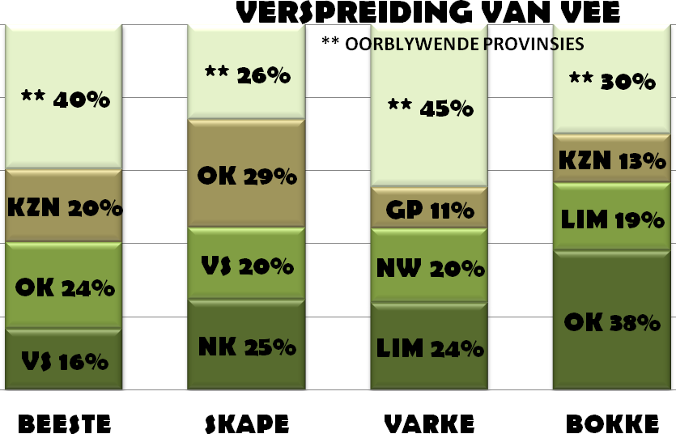
BEESTE: Die Oos-Kaap Provinsie het 3,320 milj beeste, terwyl 2,757 milj in KwaZulu-Natal Provinsie en 2,302 milj in die Vrystaat Provinsie aangetref word. Die oorblywende provinsies verteenwoordig gesamentlik sowat 5,517 milj van die totale getal beeste in Suid-Afrika.

SKAPE: Die Oos-Kaap Provinsie het die meeste skape met 7,067 milj, die Noord-Kaap Provinsie het 5,944 milj en die Vrystaat Provinsie 4,736 milj. Die oorblywende provinsies verteenwoordig sowat 6,301 milj van die totale getal skape in Suid-Afrika.

VARKE: Die Limpopo Provinsie het die grootste getal varke, 371 137. Die Noordwes Provinsie volg met 322 682 en Gauteng Provinsie met 175 589 varke. Die oorblywende provinsies verteenwoordig gesamentlik sowat 699 944 van die totale getal varke in Suid-Afrika.

BOKKE: Die grootste getal bokke, 2,288 milj word in die Oos-Kaap Provinsie aangetref, Limpopo Provinsie volg met 1,115 milj en KwaZulu-Natal Provinsie met 810 225. Die oorblywende provinsies verteenwoordig gesamentlik sowat 1,805 milj. van die totale getal bokke in Suid-Afrika

Dit sal waardeer word indien u die meegaande veeskattingsvraelys sal voltooi en dit voor 31 Julie 2014 in die ingeslote koevert sal terugstuur.

Die Direktoraat wil u graag bedank vir u volgehoue samewerking

per pro. Direkteur: Statistiek en Ekonomiese Analise

June 2014
Dear Co-operator

Newsletter: National Livestock Statistics
Estimated Livestock Numbers in the RSA (August 2013 and February 2014)

Province | Cattle |  | Sheep |  |  |  | Pigs |  | Goats
Province | Aug-13 | Feb-14 | Aug-13 |  | Feb-14 |  | Aug-13 | Feb-14 | Aug-13 | Feb-14
Province | Thousands
Western Cape | 575 | 556 |  | 2 924 | 2 770 | 173 |  | 175 | 222 | 220
Northern Cape | 498 | 511 |  | 6 188 | 5 944 | 27 |  | 27 | 515 | 512
Free State | 2 298 | 2 302 |  | 4 822 | 4 736 | 126 |  | 126 | 242 | 242
Eastern Cape | 3 284 | 3 320 |  | 7 026 | 7 067 | 96 |  | 93 | 2 263 | 2 288
KwaZulu-Natal | 2 726 | 2 757 |  | 757 | 761 | 156 |  | 155 | 819 | 810
Mpumalanga | 1 453 | 1 433 |  | 1 772 | 1 762 | 128 |  | 124 | 91 | 89
Limpopo | 1 067 | 1 062 |  | 264 | 251 | 368 |  | 371 | 1 134 | 1 115
Gauteng | 255 | 256 |  | 102 | 96 | 181 |  | 176 | 40 | 41
North West | 1 706 | 1 699 |  | 673 | 661 | 319 |  | 323 | 702 | 705
Total | 13 862 | 13 896 |  | 24 528 | 24 048 | 1 574 |  | 1 570 | 6 028 | 6 022

The numbers for cattle increased by approximately 0.25%, while the numbers for sheep, pigs and goats decreased by 1.96%, 0.25% and 0.10% respectively between August 2013 and February 2014.
CATTLE: Eastern Cape Province leads with 3,320 mill, 2,757 mill in KwaZulu-Natal Province and 2,302 mill in the Free State Province. The remaining provinces share 5,517 mill of the total cattle population in South Africa.

SHEEP: The provincial distribution of sheep is as follows: 7,067 mill in the Eastern Cape Province 5,944 mill in the Northern Cape Province and 4,736 mill in the Free State Province. 6,301 mill is shared among the remaining provinces in South Africa.

PIGS: Most of the pig population is in the Limpopo Province at 371 137, the North West Province follows with 322 682 and the Gauteng Province with 175 589. The remaining provinces share approximately 699 944 of the total pig population in South Africa.

GOATS: Of the total goat numbers 2,288 mill are found in the Eastern Cape Province, Limpopo Province follows with 1,115 mill and KwaZulu-Natal Province with 810 225. The remaining provinces share approximately 1,805 mill.

FEBRUARY 2014
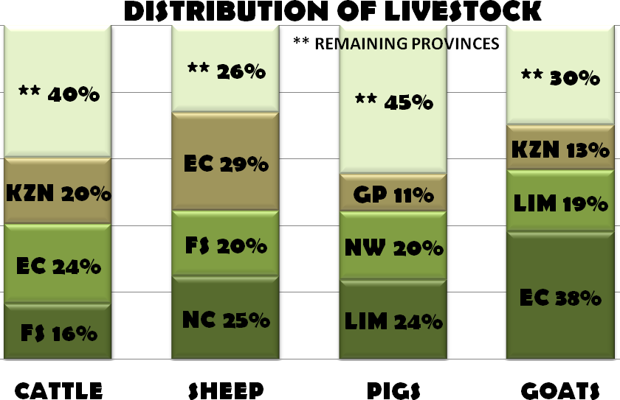

It would be appreciated if you could complete the enclosed livestock questionnaire and send it back before 31 July 2014, in the envelope provided.
The Directorate appreciates your continued support.
per pro. Director: Statistics and Economic Analysis

