Junie 2015
Geagte medewerker
Nuusbrief: Nasionale Veestatistiek
Geskatte Veegetalle in die RSA (Augustus 2014 en Februarie 2015)

Provinsie | Beeste |  | Skape |  |  |  | Varke |  | Bokke
Provinsie | Aug-14 | Feb-15 | Aug-14 |  | Feb-15 |  | Aug-14 | Feb-15 | Aug-14 | Feb-15
Provinsie | Duisende
Wes-Kaap | 564 | 552 |  | 2 818 | 2 825 | 173 |  | 173 | 220 | 216
Noord-Kaap | 503 | 511 |  | 5 995 | 6 082 | 27 |  | 25 | 513 | 519
Vrystaat | 2 304 | 2 296 |  | 4 773 | 4 753 | 125 |  | 125 | 234 | 239
Oos-Kaap | 3 338 | 3 300 |  | 6 987 | 7 022 | 94 |  | 93 | 2 273 | 2 230
KwaZulu-Natal | 2 741 | 2 713 |  | 755 | 718 | 154 |  | 156 | 808 | 807
Mpumalanga | 1 438 | 1 446 |  | 1 772 | 1 724 | 125 |  | 123 | 88 | 88
Limpopo | 1 055 | 1 047 |  | 258 | 249 | 368 |  | 371 | 1 102 | 1 030
Gauteng | 254 | 254 |  | 99 | 101 | 179 |  | 181 | 40 | 36
Noordwes | 1 719 | 1 693 |  | 666 | 654 | 317 |  | 319 | 694 | 702
Totaal | 13 916 | 13 812 |  | 24 123 | 24 128 | 1 562 |  | 1 566 | 5 972 | 5 867

Die bees- en bokgetalle het onderskeidelik afgeneem met 0.75% en 1.74%, terwyl die skaap- en varkgetalle met onderskeidelik 0.02% en 0.26% toegeneem het, vanaf Augustus 2014 tot Februarie 2015.
Februarie 2015

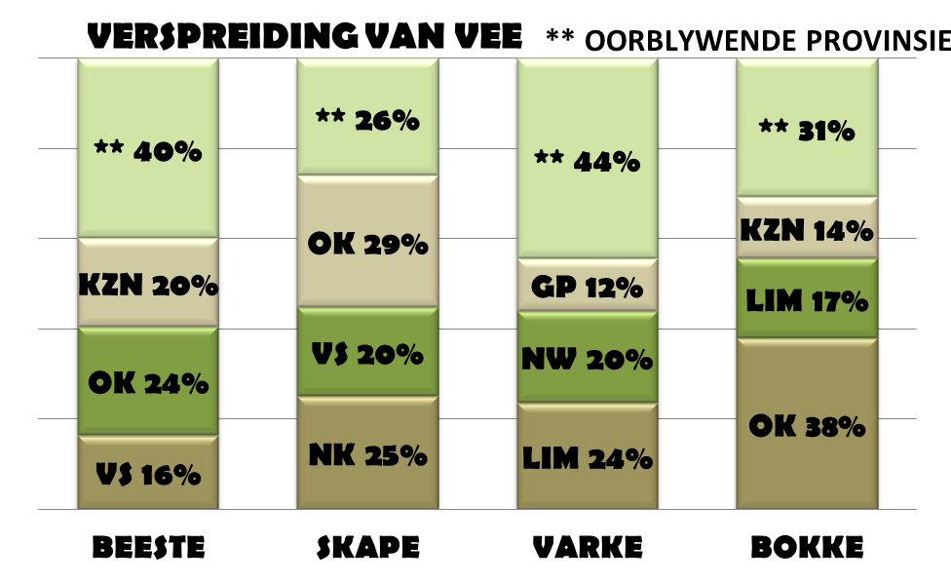
BEESTE: Die Oos-Kaap Provinsie het 3,300 milj. beeste, terwyl 2,713 milj. in KwaZulu-Natal Provinsie en 2,296 milj. in die Vrystaat Provinsie aangetref word. Die oorblywende provinsies verteenwoordig gesamentlik sowat 5,503 milj. van die totale getal beeste in Suid-Afrika.

SKAPE: Die Oos-Kaap Provinsie het die meeste skape met 7,022 milj., gevolg deur die Noord-Kaap Provinsie met 6,082 milj. en die Vrystaat Provinsie met 4,753 milj. Die oorblywende provinsies verteenwoordig sowat 6,271 milj. van die totale getal skape in Suid-Afrika.

VARKE: Die Limpopo Provinsie het die grootste getal varke, naamlik 371 181. Die Noordwes en Gauteng Provinsies volg met onderskeidelik 318 843 en 180 830 varke. Die oorblywende provinsies verteenwoordig gesamentlik sowat 694 755 van die totale getal varke in Suid-Afrika.

BOKKE: Die grootste getal bokke, 2,230 milj. word in die Oos-Kaap Provinsie aangetref, die Limpopo Provinsie volg met 1,030 milj. en KwaZulu-Natal Provinsie met 807 054. Die oorblywende provinsies verteenwoordig gesamentlik sowat 1,800 milj. van die totale getal bokke in Suid-Afrika.

Dit sal waardeer word indien u die meegaande veeskattingsvraelys sal voltooi en dit voor 31 Julie 2015 in die ingeslote koevert sal terugstuur.

Die Direktoraat wil u graag bedank vir u volgehoue samewerking

per pro. Direkteur: Statistiek en Ekonomiese Analise

June 2015
Dear Co-operator

Newsletter: National Livestock Statistics
Estimated Livestock Numbers in the RSA (August 2014 and February 2015)

Province | Cattle |  | Sheep |  |  |  | Pigs |  | Goats
Province | Aug-14 | Feb-15 | Aug-14 |  | Feb-15 |  | Aug-14 | Feb-15 | Aug-14 | Feb-15
Province | Thousands
Western Cape | 564 | 552 |  | 2 818 | 2 825 | 173 |  | 173 | 220 | 216
Northern Cape | 503 | 511 |  | 5 995 | 6 082 | 27 |  | 25 | 513 | 519
Free State | 2 304 | 2 296 |  | 4 773 | 4 753 | 125 |  | 125 | 234 | 239
Eastern Cape | 3 338 | 3 300 |  | 6 987 | 7 022 | 94 |  | 93 | 2 273 | 2 230
KwaZulu-Natal | 2 741 | 2 713 |  | 755 | 718 | 154 |  | 156 | 808 | 807
Mpumalanga | 1 438 | 1 446 |  | 1 772 | 1 724 | 125 |  | 123 | 88 | 88
Limpopo | 1 055 | 1 047 |  | 258 | 249 | 368 |  | 371 | 1 102 | 1 030
Gauteng | 254 | 254 |  | 99 | 101 | 179 |  | 181 | 40 | 36
North West | 1 719 | 1 693 |  | 666 | 654 | 317 |  | 319 | 694 | 702
Total | 13 916 | 13 812 |  | 24 123 | 24 128 | 1 562 |  | 1 566 | 5 972 | 5 867

The numbers for cattle and goats decreased by approximately 0.75% and 1.74%, while the numbers for sheep and pigs increased by 0.02% and 0.26% respectively, between August 2014 and February 2015.
CATTLE: Eastern Cape Province leads with 3,300 mill. cattle, followed by 2,713 mill. in KwaZulu-Natal Province and 2,296 mill. in the Free State Province. The remaining provinces share 5,503 mill. of the total cattle population in South Africa.

SHEEP: The provincial distribution of sheep is as follows: 7,022 mill. in the Eastern Cape Province, 6,082 mill. in the Northern Cape Province and 4,753 mill. in the Free State Province. The remaining 6,271 mill. sheep is shared amongst the other provinces in South Africa.

PIGS: Most of the pig population is in the Limpopo Province at 371 181, the North West and Gauteng Provinces follow with 318 843 and 180 830 pigs, respectively. The remaining provinces share approximately 694 755 of the total pig population in South Africa.

GOATS: Of the total goat numbers 2,230 mill. are found in the Eastern Cape Province, Limpopo Province follows with 1,030 mill. and KwaZulu-Natal Province with 807 054. The remaining provinces share approximately 1,800 mill.

February 2015

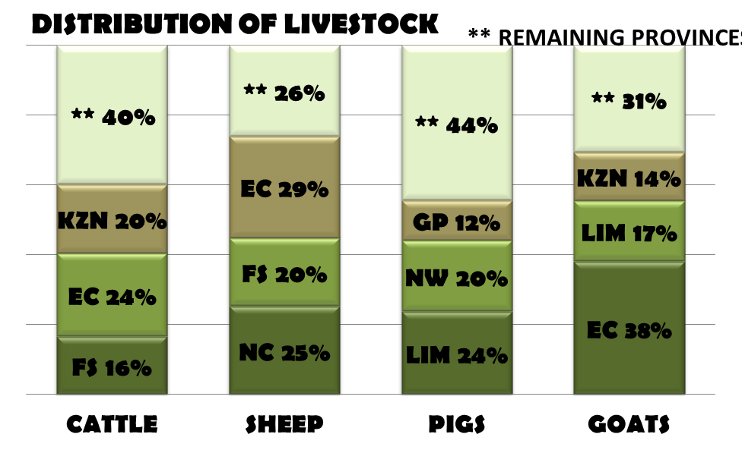

It would be appreciated if you could complete the enclosed livestock questionnaire and send it back before 31 July 2015, in the envelope provided.
The Directorate appreciates your continued support.
per pro. Director: Statistics and Economic Analysis

