

Nuusbrief: Nasionale Veestatistiek

Van: Baldwin Netshifhefhe Direktoraat: Statistiek en Ekonomiese Analise
Tel: 012 319 8043 Faks: 012 319 8035/1 E-pos: BaldwinN@daff.gov.za / SelebogoL@daff.gov.za

Geagte medewerker MEI 2020

Geskatte Veegetalle in die RSA (Augustus 2019 en Februarie 2020)

Provinsie | Beeste |  | Skape |  |  |  | Varke |  | Bokke
Provinsie | Aug-19 | Feb-20 | Aug-19 |  | Feb-20 |  | Aug-19 | Feb-20 | Aug-19 | Feb-20
Provinsie | Duisende
Wes-Kaap | 488 | 476 |  | 2 623 | 2 560 | 152 |  | 147 | 207 | 205
Noord-Kaap | 433 | 419 |  | 5 305 | 5 250 | 19 |  | 18 | 469 | 457
Vrystaat | 2 109 | 2 070 |  | 4 518 | 4 347 | 111 |  | 109 | 217 | 216
Oos-Kaap | 3 082 | 3 056 |  | 6 531 | 6 518 | 84 |  | 83 | 2 005 | 1 990
KwaZulu-Natal | 2 481 | 2 420 |  | 656 | 644 | 144 |  | 143 | 680 | 669
Mpumalanga | 1 243 | 1 238 |  | 1 554 | 1 533 | 110 |  | 105 | 79 | 77
Limpopo | 898 | 881 |  | 204 | 199 | 330 |  | 336 | 902 | 889
Gauteng | 246 | 243 |  | 87 | 85 | 156 |  | 156 | 23 | 23
Noordwes | 1 578 | 1 573 |  | 607 | 599 | 283 |  | 278 | 668 | 649
Totaal | 12 558 | 12 376 |  | 22 085 | 21 735 | 1 389 |  | 1 375 | 5 250 | 5 175

Die bees-, skaap-, vark- en bokgetalle het onderskeidelik afgeneem met 1.45%, 1.58%, 1.01% en 1.43% vanaf Augustus 2019 tot Februarie 2020.

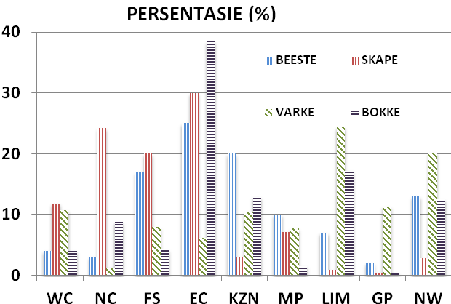
BEESTE: Die meeste beeste word in die Oos-Kaap aangetref, gevolg deur KwaZulu-Natal en dan die Vrystaat.

SKAPE: Die hoogste getal skape word in die Oos-Kaap gevind, gevolg deur die Noord-Kaap en dan die Vrystaat.

VARKE: Die meeste varke word in Limpopo aangetref, gevolg deur Noordwes en dan die Gauteng and Wes-Kaap.

BOKKE: Oos-Kaap het die meeste aantal bokke, gevolg deur onderskeidelik Limpopo en KwaZulu-Natal.

NOTAS (DEC 2019 – FEB 2020)

Reënval:
Vee:
Weiding/Veld:
Dit sal waardeer word indien u die meegaande veeskattingsvraelys sal voltooi en dit voor 31 Julie 2020 in die ingeslote koevert sal terugstuur. Of e-pos na Livestock@daff.gov.za

Die Direktoraat wil u graag bedank vir u volgehoue samewerking.

per pro. Direkteur: Statistiek en Ekonomiese Analise

Newsletter: National Livestock Statistics
From: Baldwin Netshifhefhe Directorate: Statistics and Economic Analysis
Tel: 012 319 8043 Fax: 012 319 8035/1 E-mail: BaldwinN@daff.gov.za / SelebogoL@daff.gov.za

Dear Co-operator MAY 2020

Estimated Livestock Numbers in the RSA (August 2019 and February 2020)

Province | Cattle |  | Sheep |  |  |  | Pigs |  | Goats
Province | Aug-19 | Feb-20 | Aug-19 |  | Feb-20 |  | Aug-19 | Feb-20 | Aug-19 | Feb-20
Province | Thousands
Western Cape | 488 | 476 |  | 2 623 | 2 560 | 152 |  | 147 | 207 | 205
Northern Cape | 433 | 419 |  | 5 305 | 5 250 | 19 |  | 18 | 469 | 457
Free State | 2 109 | 2 070 |  | 4 518 | 4 347 | 111 |  | 109 | 217 | 216
Eastern Cape | 3 082 | 3 056 |  | 6 531 | 6 518 | 84 |  | 83 | 2 005 | 1 990
KwaZulu-Natal | 2 481 | 2 420 |  | 656 | 644 | 144 |  | 143 | 680 | 669
Mpumalanga | 1 243 | 1 238 |  | 1 554 | 1 533 | 110 |  | 105 | 79 | 77
Limpopo | 898 | 881 |  | 204 | 199 | 330 |  | 336 | 902 | 889
Gauteng | 246 | 243 |  | 87 | 85 | 156 |  | 156 | 23 | 23
North West | 1 578 | 1 573 |  | 607 | 599 | 283 |  | 278 | 668 | 649
Total | 12 558 | 12 376 |  | 22 085 | 21 735 | 1 389 |  | 1 375 | 5 250 | 5 175
The numbers for cattle, sheep, pigs and goats decreased by approximately 1.45%, 1.58%, 1.01% and 1.43% respectively between August 2019 and February 2020.
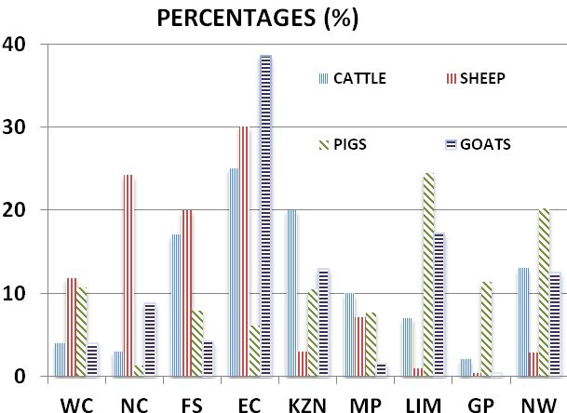
CATTLE: Eastern Cape has the highest percentage of Cattle, followed by KwaZulu-Natal and Free State.

SHEEP: The highest percentage of sheep is in Eastern Cape, followed by Northern Cape and Free State.

PIGS: Pigs are largely in Limpopo, followed by North West, Gauteng and Western Cape.

GOATS: Eastern Cape has the highest number of goats, with Limpopo and KwaZulu-Natal following respectively.

NOTES (DEC 2019 – FEB 2020)

Rain: On average, the country received normal rainfall. A number of provinces recorded flooding, with KZN experiencing heavy winds and storms.
Livestock: Livestock conditions on average are fair to good. There were mortalities in EC due to tick borne diseases. In KZN, drought, malnutrition, quarter evil and diarrhea were sources of recorded mortalities. Mortalities due to African swine fever and F&M were recorded in MP, while poisonous plant caused livestock death in NW.
Pasture/veld: On average, veld conditions were poor to reasonable. Veld fires were recorded in some part of EC, FS, KZN and Limpopo provinces.

The Department will appreciate if you could complete the enclosed livestock questionnaire and send it back before 31 July 2020, in the envelope provided. Alternatively, send to this email: Livestock@daff.gov.za
The Directorate appreciates your continued support.
per pro. Director: Statistics and Economic Analysis

