

Nuusbrief: Nasionale Veestatistiek

Van: Baldwin Netshifhefhe Direktoraat: Statistiek en Ekonomiese Analise
Tel: 012 319 8043 Faks: 012 319 8035/1 E-pos: BaldwinN@daff.gov.za / SelebogoL@daff.gov.za

Geagte medewerker MEI 2019

Geskatte Veegetalle in die RSA (Augustus 2018 en Februarie 2019)

Provinsie | Beeste |  | Skape |  |  |  | Varke |  | Bokke
Provinsie | Aug-18 | Feb-19 | Aug-18 |  | Feb-19 |  | Aug-18 | Feb-19 | Aug-18 | Feb-19
Provinsie | Duisende
Wes-Kaap | 507 | 503 |  | 2 663 | 2 651 | 159 |  | 155 | 207 | 209
Noord-Kaap | 442 | 441 |  | 5 496 | 5 402 | 20 |  | 20 | 474 | 468
Vrystaat | 2 178 | 2 130 |  | 4 510 | 4 486 | 114 |  | 115 | 217 | 215
Oos-Kaap | 3 145 | 3 126 |  | 6 630 | 6 593 | 88 |  | 85 | 2 073 | 2 061
KwaZulu-Natal | 2 481 | 2 444 |  | 680 | 664 | 144 |  | 145 | 702 | 693
Mpumalanga | 1 279 | 1 266 |  | 1 606 | 1 559 | 116 |  | 112 | 81 | 80
Limpopo | 936 | 922 |  | 213 | 209 | 350 |  | 343 | 953 | 927
Gauteng | 246 | 246 |  | 90 | 88 | 156 |  | 156 | 28 | 25
Noordwes | 1 574 | 1 561 |  | 611 | 606 | 306 |  | 289 | 668 | 668
Totaal | 12 788 | 12 639 |  | 22 499 | 22 258 | 1 453 |  | 1 420 | 5 403 | 5 346

Die bees-, skaap-, vark- en bokgetalle het onderskeidelik afgeneem met 1.17%, 1.07%, 2.27% en 1.05% vanaf Augustus 2018 tot Februarie 2019.
BEESTE: Die meeste beeste word in die Oos-Kaap aangetref, gevolg deur KwaZulu-Natal en dan die Vrystaat.

SKAPE: Die hoogste getal skape word in die Oos-Kaap gevind, gevolg deur die Noord-Kaap en dan die Vrystaat.

VARKE: Die meeste varke word in Limpopo aangetref, gevolg deur Noordwes en dan die Gauteng and Wes-Kaap.

BOKKE: Oos-Kaap het die meeste aantal bokke, gevolg deur onderskeidelik Limpopo en KwaZulu-Natal.

NOTAS (Nov – Jan)
Die meeste boere het 'n droë seisoen beleef, met lae boorgatwatervlakke, wat tot swak weidingstoestande gelei het.
Reënval: Die vlak van reënval wat vir die meeste provinsies gerapporteer is, was onder normale omstandighede, met min uitsonderings.
Vee:
Toestande vir lewende hawe was redelik of redelik gemiddeld. Vrystaat het sterftes ervaar as gevolg van veldbrande, terwyl sterftes in KZN weens weerlig veroorsaak het.
Weiding/Veld: veldtoestande was swak tot redelik, met 'n aantal provinsies wat veldbrande aangemeld het.

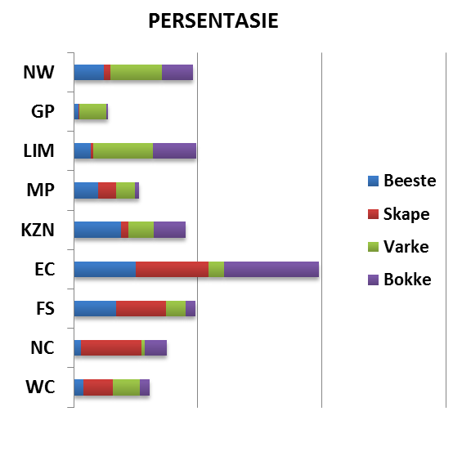
Dit sal waardeer word indien u die meegaande veeskattingsvraelys sal voltooi en dit voor 31 Julie 2019 in die ingeslote koevert sal terugstuur. Of e-pos na Livestock@daff.gov.za

Die Direktoraat wil u graag bedank vir u volgehoue samewerking.

per pro. Direkteur: Statistiek en Ekonomiese Analise

Newsletter: National Livestock Statistics
From: Baldwin Netshifhefhe Directorate: Statistics and Economic Analysis
Tel: 012 319 8043 Fax: 012 319 8035/1 E-mail: BaldwinN@daff.gov.za / SelebogoL@daff.gov.za

Dear Co-operator MAY 2019

Estimated Livestock Numbers in the RSA (August 2018 and February 2019)

Province | Cattle |  | Sheep |  |  |  | Pigs |  | Goats
Province | Aug-18 | Feb-19 | Aug-18 |  | Feb-19 |  | Aug-18 | Feb-19 | Aug-18 | Feb-19
Province | Thousands
Western Cape | 507 | 503 |  | 2 663 | 2 651 | 159 |  | 155 | 207 | 209
Northern Cape | 442 | 441 |  | 5 496 | 5 402 | 20 |  | 20 | 474 | 468
Free State | 2 178 | 2 130 |  | 4 510 | 4 486 | 114 |  | 115 | 217 | 215
Eastern Cape | 3 145 | 3 126 |  | 6 630 | 6 593 | 88 |  | 85 | 2 073 | 2 061
KwaZulu-Natal | 2 481 | 2 444 |  | 680 | 664 | 144 |  | 145 | 702 | 693
Mpumalanga | 1 279 | 1 266 |  | 1 606 | 1 559 | 116 |  | 112 | 81 | 80
Limpopo | 936 | 922 |  | 213 | 209 | 350 |  | 343 | 953 | 927
Gauteng | 246 | 246 |  | 90 | 88 | 156 |  | 156 | 28 | 25
North West | 1 574 | 1 561 |  | 611 | 606 | 306 |  | 289 | 668 | 668
Total | 12 788 | 12 639 |  | 22 499 | 22 258 | 1 453 |  | 1 420 | 5 403 | 5 346
The numbers for cattle, sheep, pigs and goats decreased by approximately 1.17%, 1.07%, 2.27% and 1.05% respectively between August 2018 and February 2019.
CATTLE: Eastern Cape has the highest percentage of Cattle, followed by KwaZulu-Natal and Free State.

SHEEP: The highest percentage of sheep is found in Eastern Cape, followed by Northern Cape and Free State.

PIGS: Pigs are largely found in Limpopo, followed by North West, Gauteng and Western Cape.

GOATS: Eastern Cape has the highest number of goats, with Limpopo and KwaZulu-Natal following respectively.

NOTES (Nov - Jan)
Most farmers have observed a dry season, with low boreholes water, resulting in poor grazing.
Rain: The level of rainfall reported for most provinces was below normal, with few exceptions.
Livestock: conditions for livestock were fair or reasonable on average. Free State experience mortalities dues to veld fires, while lightning cause mortalities in KZN.
Pasture/veld: veld conditions were poor to reasonable, with a number of provinces reporting veld fires.
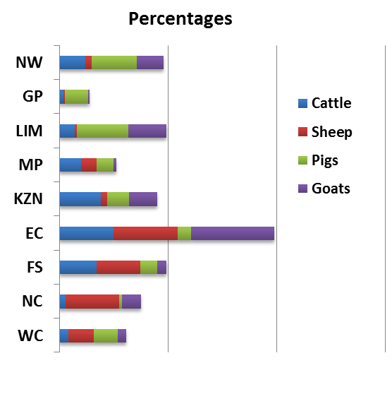

It would be appreciated if you could complete the enclosed livestock questionnaire and send it back before 31 July 2019, in the envelope provided. Alternatively, send to this email: Livestock@daff.gov.za
The Directorate appreciates your continued support.
per pro. Director: Statistics and Economic Analysis

