

Nuusbrief: Nasionale Veestatistiek

Van: Baldwin Netshifhefhe Direktoraat: Statistiek en Ekonomiese Analise
Tel: 012 319 8043 Faks: 012 319 8035/1 E-pos: BaldwinN@daff.gov.za / SelebogoL@daff.gov.za

Geagte medewerker AUGUSTUS 2018

Geskatte Veegetalle in die RSA (Augustus 2017 en MEI 2018)

Provinsie | Beeste |  | Skape |  |  |  | Varke |  | Bokke
Provinsie | Aug-17 | Mei-18 | Aug-17 |  | Mei-18 |  | Aug-17 | Mei-18 | Aug-17 | Mei-18
Provinsie | Duisende
Wes-Kaap | 518 | 510 |  | 2 695 | 2 664 | 167 |  | 161 | 209 | 208
Noord-Kaap | 479 | 445 |  | 5 582 | 5 505 | 23 |  | 20 | 482 | 475
Vrystaat | 2 179 | 2 183 |  | 4 521 | 4 505 | 116 |  | 115 | 223 | 218
Oos-Kaap | 3 149 | 3 146 |  | 6 622 | 6 646 | 89 |  | 88 | 2 097 | 2 074
KwaZulu-Natal | 2 496 | 2 485 |  | 692 | 691 | 147 |  | 145 | 712 | 705
Mpumalanga | 1 326 | 1 285 |  | 1 652 | 1 612 | 118 |  | 118 | 83 | 82
Limpopo | 981 | 942 |  | 225 | 218 | 353 |  | 353 | 971 | 963
Gauteng | 246 | 246 |  | 92 | 92 | 156 |  | 156 | 29 | 29
Noordwes | 1 580 | 1 584 |  | 608 | 616 | 311 |  | 305 | 669 | 666
Totaal | 12 954 | 12 826 |  | 22 689 | 22 549 | 1 480 |  | 1 461 | 5 475 | 5 420

Die bees-, skaap-, vark- en bokgetalle het onderskeidelik afgeneem met 0.99%, 0.62%, 1.28% en 1.00% vanaf Augustus 2017 tot Mei 2018.
Reën: Oor die algemeen het die land normale tot onder-normale reënval oor die drie maande, Mar–Mei 2018, ondervind.

Vee: Die toestand van vee oor die tydperk is gemiddeld tot redelik goed, terwyl die toestand in Limpopo swak is.

Weiding/veld: Oor die algemeen was weidingstoestande redelik goed, maar swak vir dié Wes-Kaap en Limpopo.

Ander: Wes-Kaap het gevalle van hondsdolheid, H5N8-griep, “New Castle” en “Johne” se siekte gerapporteer.
BEESTE VARKE
SKAPE BOKKE

Dit sal waardeer word indien u die meegaande veeskattingsvraelys sal voltooi en dit voor 31 OKTOBER 2018 in die ingeslote koevert sal terugstuur. Of e-pos na Livestock@daff.gov.za

Die Direktoraat wil u graag bedank vir u volgehoue samewerking.
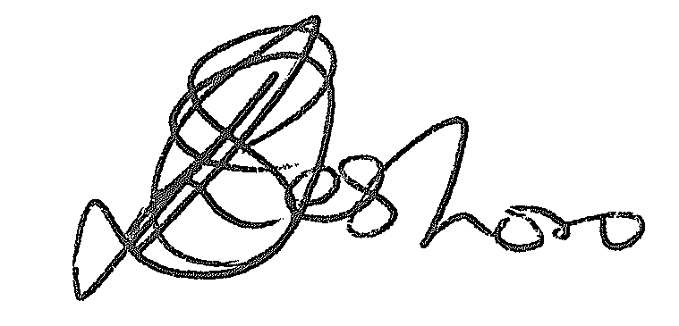
per pro. Direkteur: Statistiek en Ekonomiese Analise
Newsletter: National Livestock Statistics
From: Baldwin Netshifhefhe Directorate: Statistics and Economic Analysis
Tel: 012 319 8043 Fax: 012 319 8035/1 E-mail: BaldwinN@daff.gov.za / SelebogoL@daff.gov.za

Dear Co-operator AUGUST 2018

Estimated Livestock Numbers in the RSA (August 2017 and MAY 2018)

Province | Cattle |  | Sheep |  |  |  | Pigs |  | Goats
Province | Aug-17 | May-18 | Aug-17 |  | May-18 |  | Aug-17 | May-18 | Aug-17 | May-18
Province | Thousands
Western Cape | 518 | 510 |  | 2 695 | 2 664 | 167 |  | 161 | 209 | 208
Northern Cape | 479 | 445 |  | 5 582 | 5 505 | 23 |  | 20 | 482 | 475
Free State | 2 179 | 2 183 |  | 4 521 | 4 505 | 116 |  | 115 | 223 | 218
Eastern Cape | 3 149 | 3 146 |  | 6 622 | 6 646 | 89 |  | 88 | 2 097 | 2 074
KwaZulu-Natal | 2 496 | 2 485 |  | 692 | 691 | 147 |  | 145 | 712 | 705
Mpumalanga | 1 326 | 1 285 |  | 1 652 | 1 612 | 118 |  | 118 | 83 | 82
Limpopo | 981 | 942 |  | 225 | 218 | 353 |  | 353 | 971 | 963
Gauteng | 246 | 246 |  | 92 | 92 | 156 |  | 156 | 29 | 29
North West | 1 580 | 1 584 |  | 608 | 616 | 311 |  | 305 | 669 | 666
Total | 12 954 | 12 826 |  | 22 689 | 22 549 | 1 480 |  | 1 461 | 5 475 | 5 420
The numbers for cattle, sheep, pigs and goats decreased by approximately 0.99%, 0.62%, 1.28% and 1.00% respectively between August 2017 and May 2018.
CATTLE PIGS
SHEEP GOATS

Rain: On average, the country experienced normal to below normal rainfall over the three months, Mar-May 2018.

Livestock: Conditions of livestock over the period are on average reasonable to good, while poor for Limpopo.

Pasture/veld: Pasture conditions were on average reasonable to good, with those in Western Cape and Limpopo being poor.

Others: WC reported bouts of Rabies, H5N8 influenza, New Castle and Johne’s disease.
between August 2017 and February 2018.

It would be appreciated if you could complete the enclosed livestock questionnaire and send it back before 31 OCTOBER 2018, in the envelope provided. Alternatively, send to this email: Livestock@daff.gov.za
The Directorate appreciates your continued support.
per pro. Director: Statistics and Economic Analysis

