

Nuusbrief: Nasionale Veestatistiek

Van: Baldwin Netshifhefhe Direktoraat: Statistiek en Ekonomiese Analise
Tel: 012 319 8043 Faks: 012 319 8035/1 E-pos: BaldwinN@daff.gov.za / SelebogoL@daff.gov.za

Geagte medewerker AUGUSTUS 2019

Geskatte Veegetalle in die RSA (Augustus 2018 en MEI 2019)

Provinsie | Beeste |  | Skape |  |  |  | Varke |  | Bokke
Provinsie | Aug-18 | Mei-19 | Aug-18 |  | Mei-19 |  | Aug-18 | Mei-19 | Aug-18 | Mei-19
Provinsie | Duisende
Wes-Kaap | 507 | 498 |  | 2 663 | 2 633 | 159 |  | 153 | 207 | 207
Noord-Kaap | 442 | 442 |  | 5 496 | 5 344 | 20 |  | 19 | 474 | 470
Vrystaat | 2 178 | 2 111 |  | 4 510 | 4 573 | 114 |  | 113 | 217 | 216
Oos-Kaap | 3 145 | 3 104 |  | 6 630 | 6 540 | 88 |  | 85 | 2 073 | 2 019
KwaZulu-Natal | 2 481 | 2 465 |  | 680 | 657 | 144 |  | 145 | 702 | 682
Mpumalanga | 1 279 | 1 261 |  | 1 606 | 1 567 | 116 |  | 111 | 81 | 80
Limpopo | 936 | 910 |  | 213 | 204 | 350 |  | 335 | 953 | 909
Gauteng | 246 | 243 |  | 90 | 87 | 156 |  | 156 | 28 | 24
Noordwes | 1 574 | 1 575 |  | 611 | 608 | 306 |  | 281 | 668 | 669
Totaal | 12 788 | 12 608 |  | 22 499 | 22 213 | 1 453 |  | 1 398 | 5 403 | 5 276

Die bees-, skaap-, vark- en bokgetalle het onderskeidelik afgeneem met 1.41%, 1.27%, 3.79% en 2.35% vanaf Augustus 2018 tot Mei 2019.

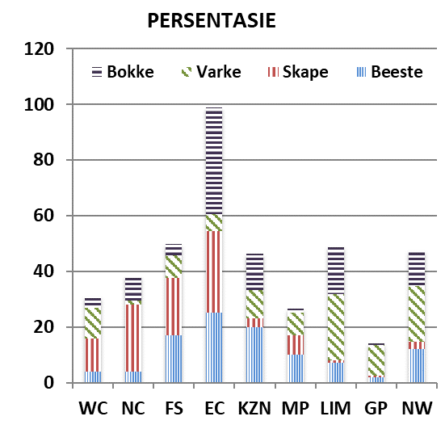
BEESTE: Die meeste beeste word in die Oos-Kaap aangetref, gevolg deur KwaZulu-Natal en dan die Vrystaat.

SKAPE: Die hoogste getal skape word in die Oos-Kaap gevind, gevolg deur die Noord-Kaap en dan die Vrystaat.

VARKE: Die meeste varke word in Limpopo aangetref, gevolg deur Noordwes en dan die Gauteng and Wes-Kaap.

BOKKE: Oos-Kaap het die meeste aantal bokke, gevolg deur onderskeidelik Limpopo en KwaZulu-Natal.

NOTAS (MAR – MEI)

Reënval: Oor die algemeen is reenval byna normaal tot normaal, en het met die veldtoestande gehelp.
Vee: Die toestande van vee bly gemiddeld tot goed. In Limpopo het bek- en klouseer voorgekom, gevolg met sterftes. Varkgriep het in die Vrystaat, Gauteng en Mpumalanga provinsies voorgekom, gevolg met sterftes. Daar was ook sterftes as gevolg van die inname van giftige plante en weerlig in onderskeidelik Gauteng en Mpumalanga provinsies.
Weiding/Veld: Oor die algemeen is toestande gemiddeld tot goed, met Limpopo en Mpumalanga met swakker toestande.
Dit sal waardeer word indien u die meegaande veeskattingsvraelys sal voltooi en dit voor 31 Oktober 2019 in die ingeslote koevert sal terugstuur. Of e-pos na Livestock@daff.gov.za

Die Direktoraat wil u graag bedank vir u volgehoue samewerking.

per pro. Direkteur: Statistiek en Ekonomiese Analise

Newsletter: National Livestock Statistics
From: Baldwin Netshifhefhe Directorate: Statistics and Economic Analysis
Tel: 012 319 8043 Fax: 012 319 8035/1 E-mail: BaldwinN@daff.gov.za / SelebogoL@daff.gov.za

Dear Co-operator AUGUST 2019

Estimated Livestock Numbers in the RSA (August 2018 and MAY 2019)

Province | Cattle |  | Sheep |  |  |  | Pigs |  | Goats
Province | Aug-18 | May-19 | Aug-18 |  | May-19 |  | Aug-18 | May-19 | Aug-18 | May-19
Province | Thousands
Western Cape | 507 | 498 |  | 2 663 | 2 633 | 159 |  | 153 | 207 | 207
Northern Cape | 442 | 442 |  | 5 496 | 5 344 | 20 |  | 19 | 474 | 470
Free State | 2 178 | 2 111 |  | 4 510 | 4 573 | 114 |  | 113 | 217 | 216
Eastern Cape | 3 145 | 3 104 |  | 6 630 | 6 540 | 88 |  | 85 | 2 073 | 2 019
KwaZulu-Natal | 2 481 | 2 465 |  | 680 | 657 | 144 |  | 145 | 702 | 682
Mpumalanga | 1 279 | 1 261 |  | 1 606 | 1 567 | 116 |  | 111 | 81 | 80
Limpopo | 936 | 910 |  | 213 | 204 | 350 |  | 335 | 953 | 909
Gauteng | 246 | 243 |  | 90 | 87 | 156 |  | 156 | 28 | 24
North West | 1 574 | 1 575 |  | 611 | 608 | 306 |  | 281 | 668 | 669
Total | 12 788 | 12 608 |  | 22 499 | 22 213 | 1 453 |  | 1 398 | 5 403 | 5 276
The numbers for cattle, sheep, pigs and goats decreased by approximately 1.41%, 1.27%, 3.79% and 2.35% respectively between August 2018 and May 2019.
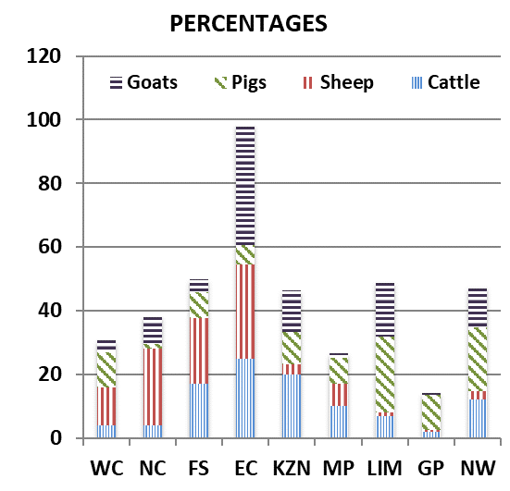
CATTLE: Eastern Cape has the highest percentage of Cattle, followed by KwaZulu-Natal and Free State.

SHEEP: The highest percentage of sheep is in Eastern Cape, followed by Northern Cape and Free State.

PIGS: Pigs are largely in Limpopo, followed by North West, Gauteng and Western Cape.

GOATS: Eastern Cape has the highest number of goats, with Limpopo and KwaZulu-Natal following respectively.

NOTES (MAR - MAY)

Rain: On average, rainfall during the period was at near normal to normal, assisting with the veld conditions.
Livestock: The conditions of livestock remain fair to good. Limpopo continued to deal with FMD, recording mortalities during this period. Free State, Gauteng and Mpumalanga experienced swine flu with mortalities occurring. Mortalities also occurred due to poisonous plants and hailstorm/lightning in Gauteng and Mpumalanga respectively.
Pasture/veld: The conditions are fair to good on average, with Limpopo and Mpumalanga being poor.

The Department will appreciate if you could complete the enclosed livestock questionnaire and send it back before 31 October 2019, in the envelope provided. Alternatively, send to this email: Livestock@daff.gov.za
The Directorate appreciates your continued support.
per pro. Director: Statistics and Economic Analysis

