

Nuusbrief: Nasionale Veestatistiek

Van: Baldwin Netshifhefhe Direktoraat: Statistiek en Ekonomiese Analise
Tel: 012 319 8043 Faks: 012 319 8035/1 E-pos: BaldwinN@daff.gov.za / SelebogoL@daff.gov.za

Geagte medewerker AUGUST 2020

Geskatte Veegetalle in die RSA (Augustus 2019 en Mei 2020)

Provinsie | Beeste |  | Skape |  |  |  | Varke |  | Bokke
Provinsie | Aug-19 | Mei-20 | Aug-19 |  | Mei-20 |  | Aug-19 | Mei-20 | Aug-19 | Mei-20
Provinsie | Duisende
Wes-Kaap | 488 | 469 |  | 2 623 | 2 556 | 152 |  | 146 | 207 | 204
Noord-Kaap | 433 | 422 |  | 5 305 | 5 250 | 19 |  | 17 | 469 | 457
Vrystaat | 2 109 | 2 064 |  | 4 518 | 4 331 | 111 |  | 111 | 217 | 215
Oos-Kaap | 3 082 | 3 054 |  | 6 531 | 6 513 | 84 |  | 82 | 2 005 | 1 992
KwaZulu-Natal | 2 481 | 2 401 |  | 656 | 634 | 144 |  | 144 | 680 | 669
Mpumalanga | 1 243 | 1 236 |  | 1 554 | 1 526 | 110 |  | 104 | 79 | 77
Limpopo | 898 | 865 |  | 204 | 194 | 330 |  | 330 | 902 | 882
Gauteng | 246 | 242 |  | 87 | 85 | 156 |  | 156 | 23 | 21
Noordwes | 1 578 | 1 573 |  | 607 | 598 | 283 |  | 278 | 668 | 657
Totaal | 12 558 | 12 326 |  | 22 085 | 21 687 | 1 389 |  | 1 368 | 5 250 | 5 174

Die bees-, skaap-, vark- en bokgetalle het onderskeidelik afgeneem met 1.85%, 1.80%, 1.51% en 1.45% vanaf Augustus 2019 tot Mei 2020.

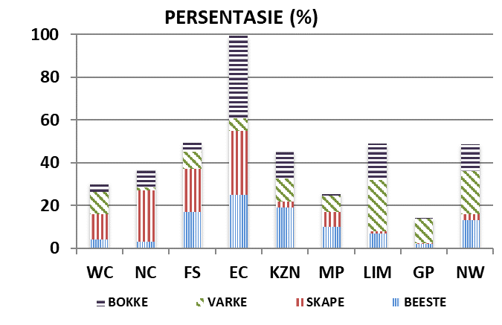
BEESTE: Die meeste beeste word in die Oos-Kaap aangetref, gevolg deur KwaZulu-Natal en dan die Vrystaat.

SKAPE: Die hoogste getal skape word in die Oos-Kaap gevind, gevolg deur die Noord-Kaap en dan die Vrystaat.

VARKE: Die meeste varke word in Limpopo aangetref, gevolg deur Noordwes en dan die Gauteng and Wes-Kaap.

BOKKE: Oos-Kaap het die meeste aantal bokke, gevolg deur onderskeidelik Limpopo en KwaZulu-Natal.

NOTAS (MAR 2020 – MEI 2020)

Reënval: In die meeste dele van die land is goeie en normale reën aangeteken, behalwe in NC.
Vee: gemiddeld was die toestande redelik in die meeste provinsies, behalwe in sommige distrikte in NC en NW. Limpopo het hoë veediefstal ondervind weens die COVID19, met sterftes in die Namakwa-distrik.
Weiding/Veld: Die toestande was gemiddeld redelik in die meeste dele van die land. Die KZN-provinsie het veldbrande gedurende hierdie tydperk aangeteken.
Dit sal waardeer word indien u die meegaande veeskattingsvraelys sal voltooi en dit voor 30 Oktober 2020 in die ingeslote koevert sal terugstuur. Of e-pos na Livestock@daff.gov.za

Die Direktoraat wil u graag bedank vir u volgehoue samewerking.

per pro. Direkteur: Statistiek en Ekonomiese Analise

Newsletter: National Livestock Statistics

From: Baldwin Netshifhefhe Directorate: Statistics and Economic Analysis
Tel: 012 319 8043 Fax: 012 319 8035/1 E-mail: BaldwinN@daff.gov.za / SelebogoL@daff.gov.za

Dear Co-operator AUGUST 2020

Estimated Livestock Numbers in the RSA (August 2019 and May 2020)

Province | Cattle |  | Sheep |  |  |  | Pigs |  | Goats
Province | Aug-19 | May-20 | Aug-19 |  | May-20 |  | Aug-19 | May-20 | Aug-19 | May-20
Province | Thousands
Western Cape | 488 | 469 |  | 2 623 | 2 556 | 152 |  | 146 | 207 | 204
Northern Cape | 433 | 422 |  | 5 305 | 5 250 | 19 |  | 17 | 469 | 457
Free State | 2 109 | 2 064 |  | 4 518 | 4 331 | 111 |  | 111 | 217 | 215
Eastern Cape | 3 082 | 3 054 |  | 6 531 | 6 513 | 84 |  | 82 | 2 005 | 1 992
KwaZulu-Natal | 2 481 | 2 401 |  | 656 | 634 | 144 |  | 144 | 680 | 669
Mpumalanga | 1 243 | 1 236 |  | 1 554 | 1 526 | 110 |  | 104 | 79 | 77
Limpopo | 898 | 865 |  | 204 | 194 | 330 |  | 330 | 902 | 882
Gauteng | 246 | 242 |  | 87 | 85 | 156 |  | 156 | 23 | 21
North West | 1 578 | 1 573 |  | 607 | 598 | 283 |  | 278 | 668 | 657
Total | 12 558 | 12 326 |  | 22 085 | 21 687 | 1 389 |  | 1 368 | 5 250 | 5 174
The numbers for cattle, sheep, pigs and goats decreased by approximately 1.85%, 1.80%, 1.51% and 1.45% respectively between August 2019 and May 2020.
CATTLE: Eastern Cape has the highest percentage of Cattle, followed by KwaZulu-Natal and Free State.

SHEEP: The highest percentage of sheep is in Eastern Cape, followed by Northern Cape and Free State.

PIGS: Pigs are largely in Limpopo, followed by North West, Gauteng and Western Cape.

GOATS: Eastern Cape has the highest number of goats, with Limpopo and KwaZulu-Natal following respectively.

NOTES (MAR 2020 – MAY 2020)

Rain: Good and normal rains were recorded in most parts of the country, except for NC.
Livestock: on average, conditions were reasonable in most provinces except for some districts in NC and NW. Limpopo experienced high livestock theft due to the COVID19, with mortalities in Namakwa district.
Pasture/veld: Conditions were on average reasonable in most parts of the country. KZN province recorded veld fires over this period.
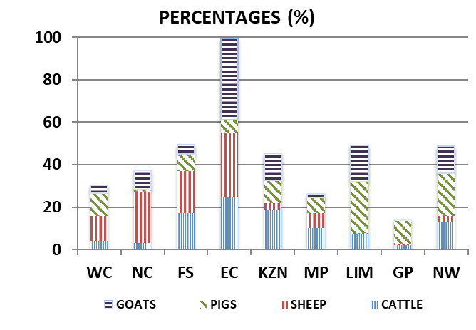
The Department will appreciate if you could complete the enclosed livestock questionnaire and send it back before 30 October 2020, in the envelope provided. Alternatively, send to this email: Livestock@daff.gov.za
The Directorate appreciates your continued support.
per pro. Director: Statistics and Economic Analysis

