

Nuusbrief: Nasionale Veestatistiek

Van: Baldwin Netshifhefhe Direktoraat: Statistiek en Ekonomiese Analise
Tel: 012 319 8043 Faks: 012 319 8035/1 E-pos: BaldwinN@daff.gov.za / SelebogoL@daff.gov.za

Geagte medewerker FEBRUARIE 2019

Geskatte Veegetalle in die RSA (Augustus 2018 en November 2018)

Provinsie | Beeste |  | Skape |  |  |  | Varke |  | Bokke
Provinsie | Aug-18 | Nov-18 | Aug-18 |  | Nov-18 |  | Aug-18 | Nov-18 | Aug-18 | Nov-18
Provinsie | Duisende
Wes-Kaap | 507 | 504 |  | 2 663 | 2 657 | 159 |  | 156 | 207 | 209
Noord-Kaap | 442 | 437 |  | 5 496 | 5 436 | 20 |  | 20 | 474 | 472
Vrystaat | 2 178 | 2 150 |  | 4 510 | 4 499 | 114 |  | 114 | 217 | 217
Oos-Kaap | 3 145 | 3 133 |  | 6 630 | 6 590 | 88 |  | 86 | 2 073 | 2 059
KwaZulu-Natal | 2 481 | 2 453 |  | 680 | 682 | 144 |  | 144 | 702 | 693
Mpumalanga | 1 279 | 1 265 |  | 1 606 | 1 554 | 116 |  | 112 | 81 | 81
Limpopo | 936 | 932 |  | 213 | 208 | 350 |  | 343 | 953 | 936
Gauteng | 246 | 246 |  | 90 | 88 | 156 |  | 156 | 28 | 28
Noordwes | 1 574 | 1 564 |  | 611 | 608 | 306 |  | 299 | 668 | 669
Totaal | 12 788 | 12 684 |  | 22 499 | 22 322 | 1 453 |  | 1 430 | 5 403 | 5 364

Die bees-, skaap-, vark- en bokgetalle het onderskeidelik afgeneem met 0.81%, 0.79%, 1.58% en 0.72% vanaf Augustus 2018 tot November 2018.
BEESTE: Die meeste beeste word in die Oos-Kaap aangetref, gevolg deur KwaZulu-Natal en dan die Vrystaat.

SKAPE: Die hoogste getal skape word in die Oos-Kaap gevind, gevolg deur die Noord-Kaap en dan die Vrystaat.

VARKE: Die meeste varke word in Limpopo aangetref, gevolg deur Noordwes en dan die Gauteng and Wes-Kaap.

BOKKE: Oos-Kaap het die meeste aantal bokke, gevolg deur onderskeidelik Limpopo en KwaZulu-Natal.

NOTAS
Die meeste boere het 'n droë seisoen beleef, met lae boorgatwatervlakke, wat tot swak weidingstoestande gelei het.
Reënval: Oor die tydperk het die meeste provinsies onder normale reënval ondervind.
Vee: Toestande vir vee was swak tot redelik. Limpopo ervaar sterftes as gevolg van die droogte en giftige plante wat geëet word, terwyl sterftes gerapporteer is in KwaZulu-Natal as gevolg van weerlig. In die Noord-Kaap het sponssiekte by vee voorgekom..
Weiding/Veld: Veldtoestande is redelik tot swak, met baie provinsies wat veldbrande ervaar. Sterftes het in die Vrystaat voorgekom.

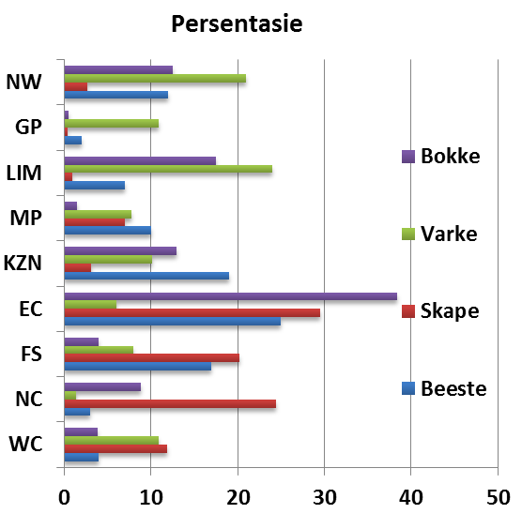
Dit sal waardeer word indien u die meegaande veeskattingsvraelys sal voltooi en dit voor 30 APRIL 2019 in die ingeslote koevert sal terugstuur. Of e-pos na Livestock@daff.gov.za

Die Direktoraat wil u graag bedank vir u volgehoue samewerking.

per pro. Direkteur: Statistiek en Ekonomiese Analise

Newsletter: National Livestock Statistics
From: Baldwin Netshifhefhe Directorate: Statistics and Economic Analysis
Tel: 012 319 8043 Fax: 012 319 8035/1 E-mail: BaldwinN@daff.gov.za / SelebogoL@daff.gov.za

Dear Co-operator FEBRUARY 2019

Estimated Livestock Numbers in the RSA (August 2017 and November 2018)

Province | Cattle |  | Sheep |  |  |  | Pigs |  | Goats
Province | Aug-18 | Nov-18 | Aug-18 |  | Nov-18 |  | Aug-18 | Nov-18 | Aug-18 | Nov-18
Province | Thousands
Western Cape | 507 | 504 |  | 2 663 | 2 657 | 159 |  | 156 | 207 | 209
Northern Cape | 442 | 437 |  | 5 496 | 5 436 | 20 |  | 20 | 474 | 472
Free State | 2 178 | 2 150 |  | 4 510 | 4 499 | 114 |  | 114 | 217 | 217
Eastern Cape | 3 145 | 3 133 |  | 6 630 | 6 590 | 88 |  | 86 | 2 073 | 2 059
KwaZulu-Natal | 2 481 | 2 453 |  | 680 | 682 | 144 |  | 144 | 702 | 693
Mpumalanga | 1 279 | 1 265 |  | 1 606 | 1 554 | 116 |  | 112 | 81 | 81
Limpopo | 936 | 932 |  | 213 | 208 | 350 |  | 343 | 953 | 936
Gauteng | 246 | 246 |  | 90 | 88 | 156 |  | 156 | 28 | 28
North West | 1 574 | 1 564 |  | 611 | 608 | 306 |  | 299 | 668 | 669
Total | 12 788 | 12 684 |  | 22 499 | 22 322 | 1 453 |  | 1 430 | 5 403 | 5 364
The numbers for cattle, sheep, pigs and goats decreased by approximately 0.81%, 0.79%, 1.58% and 0.72% respectively between August 2018 and November 2018.
CATTLE: Eastern Cape has the highest percentage of Cattle, followed by KwaZulu-Natal and Free State.

SHEEP: The highest percentage of sheep is found in Eastern Cape, followed by Northern Cape and Free State.

PIGS: Pigs are largely found in Limpopo, followed by North West, Gauteng and Western Cape.

GOATS: Eastern Cape has the highest number of goats, with Limpopo and KwaZulu-Natal following respectively.

NOTES (Sep –Nov)
Most farmers have observed a dry season, with low boreholes water, resulting in poor grazing.
Rain: over the period, most provinces experienced below to normal rainfall.
Livestock: conditions for livestock were poor to reasonable. Limpopo experience mortalities dues to drought and poisonous plant, while KZN mortalities was from lightning and Black Quarter in NC.
Pasture/veld: veld conditions we fair to poor, with many provinces experiencing veld fires, with mortalities in FS.
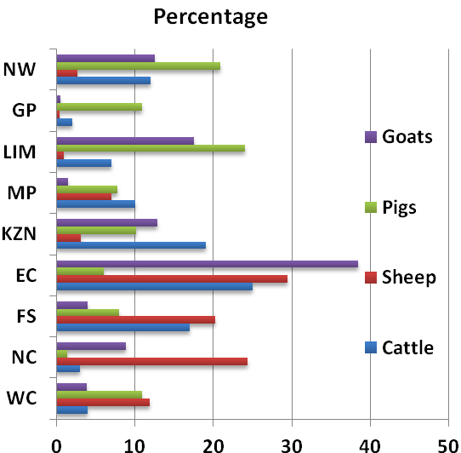

It would be appreciated if you could complete the enclosed livestock questionnaire and send it back before 30 APRIL 2019, in the envelope provided. Alternatively, send to this email: Livestock@daff.gov.za
The Directorate appreciates your continued support.
per pro. Director: Statistics and Economic Analysis

