Augustus 2013
Geagte medewerker
Nuusbrief: Nasionale Veestatistiek
Geskatte Veegetalle in die RSA (Augustus 2012 en Mei 2013)

Provinsie | Beeste |  | Skape |  |  |  | Varke |  | Bokke
Provinsie | Aug-12 | Mei-13 | Aug-12 |  | Mei-13 |  | Aug-12 | Mei-13 | Aug-12 | Mei-13
Provinsie | Duisende
Wes-Kaap | 567 | 563 |  | 2 861 | 2 897 | 175 |  | 176 | 223 | 223
Noord-Kaap | 507 | 501 |  | 6 083 | 6 174 | 28 |  | 28 | 521 | 511
Vrystaat | 2 306 | 2 308 |  | 4 768 | 4 747 | 126 |  | 128 | 245 | 240
Oos-Kaap | 3 267 | 3 305 |  | 7 085 | 7 056 | 96 |  | 97 | 2 314 | 2 320
KwaZulu-Natal | 2 729 | 2 776 |  | 764 | 752 | 156 |  | 158 | 810 | 822
Mpumalanga | 1 462 | 1 436 |  | 1 782 | 1 815 | 129 |  | 126 | 90 | 89
Limpopo | 1 055 | 1 048 |  | 262 | 260 | 370 |  | 370 | 1 187 | 1 185
Gauteng | 258 | 249 |  | 102 | 97 | 179 |  | 180 | 40 | 41
Noordwes | 1 737 | 1 729 |  | 685 | 688 | 320 |  | 319 | 711 | 703
Totaal | 13 888 | 13 915 |  | 24 392 | 24 486 | 1 579 |  | 1 582 | 6 141 | 6 134

Die bees-, skaap- en varkgetalle het onderskeidelik toegeneem met 0.19%, 0.39% en 0.19%, terwyl die bokgetalle met 0.11% afgeneem het vanaf Augustus 2012 tot Mei 2013.
MEI 2013
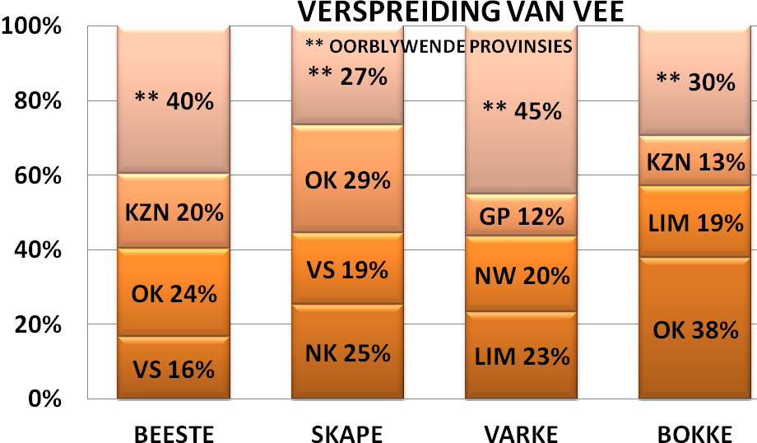
BEESTE: Die Oos-Kaap Provinsie het 3,305 milj beeste, terwyl 2,776 milj in KwaZulu-Natal Provinsie en 2,308 milj in die Vrystaat Provinsie aangetref word. Die oorblywende provinsies verteenwoordig gesamentlik sowat 5,526 milj van die totale getal beeste in Suid-Afrika.

SKAPE: Die Oos-Kaap Provinsie het die meeste skape met 7,056 milj, die Noord-Kaap Provinsie het 6,174 milj en die Vrystaat Provinsie 4,747 milj. Die oorblywende provinsies verteenwoordig sowat 6,509 milj van die totale getal skape in Suid-Afrika.

VARKE: Die Limpopo Provinsie het die grootste getal varke, 369 963. Die Noordwes Provinsie volg met 318 597 en Gauteng Provinsie met 180 434 varke. Die oorblywende provinsies verteenwoordig gesamentlik sowat 711 914 van die totale getal varke in Suid-Afrika.

BOKKE: Die grootste getal bokke, 2,320 milj word in die Oos-Kaap Provinsie aangetref, Limpopo Provinsie volg met 1,185 milj en KwaZulu-Natal Provinsie met 821 986. Die oorblywende provinsies verteenwoordig gesamentlik sowat 1,807 milj. van die totale getal bokke in Suid-Afrika

Dit sal waardeer word indien u die meegaande veeskattingsvraelys sal voltooi en dit voor 31 Oktober 2013 in die ingeslote koevert sal terugstuur.

Die Direktoraat wil u graag bedank vir u volgehoue samewerking

per pro. Direkteur: Statistiek en Ekonomiese Analise

August 2013
Dear Co-operator

Newsletter: National Livestock Statistics
Estimated Livestock Numbers in the RSA (August 2012 and May 2013)

Province | Cattle |  | Sheep |  |  |  | Pigs |  | Goats
Province | Aug-12 | May-13 | Aug-12 |  | May-13 |  | Aug-12 | May-13 | Aug-12 | May-13
Province | Thousands
Western Cape | 567 | 563 |  | 2 861 | 2 897 | 175 |  | 176 | 223 | 223
Northern Cape | 507 | 501 |  | 6 083 | 6 174 | 28 |  | 28 | 521 | 511
Free State | 2 306 | 2 308 |  | 4 768 | 4 747 | 126 |  | 128 | 245 | 240
Eastern Cape | 3 267 | 3 305 |  | 7 085 | 7 056 | 96 |  | 97 | 2 314 | 2 320
KwaZulu-Natal | 2 729 | 2 776 |  | 764 | 752 | 156 |  | 158 | 810 | 822
Mpumalanga | 1 462 | 1 436 |  | 1 782 | 1 815 | 129 |  | 126 | 90 | 89
Limpopo | 1 055 | 1 048 |  | 262 | 260 | 370 |  | 370 | 1 187 | 1 185
Gauteng | 258 | 249 |  | 102 | 97 | 179 |  | 180 | 40 | 41
North West | 1 737 | 1 729 |  | 685 | 688 | 320 |  | 319 | 711 | 703
Total | 13 888 | 13 915 |  | 24 392 | 24 486 | 1 579 |  | 1 582 | 6 141 | 6 134

The numbers for cattle, sheep and pigs increased by approximately 0.19%, 0.39% and 0.19% respectively, while the numbers for goats decreased by 0.11% between August 2012 and May 2013.
CATTLE: Eastern Cape Province leads with 3,305 mill, 2,776 mill in KwaZulu-Natal Province and 2,308 mill in the Free State Province. The remaining provinces share 5,526 mill of the total cattle population in South Africa.

SHEEP: The provincial distribution of sheep is as follows: 7,056 mill in the Eastern Cape Province 6,174 mill in the Northern Cape Province and 4,747 mill in the Free State Province. 6,509 mill is shared among the remaining provinces in South Africa.

PIGS: Most of the pig population is in the Limpopo Province at 369 963, the North West Province follows with 318 597 and the Gauteng Province with 180 434. The remaining provinces share approximately 711 914 of the total pig population in South Africa.

GOATS: Of the total goat numbers 2,320 mill are found in the Eastern Cape Province, Limpopo Province follows with 1,185 mill and KwaZulu-Natal Province with 821 986. The remaining provinces share approximately 1,807 mill.

MAY 2013
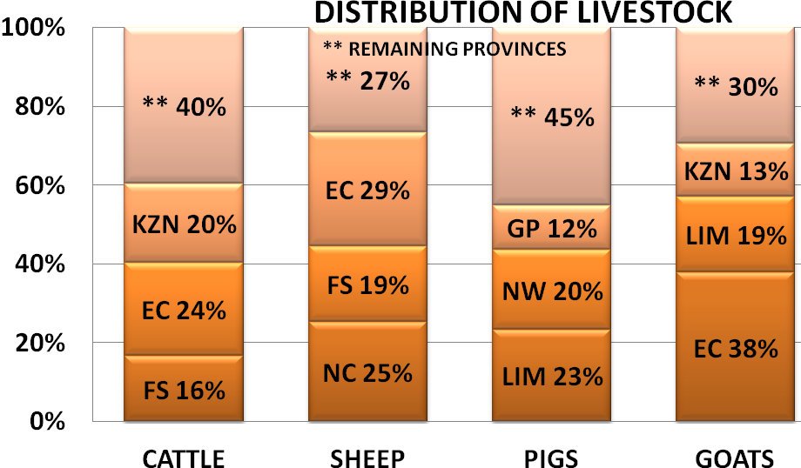

It would be appreciated if you could complete the enclosed livestock questionnaire and send it back before 31 October 2013, in the envelope provided.
The Directorate appreciates your continued support.
per pro. Director: Statistics and Economic Analysis

