***ITC TRAINING 2012***

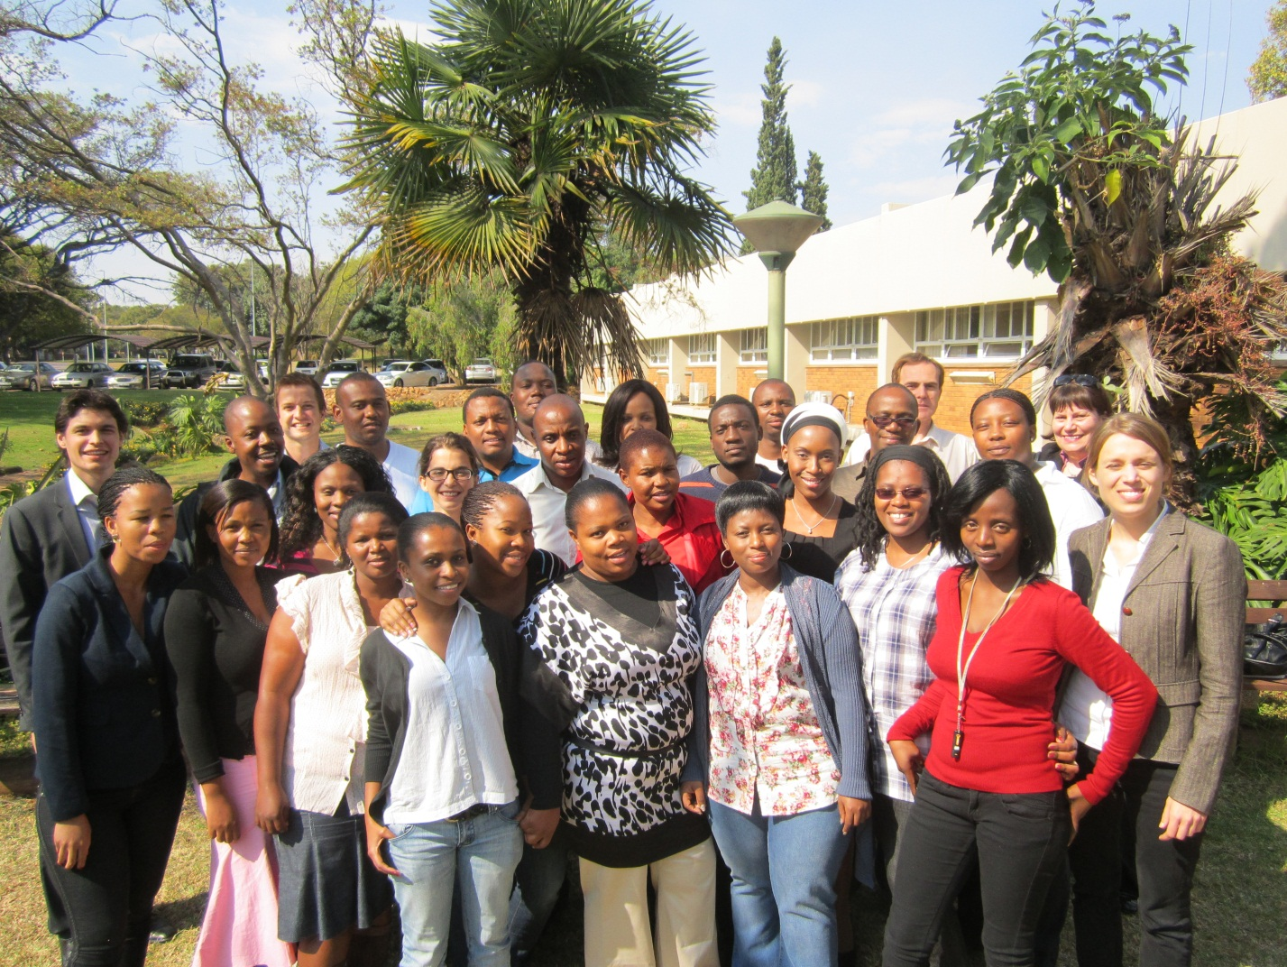

The Department of Agriculture, Forestry and Fisheries (DAFF) has a mandate to increase South Africa’s agricultural, forestry and fisheries trade with the world. In implementing this mandate, the Department identified the need to equip trade and trade related service providers within the sector with the necessary research and analytical skills in the form of mentorship based training. Such skill is essential to support the sector to participate effectively and competitively in the global trading environment through opportunity analysis and translating opportunities into business propositions for exports.

In line with the above, the Minister for Agriculture, Forestry and Fisheries signed a Memorandum of Understanding Agreement with the International Trade Centre (ITC) to provide international trade research and analytical training to the officials responsible for agricultural trade and marketing development. The Directorate: International Trade (D: ITR) conducted training together with International Trade Centre (ITC) from Geneva.

The purpose of this training was to offer training in market analysis and research methods with a view to identify export potential opportunities for S.A. agricultural, forestry and fishery products. This year the training was at its 2nd cycle and it operated within the context of the Memorandum of Understanding between ITC and the Republic of South Africa signed on 1st March 2010.

The content of the training covered advanced market analysis and research methods for identifying export potential and market opportunities and obstacles, with a view to participants using that training to write reports on the export opportunity/potential for South African products in high potential markets.

The training programme started in March with a one-month online training activities on basic trade analysis skills using ITC’s market analysis tools and MS Excel. There were 40 participants that took part on the online training. At the end of this first activity, participants were selected based on their results of an online evaluation for the advanced market analysis training programme.

Phase 2 of the training was restricted to successful participants. It consisted of three face-to-face training workshops, with each workshop running for four days. The workshops were held at the CSIR in Pretoria, in May and June. The advanced market analysis training was attended by a group of 20 officials from DAFF, NAMC, Provincial Departments of Agriculture, Provincial Export Promotion Agencies, Industry and Universities.

The participants learnt how to conduct advanced and effective market analysis and strategic international market research. The training covered the use of ITC’s international market analysis tools and international market analysis intelligence to perform export potential assessment, review international market access conditions, select attractive products and markets for export by South Africa and also to develop market profiles for those products with high export potential.

During the last workshop each group presented their completed market profiles and received direct feedbacks from the panel members. The panel was composed of DAFF Officials, Professor from University of Pretoria and ITC trainers. Certificates of participation were then presented to the participants. See the sunflower oil market analysis document attached, as the example of the market profile.

You can discover ITC’s Market Analysis Tools at: <www.intracen.org/marketanalysis>

If you are interested in participating on the online training and learn more about market analysis tools you can contact the Director: International Trade at 012 319 8451 for more information.