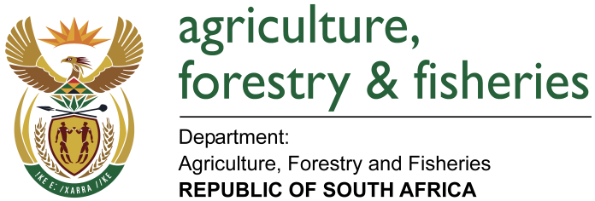

Micro Agricultural Financial Institutions of South Africa (MAFISA)
Information pamphlet 2016

1 What is MAFISA

The Micro Agricultural Financial Institutions of South Africa (MAFISA) is a financial service scheme that provides financial services to smallholder farmers (including forest growers and smallholder fisheries enterprises) and agribusinesses. MAFISA aims to improve access to finance by smallholder operators in the agriculture, forestry and fisheries sector to enable them to enhance production activities. MAFISA provides loans through a network of institutions.

2 Products and services

2.1 Available product

- Short to medium term Production loan

3 Purpose of the loan

- Purchase of production inputs (fertilizers, seeds, pesticides, animal feed and remedies etc.)
- Purchase of small equipment and implements (Knapsack spray, wheel barrow, spades, etc)

4 Who can apply?

- Smallholder farmers, forest growers and fishermen
- Land and agrarian reform beneficiaries who are smallholder operators
- Self-help groups (SHGs) / Co-operatives involved in agriculture, forestry and fisheries related enterprises
- Small agribusinesses

5 How to apply

- Contact your local Agricultural Extension Office for information
- Obtain application form from the participating institutions in your area / provinces
- Complete the application forms and attach required documents
- Submit the application form to participating intermediary

6 Eligibility criteria

- Be a South African citizen
- Must be from historically disadvantaged (designated) group
- Must be in possession of a valid South African identity document
- The enterprise pursued must indicate ability to repay the loan (i.e. must be viable)
- Be 18 years or above in age ( if between 18 and 21 there is a need for parental/guardian consent)
- Household gross monthly non farm income must not be more than R20 000
- Total enterprise turn over must not be more than R5000 000
- Can apply as an individual, group or an entity
- Enterprise must be in respect of either farming or agribusiness

8 Terms and conditions

- A maximum loan amount of up to R500 000 per person
- For loans above R25000 collateral / collateral is required
- Money borrowed has to be repaid in full together with the interest
- Money borrowed has to be used for the purpose for which it was applied
- Farmers on communal land are eligible for consideration
- Loans charged is 7% interest rate
- Funds paid to the third party / suppliers

9 Accredited MAFISA retailers

Table1: Accredited participating institutions
Institution | Area of operation | Contacts
NERPO | All provinces | Tel 012 3488566
SASA | KZN & MP | 031 5087000
PAFS | GP, KZN, LM,NW & NC | 011 3142833
MEGA | Mpumalanga | 013 7522440
ECRDA | Eastern Cape | 0437036300

10 Contact details

MAFISA call centre situated at No. 20 Steve Biko (Beatrix) Street, Arcadia, Pretoria, 0001. Tel: (012) 319 6825, x7263 Fax: (012) 319 7278: or accredited institutions as listed on table 1 above.

